PRESS RELEASE
OPEN MIND Application Example: CNC Bike
A Successful hyperMILL® Project in the World of Sports
Wessling (Germany), November 3, 2026 – A downhill race bike CNC-milled entirely from high-strength aluminum won the 2025 IXS Downhill Cup, among other races, and is currently back in competition. The creator of this special bike is Bernd Iwanow, Managing Director of CNC Future Technics GmbH. The hyperMILL® CAD/CAM suite from OPEN MIND Technologies AG implemented 5-axis machining and simulation-supported manufacturing during development to significantly benefit the “Fracebike”.
Bernd Iwanow had a vision to develop his own high-end bike and even founded a second company for this purpose under the name CNC Bike GmbH. He spent over a year working on design and development before the first prototype was manufactured. hyperMILL® not only enabled precise 5-axis machining of complex components but also fully harnessed the potential of the Hermle machining centers at CNC Future Technics. To achieve perfect surface quality, hyperMILL® offers special strategies for high-precision machining, a must for the visual aesthetics of a high-end bike. Thanks to functions such as “Surface Precision Mode,” in which toolpaths are calculated directly on the surfaces of the CAD model, a particularly uniform milling finish is achieved.
Milling Strategies and Simulation
Another milling strategy that Iwanow particularly values is “Smooth Overlap,” which ensures flawless transitions between individual machining areas. “Flawless machining is crucial, especially for prototypes: Every step has to be right, and the first part has to fit,” says Iwanow. With hyperMILL® VIRTUAL Machining, he has a reliable, NC-code-based simulation at his disposal for this purpose.
“We’re delighted by the success of the Fracebike and the growing interest in Iwanow’s work within the community. At the same time, it was great to see how skillfully he leveraged the technical capabilities of hyperMILL®. I wish him and the riders of his bikes continued success, and, of course, injury-free rides,” says Dr. Josef Koch, CTO of OPEN MIND Technologies, himself a passionate mountain biker and owner of a one-of-a-kind bicycle by Bernd Iwanow.

Key Facts at a Glance
- Sports Success: A CNC-milled downhill race bike wins the 2025 IXS Downhill Cup, among other races.
- An extraordinary project: A race bike made entirely of high-strength aluminum, developed by Bernd Iwanow, CEO of CNC Future Technics GmbH.
- Precise 5-axis machining: hyperMILL® enables the production of complex geometries with high surface quality.
- Reliable manufacturing: NC code-based simulation with hyperMILL® VIRTUAL Machining helps ensure error-free machining right from the first part.

Available images
The following images are available for download in printable format at:
https://kk.htcm.de/press-releases/open-mind/
  Source: Racement/Christoph Deik iXS Downhill Cup  For example, a bike CNC-milled and designed in hyperMILL® won the 2025 IXS Downhill Cup series. | 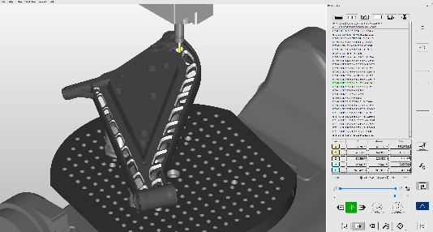  Source:  OPEN MIND  hyperMILL® VIRTUAL Machining Center: Material Removal Simulation for Milling Operations
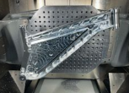
Source: OPEN MIND

The main frame of the Fracebike is made of high-strength aluminum.

Available videos
You can find the following videos on our YouTube channel: https://youtu.be/8xnTLVcc-uk?si=9rA_P-L7jZpWBpMu
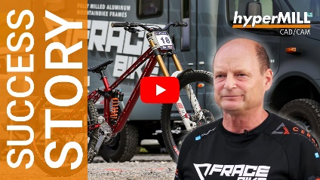Source: OPEN MIND
Video about the Fracebike project

About OPEN MIND Technologies AG
OPEN MIND Technologies AG is one of the world’s leading developers of powerful CAD/CAM solutions for machine and controller-independent programming.
OPEN MIND develops optimized CAD/CAM solutions that include innovative and unique features that can deliver significantly higher performance in both programming and machining.
hyperMILL® is a completely modular CAD/CAM solution that provides state-of-the-art CAM technologies on its own CAD platform: from 2.5D, 3D and 5-axis machining as well as turning strategies and solutions for additive manufacturing, HSC and HPC machining. Whether automation, simulation or virtual machine – trendsetting technologies expand the product range and enable continuous digital process chains. Special applications, seamless interaction with all popular CAD solutions and exceptional customer service rounds out the company’s products and capabilities.
According to the “NC Market Analysis Report 2026” compiled by CIMdata, hyperMILL® is a leading, worldwide CAD/CAM solution. Innovative CAD/CAM technologies fulfill the highest demands in aerospace, automotive, tool and mold manufacturing, production machining, medical, job shops, energy and semiconductor industries.
OPEN MIND's majority stake in manufacturing execution system (MES) developer Hummingbird expands the CAD/CAM manufacturer's product portfolio and enhances the range of connected digitalized manufacturing technologies.
OPEN MIND is a Mensch und Maschine company and has subsidiaries and qualified sales partners on all continents.
You can find more information at www.openmind-tech.com.

OPEN MIND Technologies UK Ltd., Oxford
Unit 3
Bicester Business Park
Telford Road
Bicester
Oxfordshire OX26 4LN
England
Phone: +44 1869 290 003
Fax: +44 1869 369 429
E-mail: Info.UK@openmind-tech.com

OPEN MIND Technologies USA, Inc.
1492 Highland Avenue, Unit 3
Needham MA 02492
USA
Phone: +1 339 225 4557 office
Phone: +1 888 516 1232 x0 toll-free
Fax: +1 270 912 5822
E-mail: Info.Americas@openmind-tech.com

OPEN MIND Technologies Asia Pacific Pte Ltd
MOVA Building, 22 Jalan Kilang #03-00
Singapore 159419
Phone: +65 6742 95-56
E-mail. Info.Asia@openmind-tech.com

OPEN MIND CADCAM Technologies India Private Ltd
No.610 & 611, 6th Floor, ‘B’ Wing, No.6, Mittal Tower
M.G. Road, Bangalore
560001, Karnataka
Phone: +91 80 2676 6999
E-mail: Info.India@openmind-tech.com

Head office:
OPEN MIND Technologies AG, Argelsrieder Feld 5, 82234 Wessling, Germany
Tel.: (+49-8153) 933-500, Fax: (+49-8153) 933-501
E-mail: Info@openmind-tech.com, website: www.openmind-tech.com

Press contact:
HighTech communications GmbH
Brigitte Basilio
Brunhamstrasse 21
81249 Munich
Germany
Tel.: (+49-89) 500778-20
E-mail: b.basilio@htcm.de
Website: www.htcm.de

