indie to Showcase its Radar Technology at InnoRail India
Imaging Radar for Enhanced Safety and Security in Rail Transportation
Neubiberg, Germany – October 30, 2026 – indie, a global technology leader in innovative automotive and industrial solutions, will showcase its latest radar technology at InnoRail India 2026, taking place from 26–28 November 2026, at the RDSO Stadium Grounds in Lucknow. At Booth 10.4 in the German Pavilion, indie will demonstrate how advanced radar technology can support a wide range of applications in railway infrastructure and rolling stock. Potential applications range from detecting changes in infrastructure and its surroundings caused by environmental conditions to identifying unauthorized access or interference in critical areas. Radar technology can thus complement existing and emerging monitoring technologies, contributing to safer and more resilient rail transportation.
Radar sensors have proven their reliability for decades in demanding industrial environments, including bulk material handling and crane safety applications. Recent advances in imaging radar are opening up new possibilities across a growing range of industries and use cases. In the rail sector, imaging radar has the potential to complement existing sensing technologies and enhance the safety, reliability, and resilience of railway infrastructure.
For example, trains equipped with imaging radar could help detect changes along particularly vulnerable or difficult-to-monitor sections of the rail network. This is particularly relevant as rail operators worldwide increasingly rely on advanced sensing and monitoring technologies to enhance safety and operational efficiency.
Seeking Development Partnerships
Imaging radar provides a wealth of information about objects, movements, and changes in the monitored environment. Transforming this data into actionable, application-specific information requires sensor technology and software to be tailored to the individual use case. To facilitate the development and evaluation of such applications, indie offers the AVR-QDM-110 Eval Kit, a powerful MIMO radar evaluation platform. Its sensor array can be flexibly configured to meet different application requirements.
The platform has already been evaluated in several customer projects exploring the potential of imaging radar for rail applications, including railroad crossing monitoring. At InnoRail India, indie will also showcase the versatility of radar with a technology demonstrator for contactless vibration measurement using 120 GHz radar.
With its participation at InnoRail India, indie is looking to connect with railway companies, infrastructure operators, technology providers, and potential development partners in India to explore new applications for advanced radar sensing and jointly develop solutions tailored to the specific requirements of the Indian rail market.

Available image material
The following printable images are available for download on the Internet:
https://kk.htcm.de/press-releases/symeo/
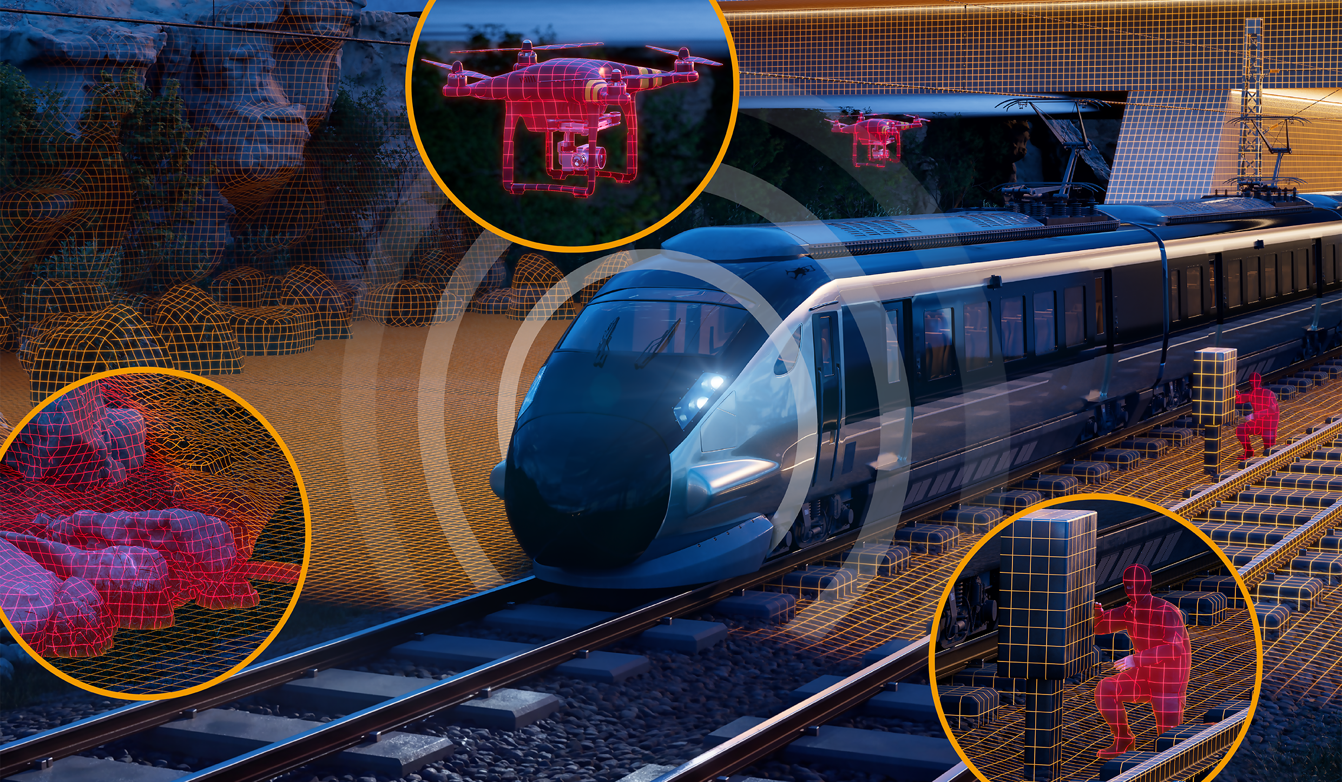 | 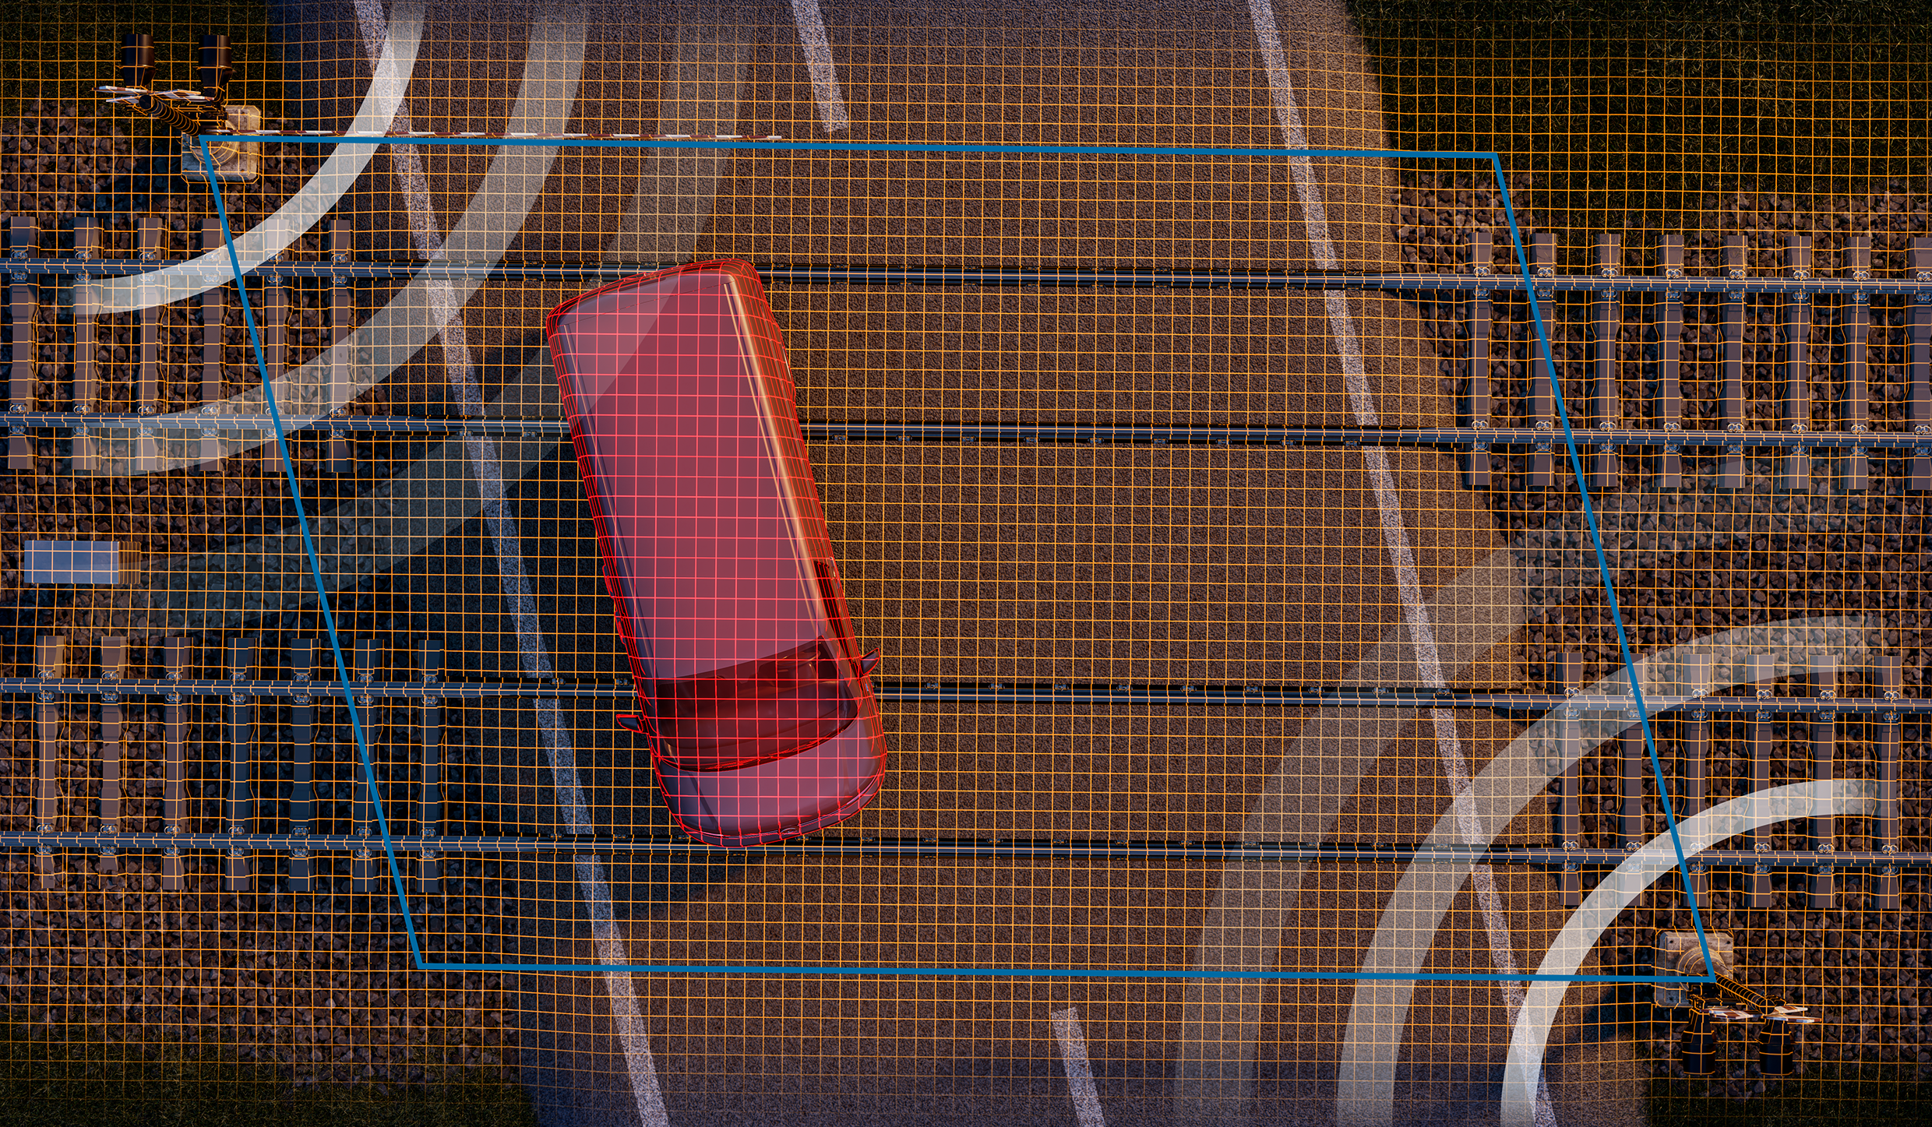
Imaging radar opens up new possibilities for monitoring railway lines and their surroundings – from environmental hazards such as landslides to drones and unauthorized interference with rail infrastructure.  Image source: indie | Imaging radar can provide reliable, continuous monitoring of level-crossings, even under challenging weather and visibility conditions.  Image source: indie

About indie
Headquartered in Aliso Viejo, CA, indie (Nasdaq: INDI) is accelerating ADAS intelligence across automotive, quantum, and Physical AI applications through next-generation hardware, system solutions, and perception software technologies. Developing high-performance, energy-efficient semiconductors, photonic, and software solutions, we are enabling machines to perceive, understand, and interact with the physical world. Spanning radar, computer vision, LiDAR, and ultrasound, our platforms power advanced safety, automation, positioning, and automated capabilities for leading automotive OEMs, intelligent machines, and emerging AI-driven systems worldwide.
Please visit us at www.indie.inc to learn more.
Press contact indie Germany GmbH – Symeo® brand:
HighTech communications GmbH
Marcus Planckh
Brunhamstrasse 21 (Building 202/2nd floor)
81249 Munich, Germany
Phone: +49 89 500-77822
E-mail: m.planckh@htcm.de
Website: www.htcm.de

