indie to Showcase its Symeo® Radar Technology at SPS 2026
Safety, Monitoring and Predictive Maintenance
with Radar
Neubiberg, Germany, 27. Oktober 2026 – indie, a global technology leader in innovative automotive and industrial solutions, will showcase its Symeo radar products and solutions at SPS in Nuremberg, Germany, from November 24–26, 2026, at booth 406 in Hall 7A. The portfolio ranges from proven radar solutions for position detection, distance measurement and collision avoidance in harsh industrial environments to functional safety, condition monitoring and predictive maintenance applications.
Radar technology offers significant advantages in harsh industrial environments: Radar sensors are low-maintenance and largely unaffected by conditions such as rain, fog or dust. This allows them to operate reliably even where optical systems reach their limits. A demonstrator at the booth will highlight these capabilities.

Radar sensors, including Symeo® LPR-1D24, Symeo® LPR-1DHP-291 and Symeo® LPR-1DHP-350, have proven themselves in applications worldwide, including ports, steel mills and bulk material handling. Cranes and rail-based transportation systems in logistics are another important area of application.

For these applications, indie also offers Symeo® LPR-SAFE, a solution for functional safety in accordance with the European standard EN ISO 13849 PLd. The system, which will also be demonstrated at the booth, consists of two redundant pairs of sensors. Their measurement results are compared in a fail-safe Siemens PLC using a certified function block compliant with EN ISO 13849 PLd.

New Applications for Industrial Radar Sensing
Modern radar sensing technology can do much more than detect distances or positions. indie has developed high-resolution imaging radar for close-range applications that can, for example, be used to create digital twins of infrastructure. The technology enables real-time monitoring of machinery, facilities and infrastructure.

At SPS, indie will demonstrate how such applications can be developed and evaluated using the AVR-QDM-110 Eval Kit, which includes a MIMO radar evaluation platform.
Another emerging application for radar in industrial environments is contactless vibration measurement, which indie will also demonstrate at its booth. Changes in the vibration behaviour of mechanical components can indicate wear and damage, making the measurement data valuable for condition monitoring and predictive maintenance.
Symeo® is a brand of indie.
For more information, visit https://www.symeo.com/en/

Available image material
The following printable images are available for download on the Internet:
https://kk.htcm.de/press-releases/symeo/
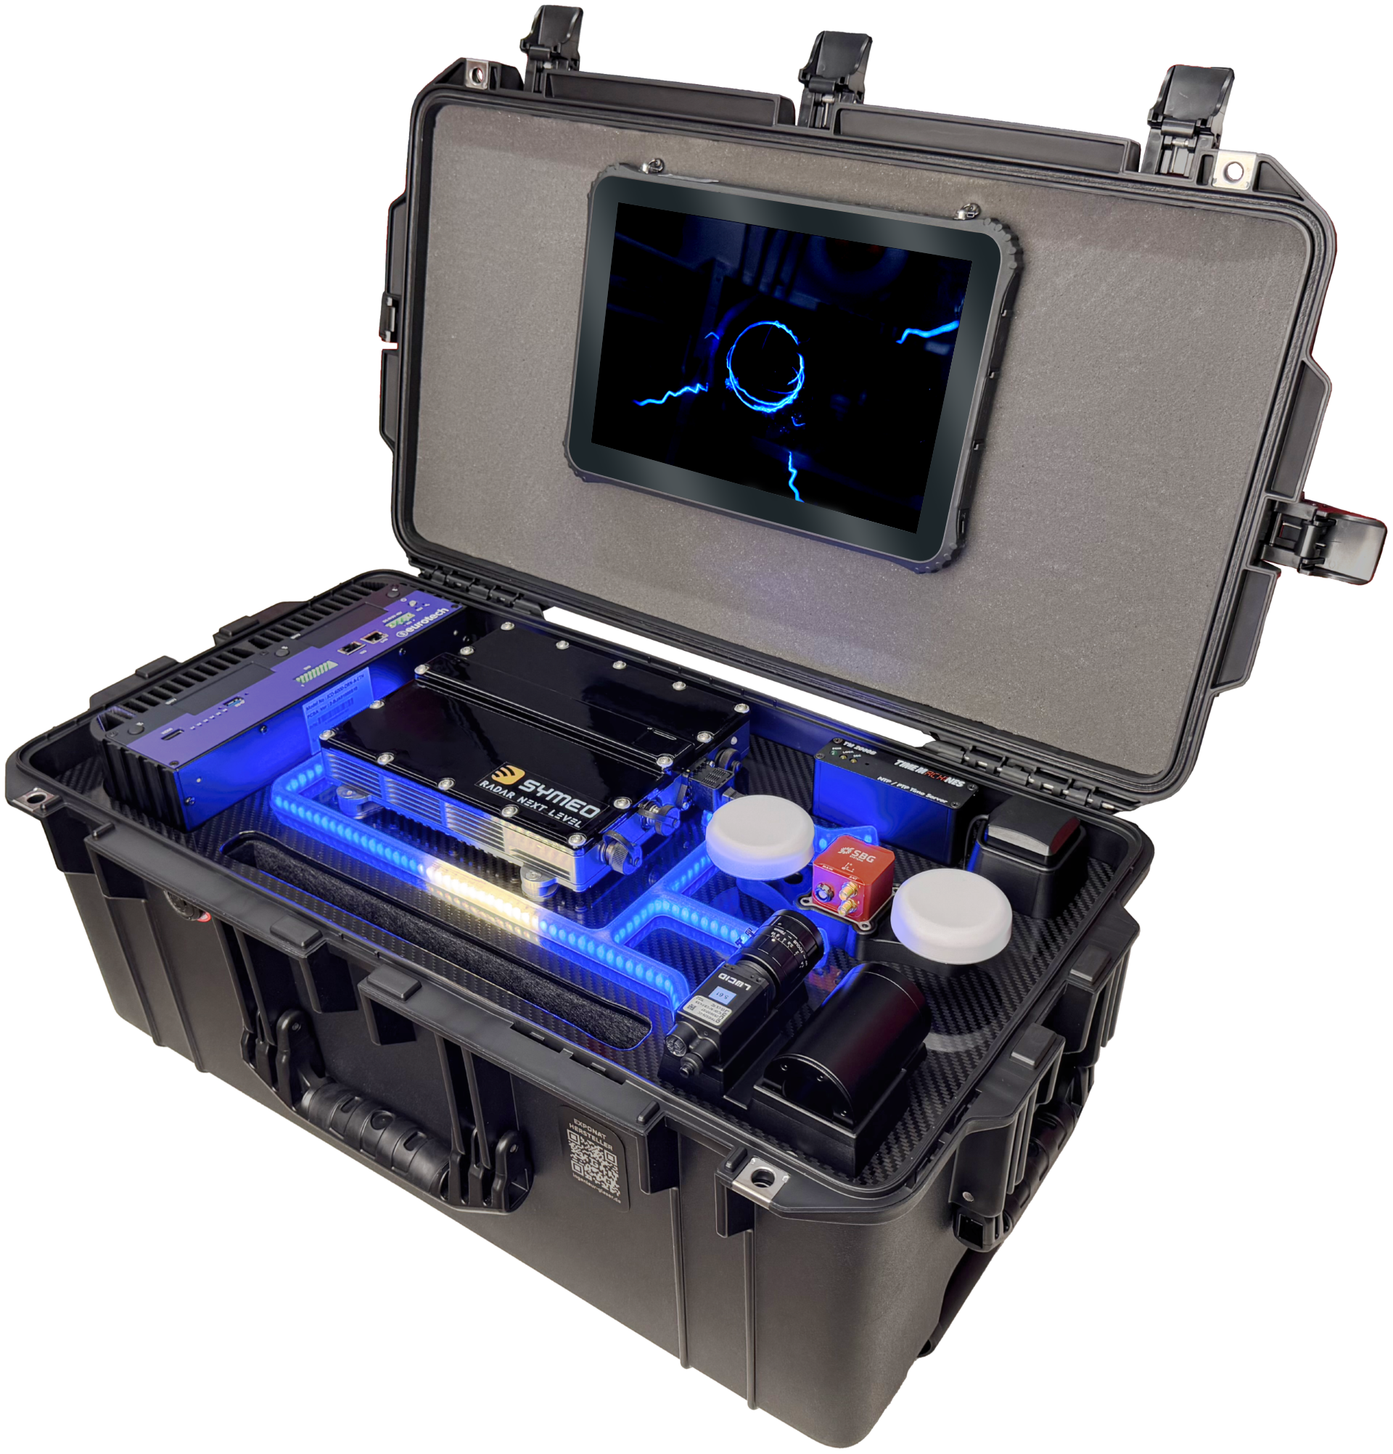  The AVR-QDM-110 Evaluation Kit is a MIMO radar evaluation platform that can be used to develop custom applications.  Source: indie | 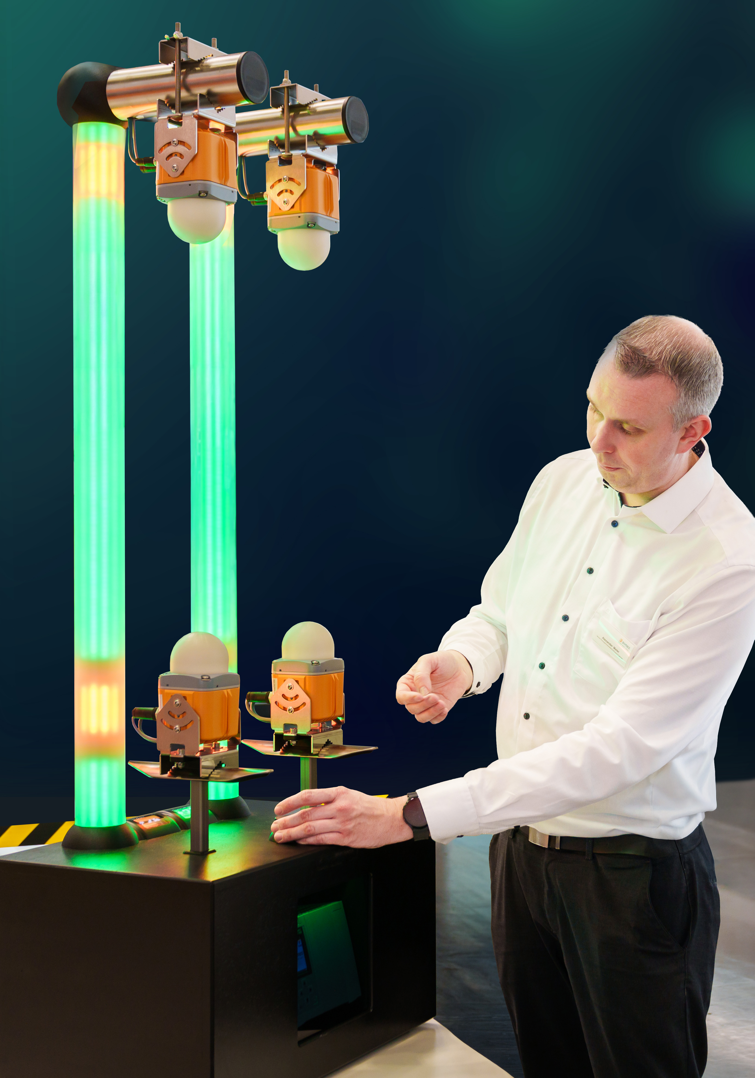  A demonstrator brings Symeo® LPR-SAFE to life.  Source: indie

About indie
Headquartered in Aliso Viejo, CA, indie (Nasdaq: INDI) is accelerating ADAS intelligence across automotive, quantum, and Physical AI applications through next-generation hardware, system solutions, and perception software technologies. Developing high-performance, energy-efficient semiconductors, photonic, and software solutions, we are enabling machines to perceive, understand, and interact with the physical world. Spanning radar, computer vision, LiDAR, and ultrasound, our platforms power advanced safety, automation, positioning, and automated capabilities for leading automotive OEMs, intelligent machines, and emerging AI-driven systems worldwide.
Please visit us at www.indie.inc to learn more.
Press contact indie Germany GmbH – Symeo® brand:
HighTech communications GmbH
Marcus Planckh
Brunhamstrasse 21 (Building 202/2nd floor)
81249 Munich, Germany
Phone: +49 89 500-77822
E-mail: m.planckh@htcm.de
Website: www.htcm.de

