indie to Showcase its Symeo® Radar Technology at Scandinavian Rail Optimisation
Imaging Radar for Climate-Resilient Rail Infrastructure
Neubiberg, Germany, October 21, 2026 – indie, global technology leader in innovative automotive and industrial solutions, will participate in the Scandinavian Rail Optimisation conference in Stockholm on November 4, 2026. At 11:00 a.m., Thomas Hörl-Weinhold, VP Business Development at indie Germany, will present “Big data and new capabilities in infrastructure monitoring with imaging radar.” In his presentation and the accompanying exhibition, indie will demonstrate the potential of its advanced Symeo imaging radar technology for monitoring and protecting rail infrastructure.
Extreme weather events are posing growing challenges to rail infrastructure. The potential consequences of heavy rainfall became evident in Sweden’s Västernorrland region in September 2025, when severe rainfall caused flooding and extensive damage to transportation infrastructure. Two freight trains subsequently derailed. Continuous monitoring of rail infrastructure and its surroundings is therefore becoming increasingly important for the early detection of risks associated with flooding, erosion, and ground movement.
Radar can complement existing sensing technologies in this context. It provides reliable data even in darkness and under challenging weather and visibility conditions, helping to make rail infrastructure more resilient. Radar sensors have already proven their reliability in demanding industrial applications such as crane safety and bulk material measurement. With imaging radar technology, the company is now expanding into additional rail applications.
Rapid Prototyping with indie’s Symeo® Radar Technology
The AVR-QDM-110 Eval Kit and its powerful MIMO radar evaluation platform enable new imaging radar applications to be developed and tested quickly. Initial solutions for rail applications are already under development, including railroad-crossing monitoring.
The wealth of information contained in radar signals opens up new possibilities for monitoring rail infrastructure and its surroundings, from detecting changes caused by environmental conditions to identifying unauthorized interference in critical areas. The key is application-specific data processing that transforms radar data into actionable information. At the Stockholm event, indie will demonstrate how this approach can enable solutions for a wide range of monitoring tasks, including applications where conventional technologies reach their limits. To illustrate the versatility of radar technology, the company will also showcase contactless vibration measurement using radar.
Symeo® is a brand of indie.
Please visit www.symeo.com/en/ to learn more.

Available image material
The following printable images are available for download on the Internet:
https://kk.htcm.de/press-releases/symeo/
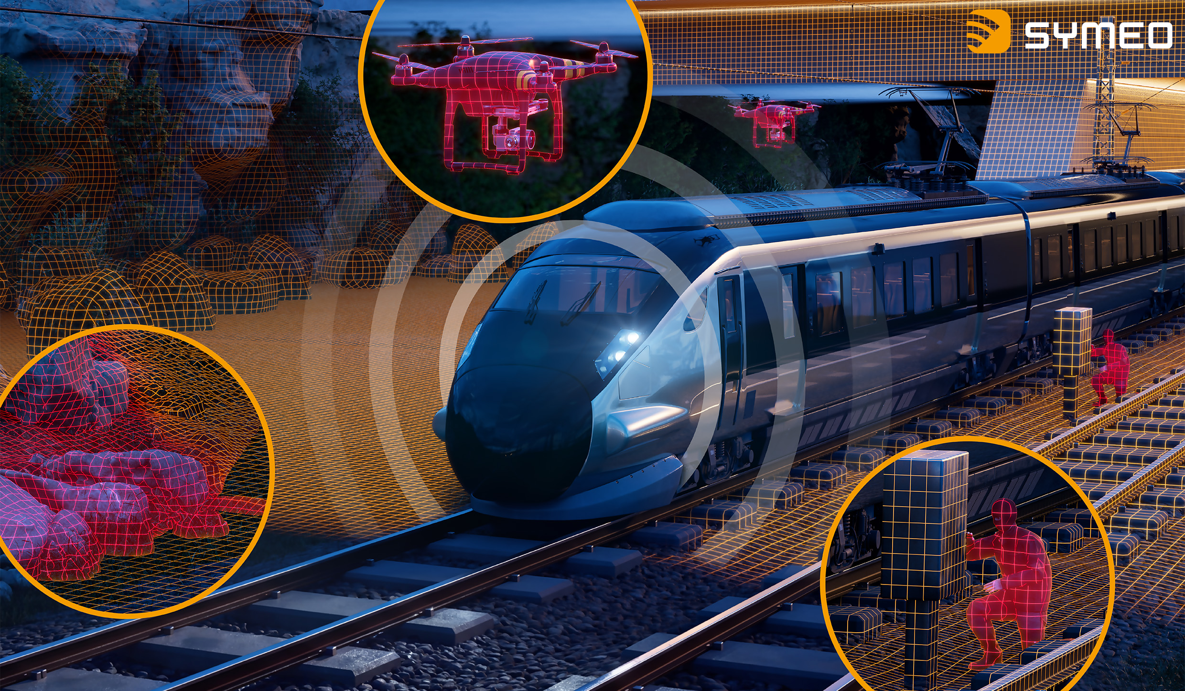 | 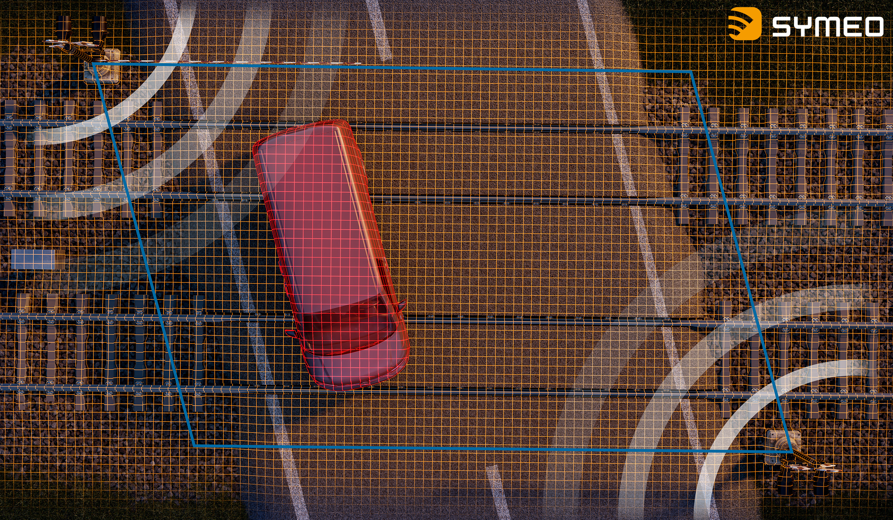
Imaging radar opens up new possibilities for monitoring railway lines and their surroundings – from environmental hazards such as landslides to drones and unauthorized interference with rail infrastructure.  Image source: indie | Imaging radar can provide reliable, continuous monitoring of level-crossings, even under challenging weather and visibility conditions.  Image source: indie

About indie
Headquartered in Aliso Viejo, CA, indie (Nasdaq: INDI) is accelerating ADAS intelligence across automotive, quantum, and Physical AI applications through next-generation hardware, system solutions, and perception software technologies. Developing high-performance, energy-efficient semiconductors, photonic, and software solutions, we are enabling machines to perceive, understand, and interact with the physical world. Spanning radar, computer vision, LiDAR, and ultrasound, our platforms power advanced safety, automation, positioning, and automated capabilities for leading automotive OEMs, intelligent machines, and emerging AI-driven systems worldwide.
Please visit us at www.indie.inc to learn more.
Press contact indie Germany GmbH – Symeo® brand:
HighTech communications GmbH
Marcus Planckh
Brunhamstrasse 21 (Building 202/2nd floor)
81249 Munich, Germany
Phone: +49 89 500-77822
E-mail: m.planckh@htcm.de
Website: www.htcm.de

