FOR THE MEDIA
ASMPT presents new SOLO placement head for AI server applications
Mastering new dimensions in BGA size and weight
Shanghai (China), October 21, 2026 – With its new SOLO placement head, ASMPT SMT Solutions, the global market and technology leader in integrated hardware and software solutions for the electronics manufacturing industry, is expanding its portfolio of solutions for the production of complex circuit boards for AI and high-performance computing (HPC) applications. Developed especially for the reliable placement of particularly large and heavy processor BGAs, the new head can initially be used on the SIPLACE SX. It handles components measuring up to 240 × 240 millimeters (9.45 × 9.45 inches) and weighing over 2 kilograms (4.4 pounds), soon to be increased to up to 5 kilograms (11 pounds).
The growing demand for AI applications and their associated computing power is driving the development of highly integrated multi-die modules. More transistors, higher memory bandwidths and thousands of power supply and signal connectors make processor BGAs increasingly complex, larger, and heavier. Whereas only one year ago large processor BGAs measured roughly 150 × 150 millimeters (9.45 × 9.45 inches) and weighed 500 grams (1.1 pounds), the next generation is already reaching 240 × 240 millimeters (8.45 × 9.45 inches) with weights of 2 kilograms (4.4 pounds) – about two times the area and four times the weight. To meet the dynamic growth of the AI market, ASMPT has developed within six months its completely new SOLO placement head as the perfect solution for handling these ever larger and more expensive processors.
Specialist for large and heavy processor BGAs
The new SOLO head is specially designed for picking and placing processor BGAs of this size and weight class. It is based on a new single-segment architecture with a strengthened and stiffened axis. The connection between the placement head and the gantry as well as the interface between nozzle and segment were also designed to withstand the greater mechanical loads. The maximum placement force is 200 newtons. Construction-wise, the head is already designed for significantly heavier components weighing up to 5 kilograms (11 pounds).
Since the highly complex processors can cost more than 20,000 U.S. dollars, they must be handled with an appropriate level of safety and reliability. The nozzles are matched to the respective housing surfaces and take into account any areas that must not be touched during pickup. And since the mass inertia of the large BGAs can be taken into consideration in the movement profiles, acceleration and rotational movements can be customized for the respective component.
The SOLO placement head handles the final step
The processor is merely one of many components on an AI server board. Before it is placed, many ICs, condensers, connectors and super-small passive components must be processed. To accomplish this, various placement heads can be combined on SIPLACE placement machines in an SMT line: The CP20 handles the speedy placement of the smallest components, the CPP covers a broad component spectrum, and the TWIN VHF handles large, heavy and unusually shaped components. The expensive processor BGAs are installed at the very end of the placement process. The new SOLO head handles this particularly critical step and ensures that these large and heavy components are picked up and placed with reliability and precision.
Process reliability along the entire line
The placement of large processor BGAs is only one part of the manufacturing process. Material feeding, circuit board handling and quality control must also be designed to meet the special requirements of AI server applications. The SIPLACE SX provides the necessary functions. Heavy-duty conveyors ensure the safe transport of large and heavy circuit boards while the SIPLACE Smart Pin Support provides the necessary support and prevents PCBs from bending and vibrating during the placement process. And before placing the processor, the machine can inspect critical board segments, especially those in the processor’s target area, for foreign matter and ensure the presence and correct position of spacers. After picking up the processor, it checks BGA connectors optically and can optionally measure the coplanarity of the solder balls via 3D laser triangulation. With the SOLO placement head, the SIPLACE SX is now keeping pace with the rapid developments in the size and weight of processor BGAs.

Illustrations for downloading
The following images are available for download in printable format at:
https://kk.htcm.de/press-releases/asmpt/

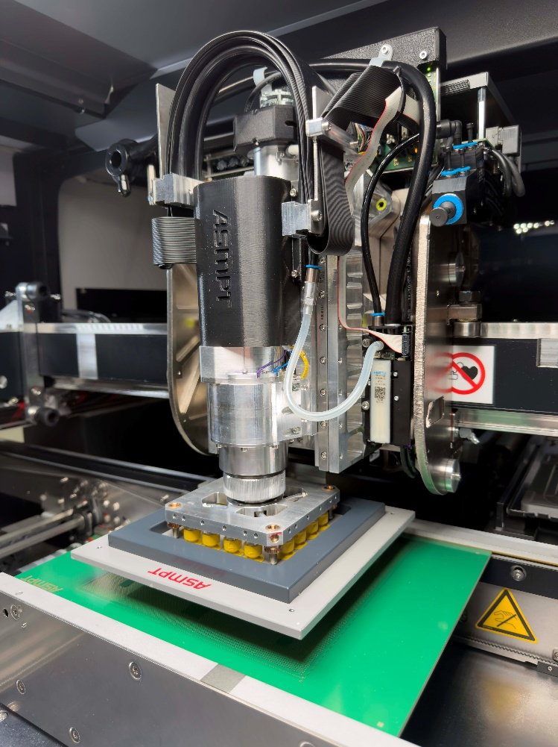

ASMPT has developed the new SOLO placement head especially for the placement of large and heavy processor BGAs.

Source: ASMPT

About ASMPT Limited (“ASMPT”)
ASMPT Limited is a leading global supplier of hardware and software solutions for the manufacture of semiconductors and electronics. Headquartered in Singapore, ASMPT’s offerings encompass the semiconductor assembly & packaging, and SMT (surface mount technology) industries, providing various solutions that organize, assemble and package delicate electronic components into a vast range of end-user devices. ASMPT partners with customers very closely, with continuous investment in R&D helping to provide cost-effective, industry-shaping solutions that achieve higher productivity, greater reliability, and enhanced quality. ASMPT is a founding member of the Semiconductor Climate Consortium.
To learn more about ASMPT, please visit www.asmpt.com.

The ASMPT SMT Solutions segment
The mission of the SMT Solutions segment within ASMPT is to implement and support the Intelligent Factory at electronics manufacturers worldwide.
ASMPT solutions support the networking, automation, and optimization of central workflows with hardware, software and services that enable electronics manufacturers to transition to the Intelligent Factory in stages and enjoy dramatic improvements in productivity, flexibility, and quality. With its integrated open automation concept, ASMPT opens the door for its customers to economically feasible automation, entirely in accordance with their individual requirements – modular, flexible, and vendor-independent.
The product range includes hardware and software such as SIPLACE placement solutions, DEK solder paste printing solutions, the SPI system Process Lens, and the WORKS Software Suite. With WORKS, ASMPT offers electronics manufacturers high-quality software for planning, controlling, analyzing and optimizing all processes on the shop floor. Maintaining close relationships with customers and technology partners is a central component of ASMPT’s strategy.
For more information about ASMPT SMT Solutions, visit smt.asmpt.com.
Media contacts:
China ASMPT Press Office
SMT Solutions
Guan Jing
Phone: +86 (755) 26934550-2109
E-mail: jing.guan@asmpt.com
Website: smt.asmpt.com

Global ASMPT Press Office
ASMPT Limited
Susanne Oswald
Rupert-Mayer-Strasse 48
81379 Munich
Germany
Phone: +49 89 20800-26439
E-Mail: susanne.oswald@asmpt.com
Website: asmpt.com

