PRESS RELEASE
hyperMILL® Suitable for AS9100/EN9100-Compliant Processes
OPEN MIND Takes Off in the Aerospace Industry
Wessling (Germany), October 20, 2026 – A growing number of manufacturers in the aerospace industry are relying on OPEN MIND’s hyperMILL® CAD/CAM suite. The software is integrated into processes designed in accordance with the European standard EN 9100 or its international counterpart, AS9100, to meet the industry’s stringent quality management requirements. As user feedback demonstrates, hyperMILL® offers numerous machining strategies that are central to typical aerospace manufacturing requirements.
Components intended to fly or be launched into orbit must be lightweight yet sturdy - that would be a simplified description of the requirements for manufacturing in the aerospace industry. Machining tasks range from engine and landing gear to structural and eVTOL parts, all the way to rocket components such as thrust frames, fasteners and fuel tanks. The geometries are sometimes complex, and the requirements for surface finish and dimensional accuracy are usually exceptionally high. With unique 5-axis technologies, powerful turning and milling strategies, and specialized solution packages for blisks and impellers, hyperMILL® provides the necessary capabilities. The NC code-based machining simulation with hyperMILL® VIRTUAL Machining also ensures that costly errors are avoided. “We knew exactly what to expect on the machine because the simulation matched reality exactly,” says Denton Lewis, CAM Manager at Western Precision Products, an aerospace contract manufacturer.
Efficient, reliable processes
The aerospace industry uses many materials that are difficult to machine: titanium, Inconel, superalloys, and fiber-reinforced composites. One of hyperMILL®’s strengths is its ability to deliver machining strategies that minimize wear on tools and machines, ensuring precise and safe processes. Optimized High-Performance Cutting (HPC) strategies simplify the handling of large chip volumes. Shreeram Aerospace & Defense machines 10.5 kg components with numerous pockets and walls that are in some cases only two millimeters thick from a raw aluminum blank weighing about 150 kg to manufacture antenna reflector panels. “Our surface quality has improved from Ra 0.8 µm to Ra 0.4 µm, even though the pocket walls are often only two millimeters thick,” reports Sandeep Satani, Chairman and Managing Director of Shreeram Aerospace & Defence LLP. At the same time, the company was able to reduce the roughing time for these reflector panels from 40 to 30 hours using hyperMILL® MAXX Machining.
In Practice and Research
“Components machined with hyperMILL® are already orbiting the Earth in satellites, and our CAM system is gaining more and more supporters in the aerospace industry. Our customers in this sector will continue to benefit greatly from our technology, because through our collaboration with research institutes, we are at the forefront of the development of new materials and manufacturing methods for the aerospace industry,” explains Dirk Lehmann, Team Leader for Sales North at OPEN MIND Technologies AG.

Key Facts at a Glance
- Aerospace: hyperMILL® is suitable for integration into AS9100/EN9100-compliant manufacturing processes.
- Complex machining tasks: 5-axis technologies, turning and milling strategies, and specialized solutions for blisks and impellers.
- Process reliability: NC code-based simulation with hyperMILL® VIRTUAL Machining for safe and reliable manufacturing.
- Measurable improvements: Shreeram Aerospace & Defence has reduced roughing time from 40 to 30 hours and improved surface roughness from Ra 0.8 to Ra 0.4 µm.

Available images
The following images are available for download in printable format at:
https://kk.htcm.de/press-releases/open-mind/
Source: OPEN MIND  Engine components are among the most demanding components in the aviation industry. | 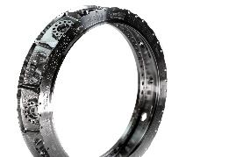  Source: OPEN MIND  hyperMILL® offers powerful milling and turning technologies for machining difficult-to-machine materials, such as engine rings.

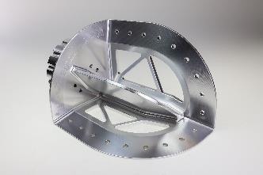
Source: OPEN MIND

This connecting plate features typical structural characteristics found in the aerospace industry. Innovative roughing and finishing strategies ensure high efficiency and precision.

Available videos
You can find the following videos on our YouTube channel:
https://youtu.be/wpnmfCXE-FY?si=NblmEvsrBCoFmC6b
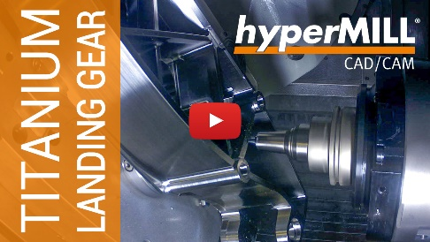
Source: OPEN MIND

This titanium landing gear component demonstrates the capabilities of hyperMILL®’s high-performance strategies, which enable efficient and precise machining with high surface quality.

About OPEN MIND Technologies AG
OPEN MIND Technologies AG is one of the world’s leading developers of powerful CAD/CAM solutions for machine and controller-independent programming.
OPEN MIND develops optimized CAD/CAM solutions that include innovative and unique features that can deliver significantly higher performance in both programming and machining.
hyperMILL® is a completely modular CAD/CAM solution that provides state-of-the-art CAM technologies on its own CAD platform: from 2.5D, 3D and 5-axis machining as well as turning strategies and solutions for additive manufacturing, HSC and HPC machining. Whether automation, simulation or virtual machine – trendsetting technologies expand the product range and enable continuous digital process chains. Special applications, seamless interaction with all popular CAD solutions and exceptional customer service rounds out the company’s products and capabilities.
According to the “NC Market Analysis Report 2026” compiled by CIMdata, hyperMILL® is a leading, worldwide CAD/CAM solution. Innovative CAD/CAM technologies fulfill the highest demands in aerospace, automotive, tool and mold manufacturing, production machining, medical, job shops, energy and semiconductor industries.
OPEN MIND's majority stake in manufacturing execution system (MES) developer Hummingbird expands the CAD/CAM manufacturer's product portfolio and enhances the range of connected digitalized manufacturing technologies.
OPEN MIND is a Mensch und Maschine company and has subsidiaries and qualified sales partners on all continents.
You can find more information at www.openmind-tech.com.

OPEN MIND Technologies UK Ltd., Oxford
Unit 3
Bicester Business Park
Telford Road
Bicester
Oxfordshire OX26 4LN
England
Phone: +44 1869 290 003
Fax: +44 1869 369 429
E-mail: Info.UK@openmind-tech.com

OPEN MIND Technologies USA, Inc.
1492 Highland Avenue, Unit 3
Needham MA 02492
USA
Phone: +1 339 225 4557 office
Phone: +1 888 516 1232 x0 toll-free
Fax: +1 270 912 5822
E-mail: Info.Americas@openmind-tech.com

OPEN MIND Technologies Asia Pacific Pte Ltd
MOVA Building, 22 Jalan Kilang #03-00
Singapore 159419
Phone: +65 6742 95-56
E-mail. Info.Asia@openmind-tech.com

OPEN MIND CADCAM Technologies India Private Ltd
No.610 & 611, 6th Floor, ‘B’ Wing, No.6, Mittal Tower
M.G. Road, Bangalore
560001, Karnataka
Phone: +91 80 2676 6999
E-mail: Info.India@openmind-tech.com

Head office:
OPEN MIND Technologies AG, Argelsrieder Feld 5, 82234 Wessling, Germany
Tel.: (+49-8153) 933-500, Fax: (+49-8153) 933-501
E-mail: Info@openmind-tech.com, website: www.openmind-tech.com

Press contact:
HighTech communications GmbH
Brigitte Basilio
Brunhamstrasse 21
81249 Munich
Germany
Tel.: (+49-89) 500778-20
E-mail: b.basilio@htcm.de
Website: www.htcm.de

