PRESS RELEASE

Hohenlohe Plus visits Würth Elektronik
Networking Event Connects Regional Businesses and Local Governments
Waldenburg (Germany), October 13, 2026 – More than 40 representatives from businesses and local governments in the Hohenlohe district met at Würth Elektronik in Waldenburg on September 29. As the host, Würth Elektronik gave participants insights into its development and quality assurance processes. A tour of the laboratories and opportunities for personal exchange were the highlights of the Hohenlohe Plus networking event. The association is committed to promoting and strengthening the region as an attractive place to work and live, with a particular focus on securing a skilled workforce.
Sebastian Valet, Managing Director at Würth Elektronik eiSos, welcomed representatives of well-known companies from a range of industries in the Hohenlohe district, including JAKO, Rommelag, STRABAG, Bürkert, ebm-papst, and Optima. Bernd Herzog, Mayor of Waldenburg, also took the opportunity to learn more about Würth Elektronik, a global manufacturer of electronic and electromechanical components.
In his presentation, Valet focused in particular on Würth Elektronik’s close ties to the Würth Group, a global family-owned business that stands for stability, reliable values, and long-term financial security. He highlighted sustained international explansion and a strong focus on customers and service as key building blocks for global success.
“As an internationally active company with strong family roots, we know how important it is to combine global competitiveness with a genuine sense of regional connection. Our strong customer and service orientation is the foundation of our success,” Valet emphasized. “At the same time, direct dialogue with local stakeholders is invaluable: Only by working hand in hand with the business community and local governments can we overcome pressing challenges—such as securing a skilled workforce—and continue to develop Hohenlohe as a strong, innovative region in the long term.”
Following the presentation, the guests toured the high-tech laboratories and learned about the development and testing processes conducted there.
The tour was followed by in-depth discussions and an opportunity to look ahead to future initiatives. Hohenlohe Plus network meetings take place twice a year, with the next major event scheduled for 2027. Between meetings, collaboration continues through workshops and focus groups addressing the specific topics of “visibility,” “staff,” “social media,” and “networking.”

Available images
The following images can be downloaded from the Internet in printable quality: https://kk.htcm.de/press-releases/wuerth/
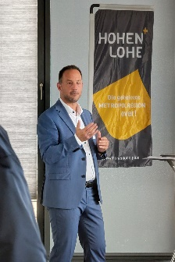  Image source: Würth Elektronik  A look behind the scenes at Würth Elektronik eiSos: Managing Director Sebastian Valet gave a presentation on the company. | 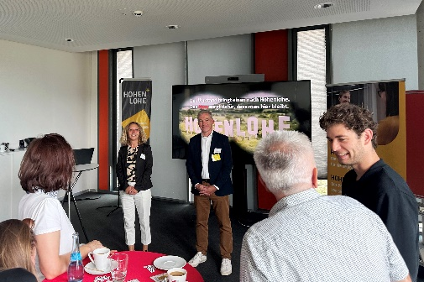  Image source: Würth Elektronik  Anika Sander, Human Resources Marketing and Employer Branding at Würth Elektronik eiSos, and Dr. Ralf Eisenbeiß, Managing Director of Hohenlohe Plus.

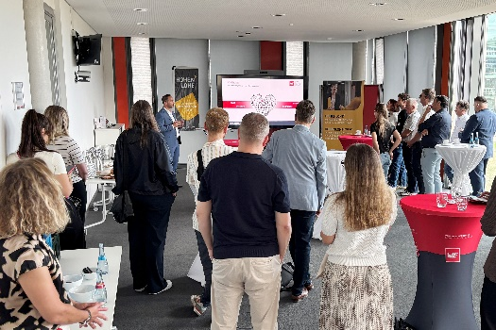
Image source: Würth Elektronik
The participants took the opportunity to strengthen existing relationships and forge new connections within the region.

About the Würth Elektronik eiSos Group
Würth Elektronik eiSos Group is a manufacturer of electronic and electromechanical components for the electronics industry and a technology company that spearheads pioneering electronic solutions. Würth Elektronik eiSos is one of the largest European manufacturers of passive components and is active in 50 countries. Production sites in Europe, Asia and North America supply a growing number of customers worldwide.
The product range includes passive components, power modules, digital isolators, optoelectronics, electromechanical components, thermal management solutions, sensors and wireless modules. The portfolio is rounded off by customer-specific solutions.
The unrivaled service orientation of the company is characterized by the availability of all catalog components from stock without minimum order quantity, free samples and extensive support through technical sales staff and selection tools.
Würth Elektronik is part of the Würth Group, the global market leader in the development, production, and sale of fastening and assembly materials, and employs around 7,300 people. In 2025, the Würth Elektronik Group generated sales of 1.06 Billion Euro.
Würth Elektronik: more than you expect!
Further information at www.we-online.com

Further information:  Würth Elektronik eiSos GmbH & Co. KG  Sarah Hurst  Clarita-Bernhard-Strasse 9  81249 Munich  Germany  Phone: +49 7942 945-5186  E-mail: sarah.hurst@we-online.de  www.we-online.com | Press contact:  HighTech communications GmbH  Brigitte Basilio  Brunhamstrasse 21  81249 Munich  Germany  Phone: +49 89 500778-20  E-mail: b.basilio@htcm.de  www.htcm.de

