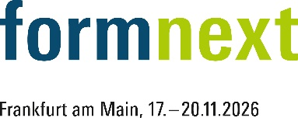
PRESS RELEASE
OPEN MIND at Formnext Expo 2026
Seamless Additive and Subtractive Processes with hyperMILL®
Hall 12.0, Booth A18
Wessling (Germany), October 6, 2026 – From November 17–20, 2026, at Booth A18 in Hall 12.0 at Formnext, OPEN MIND will demonstrate how the hyperMILL® CAD/CAM system supports additive manufacturing and subtractive post-processing of parts. Intelligent, end-to-end processes are not limited to hybrid machines. The BEST FIT function eliminates sources of error when switching between machines.
Whether using Direct Energy Deposition (DED) or Wire Arc Additive Manufacturing (WAAM), fully exploiting the potential of additive manufacturing often requires programming highly complex 5-axis simultaneous machining operations. DED additive manufacturing toolpath planning differs from the subtractive one in the sense that the first focuses on keeping a constant velocity to achieve a uniform material deposition, while the second on respecting precise position and orientation. With hyperMILL® ADDITIVE Manufacturing, NC codes for metal deposition can be programmed with ease. Thanks to hyperMILL® VIRTUAL Machining, the simulation of machine movements for collision avoidance is based on the NC code and the machine’s digital twin. Unlike many other solutions, the ADDITIVE Manufacturing module is fully integrated into hyperMILL® and serves as a comprehensive software solution for efficient hybrid machining that combines additive and subtractive processes on a single machine.
Close to the final dimensions
While hybrid machines offer advantages in maintenance, prototyping, and small-batch production, a process chain involving multiple machines can be more cost-effective for larger production runs. Until now, one of the major challenges in post-processing 3D printed parts has been aligning the blank in the machine tool. Since high-precision machining is performed on 3D-printed parts that are already close to their final dimensions, OPEN MIND offers BEST FIT, an automated solution for precise workpiece alignment. BEST FIT replaces the costly and error-prone manual workpiece alignment process by adapting the NC code and machine simulation to the actual position and orientation of the part.
“From conformal cooling channels in mold manufacturing to innovative material combinations and customized medical implants, all the way up to lightweight structural components for the aerospace industry: Formnext exhibitors and visitors are well aware of the potential of the additive and hybrid technology. And in fact, many well-known companies in these industries are already using hyperMILL®’s additive manufacturing capabilities,” says David Bourdages, Product Manager for Additive Manufacturing at OPEN MIND Technologies AG. “As additive manufacturing becomes increasingly established, it is equally important to create a robust, integrated virtual environment that supports all phases of production. This is where software plays a key role, and hyperMILL® is perfectly suited to meet these requirements. We offer seamless process chains covering the entire production process, from CAD to CAM programming for additive and subtractive manufacturing to NC-code-based simulation using a digital twin, the integration of CAD/CAM software and machines with hyperMILL® CONNECTED Machining, and finally production planning and control with Hummingbird-MES.”

Available Images
The following images are available for download in print-ready format on the Internet:
https://kk.htcm.de/press-releases/open-mind/
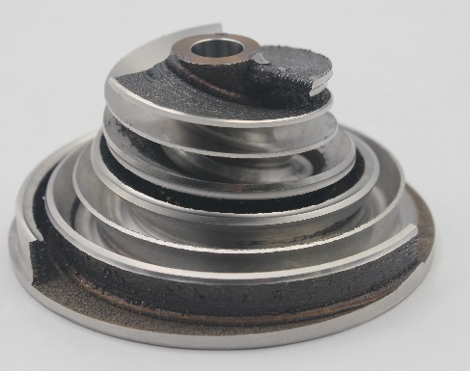
Source: OPEN MIND

Pump impeller produced using additive manufacturing followed by subtractive machining.

About OPEN MIND Technologies AG
OPEN MIND Technologies AG is one of the world’s leading developers of powerful CAD/CAM solutions for machine and controller-independent programming.
OPEN MIND develops optimized CAD/CAM solutions that include innovative and unique features that can deliver significantly higher performance in both programming and machining.
hyperMILL® is a completely modular CAD/CAM solution that provides state-of-the-art CAM technologies on its own CAD platform: from 2.5D, 3D and 5-axis machining as well as turning strategies and solutions for additive manufacturing, HSC and HPC machining. Whether automation, simulation or virtual machine – trendsetting technologies expand the product range and enable continuous digital process chains. Special applications, seamless interaction with all popular CAD solutions and exceptional customer service rounds out the company’s products and capabilities.
According to the “NC Market Analysis Report 2026” compiled by CIMdata, hyperMILL® is a leading, worldwide CAD/CAM solution. Innovative CAD/CAM technologies fulfill the highest demands in aerospace, automotive, tool and mold manufacturing, production machining, medical, job shops, energy and semiconductor industries.
OPEN MIND's majority stake in manufacturing execution system (MES) developer Hummingbird expands the CAD/CAM manufacturer's product portfolio and enhances the range of connected digitalized manufacturing technologies.
OPEN MIND is a Mensch und Maschine company and has subsidiaries and qualified sales partners on all continents.
You can find more information at www.openmind-tech.com.

OPEN MIND Technologies UK Ltd., Oxford
Unit 3
Bicester Business Park
Telford Road
Bicester
Oxfordshire OX26 4LN
England
Phone: +44 1869 290 003
Fax: +44 1869 369 429
E-mail: Info.UK@openmind-tech.com

OPEN MIND Technologies USA, Inc.
1492 Highland Avenue, Unit 3
Needham MA 02492
USA
Phone: +1 339 225 4557 office
Phone: +1 888 516 1232 x0 toll-free
Fax: +1 270 912 5822
E-mail: Info.Americas@openmind-tech.com

OPEN MIND Technologies Asia Pacific Pte Ltd
MOVA Building, 22 Jalan Kilang #03-00
Singapore 159419
Phone: +65 6742 95-56
E-mail. Info.Asia@openmind-tech.com

OPEN MIND CADCAM Technologies India Private Ltd
No.610 & 611, 6th Floor, ‘B’ Wing, No.6, Mittal Tower
M.G. Road, Bangalore
560001, Karnataka
Phone: +91 80 2676 6999
E-mail: Info.India@openmind-tech.com

Head office:
OPEN MIND Technologies AG, Argelsrieder Feld 5, 82234 Wessling, Germany
Tel.: (+49-8153) 933-500, Fax: (+49-8153) 933-501
E-mail: Info@openmind-tech.com, website: www.openmind-tech.com

Press contact:
HighTech communications GmbH
Brigitte Basilio
Brunhamstrasse 21
81249 Munich
Germany
Tel.: (+49-89) 500778-20
E-mail: b.basilio@htcm.de
Website: www.htcm.de

