PRESS RELEASE
OPEN MIND at AMB 2026
Simulation in the hyperMILL® Virtual Machine
Wessling (Germany), October 1, 2026 – OPEN MIND witnessed an exceptionally positive appearance at AMB in Stuttgart. The booth was consistently well attended, and the hyperMILL® VIRTUAL Machining package, with its NC code-based simulation capability, attracted significant interest. Visitors were also keen to learn about the turning solutions and the wide range of automation functions offered by the CAD/CAM suite. The Hummingbird MES also drew a strong response, with numerous visitors requesting demonstrations and additional information.
“hyperMILL® VIRTUAL Machining shows exactly what will happen on the machine. This becomes especially clear when we demonstrate it—and even more impressive when you understand that the simulation is based on the machine data and the actual NC code,” explains Ales Vurusic, Central Region Sales Team Leader at OPEN MIND Technologies AG. “Customers then realize that using digital twins of the entire machining process provides an unprecedented level of safety for both the workpiece and the machine.”
Automated programming
Existing hyperMILL® users took the opportunity to learn about the automation options for CAM programming. Automating routine tasks is especially attractive for companies where work preparation becomes a bottleneck.
Although most visitors were primarily interested in generating NC code for milling, the workstation featuring hyperMILL® TURNING Solutions also attracted many visitors. The same was true of the Hummingbird Manufacturing Execution System presentation. One MES function particularly appealed to hyperMILL® users: centralized tool management.

Available image material
The following high-resolution image material is available for download online:
https://kk.htcm.de/press-releases/open-mind/
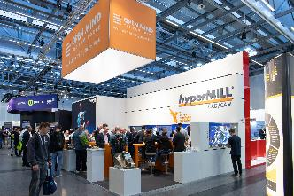  Source: OPEN MIND  The OPEN MIND booth at AMB was consistently well attended. | 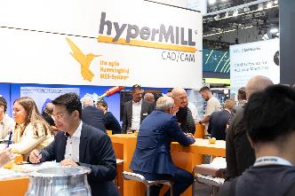  Source: OPEN MIND  The hyperMILL® feature packages and the Hummingbird MES provided plenty of topics for discussion.
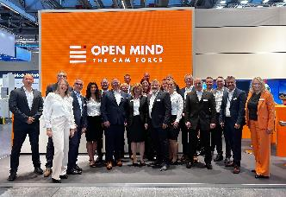  Source: OPEN MIND  The OPEN MIND trade fair team had every reason to celebrate. | 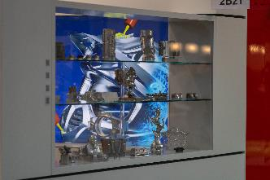  Source: OPEN MIND  Machining is fun—an impression conveyed by the “trophy cabinet” featuring exhibits from previous years.
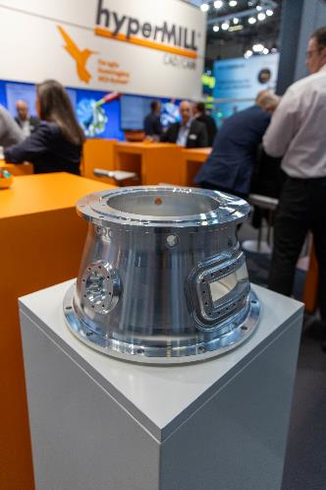
Source: OPEN MIND

This year’s exhibit: an engine case as an example from the aerospace industry, where OPEN MIND has recently won several important customers.

About OPEN MIND Technologies AG
OPEN MIND Technologies AG is one of the world’s leading developers of powerful CAD/CAM solutions for machine and controller-independent programming.
OPEN MIND develops optimized CAD/CAM solutions that include innovative and unique features that can deliver significantly higher performance in both programming and machining.
hyperMILL® is a completely modular CAD/CAM solution that provides state-of-the-art CAM technologies on its own CAD platform: from 2.5D, 3D and 5-axis machining as well as turning strategies and solutions for additive manufacturing, HSC and HPC machining. Whether automation, simulation or virtual machine – trendsetting technologies expand the product range and enable continuous digital process chains. Special applications, seamless interaction with all popular CAD solutions and exceptional customer service rounds out the company’s products and capabilities.

According to the “NC Market Analysis Report 2026” compiled by CIMdata, hyperMILL® is a leading, worldwide CAD/CAM solution. Innovative CAD/CAM technologies fulfill the highest demands in aerospace, automotive, tool and mold manufacturing, production machining, medical, job shops, energy and semiconductor industries.
OPEN MIND's majority stake in manufacturing execution system (MES) developer Hummingbird expands the CAD/CAM manufacturer's product portfolio and enhances the range of connected digitalized manufacturing technologies.
OPEN MIND is a Mensch und Maschine company and has subsidiaries and qualified sales partners on all continents.
You can find more information at www.openmind-tech.com.

OPEN MIND Technologies UK Ltd., Oxford
Unit 3
Bicester Business Park
Telford Road
Bicester
Oxfordshire OX26 4LN
England
Phone: +44 1869 290 003
Fax: +44 1869 369 429
E-mail: Info.UK@openmind-tech.com

OPEN MIND Technologies USA, Inc.
1492 Highland Avenue, Unit 3
Needham MA 02492
USA
Phone: +1 339 225 4557 office
Phone: +1 888 516 1232 x0 toll-free
Fax: +1 270 912 5822
E-mail: Info.Americas@openmind-tech.com

OPEN MIND Technologies Asia Pacific Pte Ltd
MOVA Building, 22 Jalan Kilang #03-00
Singapore 159419
Phone: +65 6742 95-56
E-mail. Info.Asia@openmind-tech.com

OPEN MIND CADCAM Technologies India Private Ltd
No.610 & 611, 6th Floor, ‘B’ Wing, No.6, Mittal Tower
M.G. Road, Bangalore
560001, Karnataka
Phone: +91 80 2676 6999
E-mail: Info.India@openmind-tech.com

Head office:
OPEN MIND Technologies AG, Argelsrieder Feld 5, 82234 Wessling, Germany
Tel.: (+49-8153) 933-500, Fax: (+49-8153) 933-501
E-mail: Info@openmind-tech.com, website: www.openmind-tech.com

Press contact:
HighTech communications GmbH
Brigitte Basilio
Brunhamstrasse 21
81249 Munich
Germany
Tel.: (+49-89) 500778-20
E-mail: b.basilio@htcm.de
Website: www.htcm.de

