FOR THE MEDIA
ASMPT expands Virtual Assist with AI-powered spare parts identification
Ask a question or take a photo: Virtual Assist supports service and maintenance
Atlanta (USA), September 29, 2026 – ASMPT SMT Solutions, the global market and technology leader in hardware and software solutions for electronics manufacturing, is adding new service and maintenance capabilities to its Virtual Assist digital assistant. In addition to an enhanced AI chat, users can now identify spare parts from a photo. A picture of the removed component is all Virtual Assist needs to suggest matching spare parts. This simplifies service and maintenance tasks and saves time when searching for the right part.

Virtual Assist supports users of SIPLACE placement machines and DEK printers worldwide with onboarding, service and maintenance. The application is available as an app for Android and iOS as well as through a web browser.

Users could already search for specific information using natural language. The new version turns this into an interactive dialog: Users can ask follow-up questions, narrow down results or refine their query step by step. For example, a search can subsequently be limited to a specific machine. Virtual Assist processes questions and answers in the user's language and, where appropriate, directs users to the relevant sections of ASMPT documentation.

Identify spare parts with a smartphone
A photo of the removed part is all that is needed to identify a hardware component. Virtual Assist compares the image with stored spare parts data and displays the three most likely matches, along with a confidence score for each. The user makes the final selection. This makes it possible to quickly and reliably distinguish between different variants of a spare part. An integrated workflow then allows the selected part to be forwarded by email to the appropriate contact for ordering.
Currently, image recognition is designed for parts that have been removed from the machine. An extension that will also enable components to be identified directly inside the machine is already being tested.
Reliable answers based on existing documentation
Unlike many AI applications that draw on publicly available sources, Virtual Assist uses ASMPT's own documentation to answer ASMPT-specific questions. Customers with the appropriate subscription can also integrate their own documentation, for example for other machines and equipment in their production environment. This content can then be searched and accessed using the same AI capabilities. All documents remain within the respective customer's environment at all times and are not shared with other customers.
“Every minute can matter in service,” says Jim Leather, Director of IoT Solutions at ASMPT SMT Solutions. “With Virtual Assist, users get the information they need right where they need it, within seconds and without spending time searching through multiple documents. The previous solution already reduced the time spent searching for information by up to 95 percent. With the new AI chat and image-based spare parts identification, accessing this knowledge becomes even faster and easier.”
Many service and maintenance questions can therefore be answered directly based on the available documentation. Personal support from ASMPT remains available to customers whenever they need it.

Illustrations for downloading
The following images are available for download in printable format at:
https://kk.htcm.de/press-releases/asmpt/

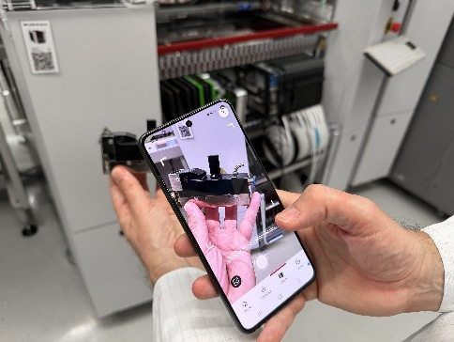 | 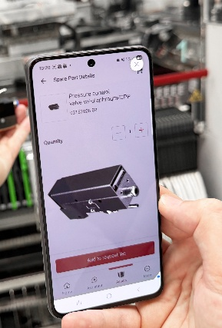
One photo is all it takes: With Virtual Assist’s new AI-powered image recognition, removed components can be identified directly using a smartphone.  Source: ASMPT | Virtual Assist compares images of components with stored spare parts data, helping users quickly identify the right spare part.  Source: ASMPT

About ASMPT Limited (“ASMPT”)
ASMPT Limited is a leading global supplier of hardware and software solutions for the manufacture of semiconductors and electronics. Headquartered in Singapore, ASMPT’s offerings encompass the semiconductor assembly & packaging, and SMT (surface mount technology) industries, providing various solutions that organize, assemble and package delicate electronic components into a vast range of end-user devices. ASMPT partners with customers very closely, with continuous investment in R&D helping to provide cost-effective, industry-shaping solutions that achieve higher productivity, greater reliability, and enhanced quality. ASMPT is a founding member of the Semiconductor Climate Consortium.
To learn more about ASMPT, please visit us at asmpt.com.

The ASMPT SMT Solutions segment
The mission of the SMT Solutions segment within ASMPT is to implement and support the Intelligent Factory at electronics manufacturers worldwide.
ASMPT solutions support the networking, automation, and optimization of central workflows with hardware, software and services that enable electronics manufacturers to transition to the Intelligent Factory in stages and enjoy dramatic improvements in productivity, flexibility, and quality. With its integrated open automation concept, ASMPT opens the door for its customers to economically feasible automation, entirely in accordance with their individual requirements – modular, flexible, and vendor-independent.
The product range includes hardware and software such as SIPLACE placement solutions, DEK solder paste printing solutions, the SPI system Process Lens, and the WORKS Software Suite. With WORKS, ASMPT offers electronics manufacturers high-quality software for planning, controlling, analyzing and optimizing all processes on the shop floor. Maintaining close relationships with customers and technology partners is a central component of ASMPT’s strategy.
For more information about ASMPT SMT Solutions visit smt.asmpt.com.
Media contacts:
AMCAS ASMPT Press Office
SMT Solutions
Mark Ogden
Phone: +1 (770) 797 3189
E-mail: ogden.mark@asmpt.com
Website: smt.asmpt.com

Global ASMPT Press Office
ASMPT Limited
Susanne Oswald
Rupert-Mayer-Strasse 48
81379 Munich
Germany
Tel: +49 89 20800-26439
E-mail: susanne.oswald@asmpt.com
Website: asmpt.com

