FOR THE MEDIA
ASMPT looks back on a successful Productronica India 2026
Strong India debut for SIPLACE V
Singapore, September 24, 2026 – ASMPT SMT Solutions, the global market and technology leader in integrated hardware and software solutions for electronics manufacturing, received a strong response from visitors at Productronica India 2026 in Bengaluru. The ASMPT booth saw a steady stream of visitors throughout the three-day event. Particular attention focused on the India debut of the new SIPLACE V placement platform and the live demonstration of large BGA placement for AI server applications on the SIPLACE SX.
“The response over all three days was overwhelming. Our booth was continuously busy, and we had many valuable discussions with electronics manufacturers from different industries,” says Neeraj Bhardwaj, General Manager for India, Bangladesh & Sri Lanka at ASMPT SMT Solutions India. “The solutions we presented covered a broad range of requirements in the Indian electronics market – from telecommunications and automotive to EMS. The machines on display gave visitors the opportunity to experience the technologies first-hand and discuss their specific production requirements with our experts.”
Strong interest in the new SIPLACE V
Visitors were particularly interested in the performance improvements offered by the new SIPLACE V platform and how it compares with existing placement solutions. Designed from the ground up, the SIPLACE V combines significantly higher real performance with flexibility and high process quality. Its new machine architecture, featuring a highly rigid frame, efficient linear drives and high-resolution measurement systems, enables higher acceleration and shorter non-productive movements. Under real production conditions, the platform achieves performance gains of up to 30 percent in key electronics manufacturing sectors. Its high-speed placement head processes up to 52,500 components per hour with a placement accuracy of 25 µm @ 3σ. The platform also covers a broad spectrum of components, from ultra-small 016008M components to large-format and challenging ones.
Large BGA placement attracts attention
Another focus at the booth was the production of AI server boards and, in particular, the handling and placement of increasingly large and heavy processor BGAs, demonstrated live on the SIPLACE SX placement platform. Such modules can measure up to 150 × 150 millimeters and weigh more than 500 grams.
For these demanding applications, the SIPLACE SX can be equipped with the placement head TWIN VHF for large and heavy processor BGAs. Component-specific nozzles and consideration of the individual BGA’s mass inertia during program generation help ensure reliable handling and placement even of heavy components. Its Heavy-Duty Conveyor handles boards weighing up to ten kilograms, while SIPLACE Smart Pin Support automatically positions and continuously monitors support pins to prevent warpage of large boards. The DEK TQ printer complemented the presentation with high-precision solder paste printing.
Solutions for a diverse electronics market
The hardware demonstrations were complemented by the WORKS software suite for all workflows along the SMT line, as well as by ASMPT Factory Solutions for the holistic optimization of the SMT production. Visitors were able to see for themselves how production data can be used to increase transparency and identify opportunities for optimization throughout the intelligent factory.

Illustrations for downloading
The following images are available for download in printable format at:
https://kk.htcm.de/press-releases/asmpt/

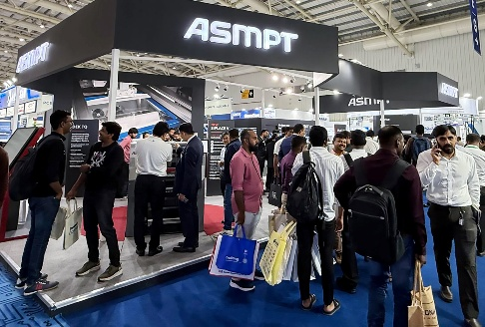 | 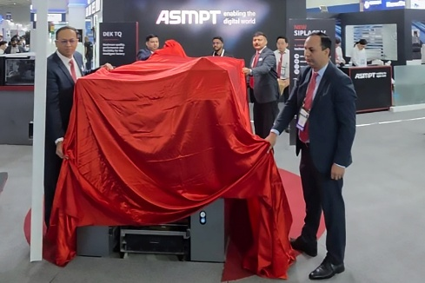
The ASMPT booth attracted a steady stream of visitors throughout all three days of Productronica India 2026, including representatives from major electronics manufacturers and EMS companies across a broad range of industries.  Source: ASMPT | Official unveiling: The ASMPT team presents the SIPLACE V to customers, partners and industry representatives in South Asia on the opening day of Productronica India 2026.  Source: ASMPT
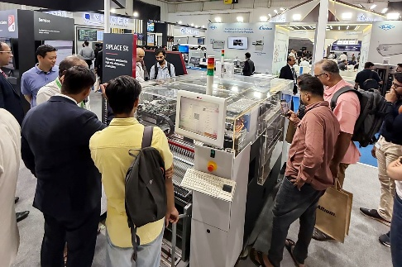 | 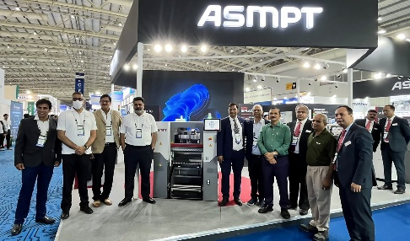
Through the transparent machine cover, visitors had a clear view of the live demonstration of the SIPLACE SX placing large processor BGAs for AI server applications.  Source: ASMPT | The ASMPT team together with its business partners Maxim SMT Technology and ALN Tronics, who supported customer engagement, demonstrations and in-depth discussions throughout the three-day event.  Source: ASMPT

About ASMPT Limited (“ASMPT”)
ASMPT Limited is a leading global supplier of hardware and software solutions for the manufacture of semiconductors and electronics. Headquartered in Singapore, ASMPT’s offerings encompass the semiconductor assembly & packaging, and SMT (surface mount technology) industries, providing various solutions that organize, assemble and package delicate electronic components into a vast range of end-user devices. ASMPT partners with customers very closely, with continuous investment in R&D helping to provide cost-effective, industry-shaping solutions that achieve higher productivity, greater reliability, and enhanced quality. ASMPT is a founding member of the Semiconductor Climate Consortium.
To learn more about ASMPT, please visit us at asmpt.com.

The ASMPT SMT Solutions segment
The mission of the SMT Solutions segment within ASMPT is to implement and support the Intelligent Factory at electronics manufacturers worldwide.
ASMPT solutions support the networking, automation, and optimization of central workflows with hardware, software and services that enable electronics manufacturers to transition to the Intelligent Factory in stages and enjoy dramatic improvements in productivity, flexibility, and quality. With its integrated open automation concept, ASMPT opens the door for its customers to economically feasible automation, entirely in accordance with their individual requirements – modular, flexible, and vendor-independent.
The product range includes hardware and software such as SIPLACE placement solutions, DEK solder paste printing solutions, the SPI system Process Lens, and the WORKS Software Suite. With WORKS, ASMPT offers electronics manufacturers high-quality software for planning, controlling, analyzing and optimizing all processes on the shop floor. Maintaining close relationships with customers and technology partners is a central component of ASMPT’s strategy.
For more information about ASMPT SMT Solutions visit smt.asmpt.com.
Media contacts:
ASMPT ROA Press Office
SMT Solutions
ASMPT SMT Singapore Pte. Ltd.
Janet Loh
Phone: +65 6877 3948
E-mail: Janet.loh@asmpt.com
Website: smt.asmpt.com

Global ASMPT Press Office
ASMPT Limited
Susanne Oswald
Rupert-Mayer-Strasse 48
81379 Munich
Germany
Phone: +49 89 20800-26439
E-Mail: susanne.oswald@asmpt.com
Website: asmpt.com

