FOR THE MEDIA
ASMPT at NEPCON Asia 2026
SIPLACE V makes its China debut
Singapore, September 22, 2026 – ASMPT SMT Solutions, the global market and technology leader in integrated hardware and software solutions for electronics manufacturing, will present its latest solutions for the intelligent factory at NEPCON Asia in Shenzhen from October 27 to 29, 2026. The highlight at Booth 13D90 in Hall 13 will be the China launch of the new SIPLACE V placement platform. Further highlights include the DEK TQ XL printer and placement solutions for AI and high-performance computing applications, the multifunctional SIPLACE CA2 platform for advanced packaging, and integrated software and automation solutions.
Up to 30% more real performance
Developed from the ground up, the SIPLACE V placement platform combines significantly higher real performance with flexibility, process excellence and long-term investment protection. A new machine architecture with a highly rigid frame, efficient linear drives and high-resolution measurement systems enables higher acceleration and shorter non-productive movements. Under real production conditions, the platform achieves performance gains of up to 30 percent in key electronics manufacturing sectors. At NEPCON Asia, ASMPT will demonstrate the SIPLACE V at a benchmark placement rate of more than 52,500 components per hour. Single- and dual-lane configurations, Smart Pin Support and compatibility with existing SIPLACE X feeders give manufacturers considerable flexibility in configuring the platform. High-resolution vision systems, individual component inspection and closed-loop sensor technology help ensure consistently high process quality even at high placement speeds.
Ready for AI server boards
AI servers and high-performance computing are placing new demands on SMT production, with increasingly large boards and heavy processor BGAs. On the SIPLACE SX placement platform, ASMPT will demonstrate solutions for the automated handling of large, heavy and odd-shaped components, including BGAs measuring up to 150 × 150 mm and weighing more than 500 g. The DEK TQ XL complements these placement solutions on the printing side. Designed for large-format applications such as AI servers, high-performance computing and communications equipment, it processes boards measuring up to 850 × 610 × 8 mm. Despite these dimensions, the printer achieves a core cycle time of only 12 seconds and wet-print accuracy of ±20 μm @ 2.0 cpk. Numerous automation options provide additional efficiency, such as the new automated setup changeover, which reduces the time required for manual changeovers on the printer from about four minutes to just 30 seconds.
SMT meets advanced packaging
With the SIPLACE CA2, ASMPT will also showcase how SMT and advanced packaging processes can be combined on a single platform. The multifunctional machine processes components from conventional feeders as well as dies directly from sawn wafers, eliminating intermediate die-taping processes. With placement accuracy of up to 10 μm @ 3 σ, it supports applications such as system-in-package, embedded packaging and high-accuracy SMT manufacturing.
More automation, intelligent data use
“We boost your intelligent factory” is ASMPT’s key message at NEPCON Asia – and the presentation extends well beyond hardware. ASMPT will also demonstrate how software and automation can increase productivity across the SMT shop floor. The WORKS Software Suite and Factory Solutions support production planning, material flow, programming, production monitoring, traceability and maintenance. Highlights include automated program changes based on IPC-HERMES-9852, closed-loop maintenance solutions for placement heads, feeders and nozzles, and integrated traceability of products, processes and operator activities.
ASMPT will also present the latest version of Virtual Assist, its AI-based expert system for onboarding, service and maintenance, featuring an enhanced AI chat for continuous dialogue and image-based spare-parts recognition via smartphone photos.
“NEPCON Asia is an ideal opportunity to show how new hardware, software and automation work together to boost electronics manufacturing,” says Jay Zhu, Senior Manager Product Marketing, Greater China at ASMPT SMT Solutions. “From the new SIPLACE V and solutions for AI and high-performance computing to advanced packaging and intelligent software, we are helping manufacturers increase productivity while maintaining the flexibility they need for future applications.”

Illustrations for downloading
The following images are available for download in printable format at:
https://kk.htcm.de/press-releases/asmpt/

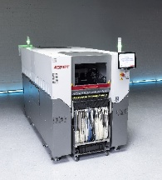 | 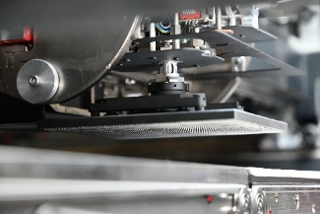
The new SIPLACE V platform handles the entire range of components – from ultra-small 016008M chips to large-format components – and really shines when dealing with challenging or odd-shaped components.  Source: ASMPT | The TWIN VHF (Very High Force) placement head is designed to handle large AI processor BGAs.  Source: ASMPT
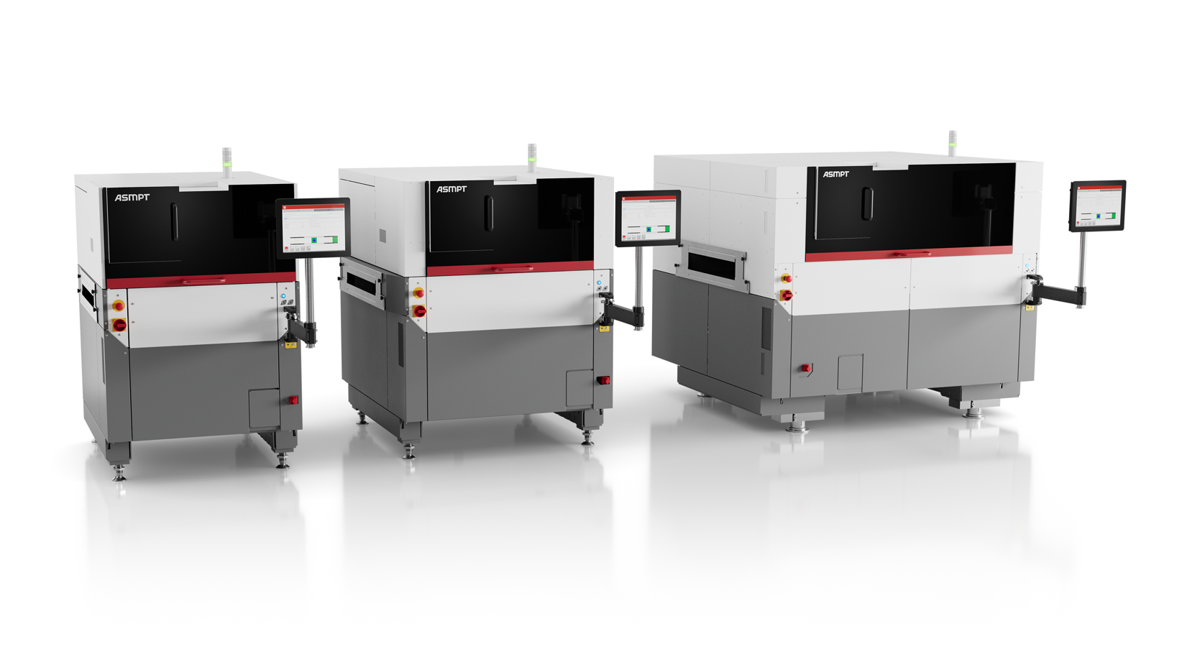 | 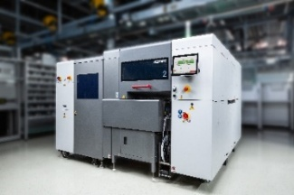
With its three DEK TQ, DEK TQ L and DEK TQ XL models, the DEK TQ platform covers the complete product spectrum in electronics manufacturing.  Source: ASMPT | The SIPLACE CA2 eliminates costly die-taping steps and adds greater flexibility to advanced packaging production.  Source: ASMPT
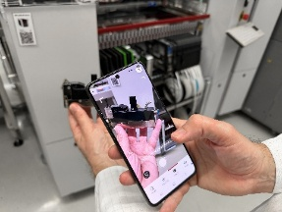
Virtual Assist puts expert knowledge at operators’ fingertips, helping them solve problems faster and reduce service and maintenance effort.
Source: ASMPT

About ASMPT Limited (“ASMPT”)
ASMPT Limited is a leading global supplier of hardware and software solutions for the manufacture of semiconductors and electronics. Headquartered in Singapore, ASMPT’s offerings encompass the semiconductor assembly & packaging, and SMT (surface mount technology) industries, providing various solutions that organize, assemble and package delicate electronic components into a vast range of end-user devices. ASMPT partners with customers very closely, with continuous investment in R&D helping to provide cost-effective, industry-shaping solutions that achieve higher productivity, greater reliability, and enhanced quality. ASMPT is a founding member of the Semiconductor Climate Consortium.
To learn more about ASMPT, please visit us at asmpt.com.

The ASMPT SMT Solutions segment
The mission of the SMT Solutions segment within ASMPT is to implement and support the Intelligent Factory at electronics manufacturers worldwide.
ASMPT solutions support the networking, automation, and optimization of central workflows with hardware, software and services that enable electronics manufacturers to transition to the Intelligent Factory in stages and enjoy dramatic improvements in productivity, flexibility, and quality. With its integrated open automation concept, ASMPT opens the door for its customers to economically feasible automation, entirely in accordance with their individual requirements – modular, flexible, and vendor-independent.
The product range includes hardware and software such as SIPLACE placement solutions, DEK solder paste printing solutions, the SPI system Process Lens, and the WORKS Software Suite. With WORKS, ASMPT offers electronics manufacturers high-quality software for planning, controlling, analyzing and optimizing all processes on the shop floor. Maintaining close relationships with customers and technology partners is a central component of ASMPT’s strategy.
For more information about ASMPT SMT Solutions visit smt.asmpt.com.
Media contacts:
ASMPT ROA Press Office
SMT Solutions
ASMPT SMT Singapore Pte. Ltd.
Janet Loh
Phone: +65 6877 3948
E-mail: Janet.loh@asmpt.com
Website: smt.asmpt.com

Global ASMPT Press Office
ASMPT Limited
Susanne Oswald
Rupert-Mayer-Strasse 48
81379 Munich
Germany
Phone: +49 89 20800-26439
E-Mail: susanne.oswald@asmpt.com
Website: asmpt.com

