FOR THE MEDIA
ASMPT at SEMICON West 2026
Accelerating AI through Advanced Packaging
Billerica (USA), September 16, 2026 – ASMPT, a market and technology leader in equipment for semiconductor and electronics manufacturing, will showcase its advanced packaging portfolio at SEMICON West 2026, taking place October 13–15 at the Moscone Center in San Francisco. At Booth 1153, ASMPT will present technologies supporting next-generation AI and high-performance computing (HPC), with a focus on 2.5D and 3D packaging, chiplet and heterogeneous integration, as well as photonics and Co-Packaged Optics (CPO). One of the highlights will be the new ALSI LASER1206 for high-precision laser dicing and grooving.
AI, HPC and data center applications are driving increasingly complex semiconductor architectures, making advanced packaging a key enabler of future systems. ASMPT supports 2.5D and 3D packaging, chiplet and heterogeneous integration with technologies including Thermocompression Bonding (TCB) and Hybrid Bonding. Under the theme “Empower the Intelligence Revolution”, ASMPT will highlight its advanced packaging portfolio together with technologies for photonics and Co-Packaged Optics (CPO) at SEMICON West.
“Advanced packaging has become a key enabler for the next generation of AI,” says Jean-Marc Peallat, Regional Head ASMPT Semiconductor Solutions Americas. “The challenge is to turn increasingly complex semiconductor architectures into reliable, scalable manufacturing processes. This is where our broad advanced packaging portfolio and close collaboration with customers make a difference.”
High-precision wafer processing
One of the technologies highlighted at the ASMPT booth will be the ALSI LASER1206, the latest platform for laser dicing and grooving. Developed for the increasingly complex requirements of IDMs and foundries, the system processes a wide range of semiconductor materials used in advanced memory, logic, AI and power applications. Its patented multi-beam UV laser technology combines high-precision processing with minimal heat impact, helping to reduce burr formation and die-strength degradation.
The ALSI LASER1206 offers fully automated handling of film frames and bare wafers and integrates wafer coating and cleaning. Its planar motion system achieves positioning accuracy of less than 1.5 µm. For grooving, the system processes wafers from 60 to 800 µm thick; for dicing, the range is 20 to 200 µm.
Photonics moves toward volume production
Photonics and Co-Packaged Optics are another focus at SEMICON West. Integrating optical components such as glass dies, micro-lenses and photonic integrated circuits alongside high-performance processors places high demands on assembly precision and process control.
For volume production, however, precision alone is not enough. Alignment must remain stable throughout bonding and curing, while adhesive processing, inspection and metrology need to be tightly controlled. ASMPT brings these capabilities together with high-precision placement, vision alignment, in-line metrology and automation. This helps manufacturers reduce process variation, maintain consistent optical performance and move demanding photonics and CPO applications from development toward scalable production.

Illustrations for downloading
The following images are available for download in printable format at:
https://kk.htcm.de/press-releases/asmpt/

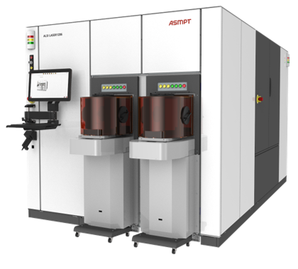 | 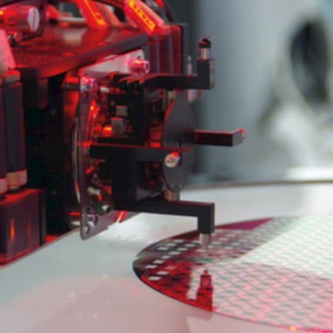
ALSI LASER1206, the fully automatic laser dicing and grooving system from ASMPT.  Image credit: ASMPT | ASMPT’s high-speed eutectic bonding technology supports precise and scalable manufacturing of demanding photonics applications.  Image credit: ASMPT

About ASMPT Limited (“ASMPT”)
ASMPT Limited is a leading global supplier of hardware and software solutions for the manufacture of semiconductors and electronics. Headquartered in Singapore, ASMPT’s offerings encompass the semiconductor assembly & packaging, and SMT (surface mount technology) industries, providing various solutions that organize, assemble and package delicate electronic components into a vast range of end-user devices. ASMPT partners with customers very closely, with continuous investment in R&D helping to provide cost-effective, industry-shaping solutions that achieve higher productivity, greater reliability, and enhanced quality. ASMPT is a founding member of the Semiconductor Climate Consortium.
To learn more about ASMPT, please visit us at asmpt.com.

About ASMPT Semiconductor Solutions (“ASMPT SEMI”)
ASMPT SEMI is the leading supplier in advanced packaging and semiconductor assembly solutions. With a commitment to innovation and customer satisfaction, ASMPT SEMI provides a comprehensive range of products and services that cater to the evolving needs of the microelectronics industry. Their expertise spans across areas such as flip-chip and wafer-level packaging, advanced interconnect technologies, and more. ASMPT SEMI's cutting-edge solutions enable customers to achieve higher performance, increased reliability, and improved cost-efficiency when producing their semiconductor devices.
ASMPT SEMI sees itself as a pioneer and driving force of the Intelligence Revolution. With its advanced packaging and assembly technologies, the business segment creates the invisible connections that enable intelligent applications in Artificial Intelligence, Smart Mobility and Hyperconnectivity.
For more information about ASMPT SEMI, visit semi.asmpt.com.
Media contacts:
Global ASMPT Press Office
ASMPT Limited
Susanne Oswald
Rupert-Mayer-Strasse 48
81379 Munich
Germany
Phone: +49 89 20800-26439
E-Mail: susanne.oswald@asmpt.com
Website: asmpt.com

HighTech communications GmbH
Barbara Ostermeier
Brunhamstrasse 21
81249 Munich
Germany
Phone: +49 89 500778-10
E-Mail: b.ostermeier@htcm.de
Website: www.htcm.de

