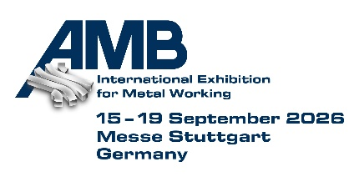
PRESS RELEASE
OPEN MIND to Showcase Hummingbird-MES at AMB 2026
End-to-End Digital Process Chain
Hall 2, Booth 2B21
Wessling (Germany), September 15, 2026 – OPEN MIND Technologies AG will be exhibiting at AMB in Stuttgart from September 15–19, 2026. At Booth 2B21 in Hall 2, the company will showcase hyperMILL® CAD/CAM suite as well as the Hummingbird Manufacturing Execution System (MES). Hummingbird-MES was developed for manufacturing environments where orders, priorities, and capacity utilization are constantly changing. Employing a modular approach, each module can also be used independently while being part of a seamless process chain.
Hummingbird-MES is designed to ensure transparency and predictability precisely where it can be easily lost due to single-part and small-batch production. A key differentiator is its strict event-driven control where every part produced updates the status in real time for all users.
Four Entry Points to Digital Manufacturing
The areas where companies see the most urgent need for process digitization vary widely. That’s why Hummingbird-MES offers four building blocks, each of which can serve as a starting point.
Planning and Control
Hummingbird connects planning and the shop floor in a single digital system; it detects deviations in real time and enables immediate adjustments via an agile planning board. This ensures transparency and allows production to be quickly adapted to changing conditions. For example, machine capacities can be utilized differently to meet delivery deadlines.
CAM/CNC Integration
Hummingbird-MES benefits from seamless integration with hyperMILL®. CAM projects, NC programs, and process and tool data are centrally managed, versioned, and transferred to the machine without any data loss. NC programs are sent from the CAM project to production at the push of a button. As a result, all necessary information is available digitally at the machine workstations. In addition to the current NC program, this includes setup information and job data. The machine operator can be confident that all current data is available and can focus entirely on production.
Tool Logistics
Since searching for tools, inefficient inventory management with excess tool stock, or premature tool changes represent an avoidable cost factor for many companies, tool management is an ideal starting point. This involves, for example, remaining tool life and tool measurement, as well as the storage and logistics of tools and holders. Feedback from machine operators can also be recorded if deviations in cutting parameters or tool life occur in practice.
Machine Data Collection
Only automated machine data collection reveals how efficiently machines actually operate. Hummingbird automatically collects available machine data and displays it in clear, easy-to-read dashboards. Machine and operational status, as well as runtime and downtime are analyzed in real time. Machine data collection generates and monitors Key Performance Indicators (KPIs), integrates a wide variety of machines, and is an essential component of a comprehensive MES, serving as the foundation for informed decisions and continuous process optimization.

Available images
The following images are available for download in printable format at:
https://kk.htcm.de/press-releases/open-mind/

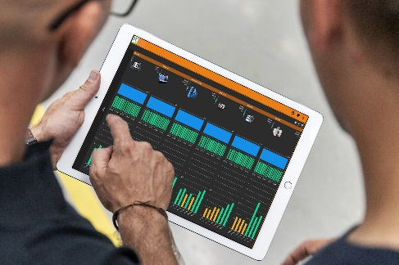  Source: OPEN MIND  Capture machine data in real time and display it clearly with Hummingbird. | 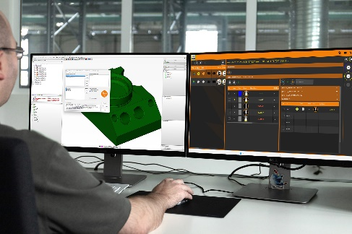  Source: OPEN MIND  Seamless data flow: NC programs are transferred from the CAM project to production at the push of a button.

About OPEN MIND Technologies AG
OPEN MIND Technologies AG is one of the world’s leading developers of powerful CAD/CAM solutions for machine and controller-independent programming.
OPEN MIND develops optimized CAD/CAM solutions that include innovative and unique features that can deliver significantly higher performance in both programming and machining.
hyperMILL® is a completely modular CAD/CAM solution that provides state-of-the-art CAM technologies on its own CAD platform: from 2.5D, 3D and 5-axis machining as well as turning strategies and solutions for additive manufacturing, HSC and HPC machining. Whether automation, simulation or virtual machine – trendsetting technologies expand the product range and enable continuous digital process chains. Special applications, seamless interaction with all popular CAD solutions and exceptional customer service rounds out the company’s products and capabilities.
According to the “NC Market Analysis Report 2026” compiled by CIMdata, hyperMILL® is a leading, worldwide CAD/CAM solution. Innovative CAD/CAM technologies fulfill the highest demands in aerospace, automotive, tool and mold manufacturing, production machining, medical, job shops, energy and semiconductor industries.
OPEN MIND's majority stake in manufacturing execution system (MES) developer Hummingbird expands the CAD/CAM manufacturer's product portfolio and enhances the range of connected digitalized manufacturing technologies.
OPEN MIND is a Mensch und Maschine company and has subsidiaries and qualified sales partners on all continents.
You can find more information at www.openmind-tech.com.

OPEN MIND Technologies UK Ltd., Oxford
Unit 3
Bicester Business Park
Telford Road
Bicester
Oxfordshire OX26 4LN
England
Phone: +44 1869 290 003
Fax: +44 1869 369 429
E-mail: Info.UK@openmind-tech.com

OPEN MIND Technologies USA, Inc.
1492 Highland Avenue, Unit 3
Needham MA 02492
USA
Phone: +1 339 225 4557 office
Phone: +1 888 516 1232 x0 toll-free
Fax: +1 270 912 5822
E-mail: Info.Americas@openmind-tech.com

OPEN MIND Technologies Asia Pacific Pte Ltd
MOVA Building, 22 Jalan Kilang #03-00
Singapore 159419
Phone: +65 6742 95-56
E-mail. Info.Asia@openmind-tech.com

OPEN MIND CADCAM Technologies India Private Ltd
No.610 & 611, 6th Floor, ‘B’ Wing, No.6, Mittal Tower
M.G. Road, Bangalore
560001, Karnataka
Phone: +91 80 2676 6999
E-mail: Info.India@openmind-tech.com

Head office:
OPEN MIND Technologies AG, Argelsrieder Feld 5, 82234 Wessling, Germany
Tel.: (+49-8153) 933-500, Fax: (+49-8153) 933-501
E-mail: Info@openmind-tech.com, website: www.openmind-tech.com

Press contact:
HighTech communications GmbH
Brigitte Basilio
Brunhamstrasse 21
81249 Munich
Germany
Tel.: (+49-89) 500778-20
E-mail: b.basilio@htcm.de
Website: www.htcm.de

