

NEWS RELEASE

For Release: IMMEDIATELY With Art: Digital Images
Editorial Michael McCue OPEN MIND Alan Levine
Contact: McCue & Associates LLC Contact: OPEN MIND Technologies USA, Inc.
978-733-1353 339-225-4557 mmccue@mccueassociates.com alan.levine@openmind-tech.com

OPEN MIND Technologies USA Celebrates 30th Anniversary

NEEDHAM, MA U.S.A. (September 1, 2026) – OPEN MIND Technologies USA, the North American subsidiary of OPEN MIND Technologies AG, is celebrating its 30th anniversary of delivering advanced CAD/CAM solutions to manufacturers across the United States, Canada, and Mexico. OPEN MIND is the developer of the hyperMILL® software suite, one of the world’s leading CAD/CAM solutions.
Since its founding, OPEN MIND USA has played a key role in bringing the powerful hyperMILL® CAD/CAM suite to North America, supporting customers in achieving higher precision, efficiency, and productivity in machining.

“We are proud to celebrate 30 years of innovation and partnership with our customers,” said Alan Levine, Managing Director of OPEN MIND Technologies USA, Inc. “Our success is built on the strength of our technology and, equally important, on the expertise and dedication of our local team. By combining global innovation with regional support, we continue to help manufacturers solve complex machining challenges and stay competitive. Also, by increasing our collaboration with machine tool and cutting tool partners, we continue to expand our customers’ knowledge of the latest technologies.”
Alan Levine, Managing Director of OPEN MIND Technologies USA
Levine added, “Our presence across North America enables us to work closely with customers on a local level, understand their evolving requirements, and deliver tailored solutions backed by strong technical support and consulting.”
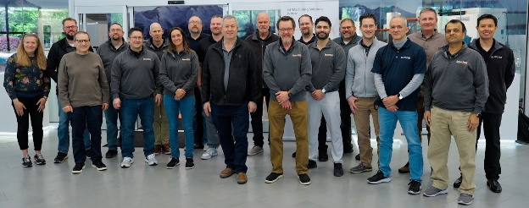
Volker Nesenhöner, CEO of OPEN MIND Technologies AG, emphasized the importance of the region: “North America has been a key growth market for OPEN MIND for three decades. We congratulate Alan Levine and the entire team on this milestone. Their commitment to customer success and technical excellence has significantly contributed to strengthening our market position and expanding the adoption of hyperMILL® across demanding industries.”
As a pioneer in advanced manufacturing technologies, OPEN MIND has continuously driven innovation in CAD/CAM. The company was among the first to introduce automatic multi-axis simultaneous machining strategies and has since developed numerous other advanced technologies.
OPEN MIND Technologies USA Team
Today, hyperMILL® provides a comprehensive range of capabilities, supports seamless interaction with CAD systems and plays a central role in enabling efficient, future-ready production processes.
OPEN MIND solutions are widely used across key industries such as aerospace, automotive, medical technology, tool and mold making, energy, and precision engineering, where high performance and process reliability are critical.
With a strong focus on innovation and customer value, OPEN MIND continues to advance its technologies to help manufacturers improve quality, reduce lead times, and optimize costs, reinforcing its position as one of the leading CAD/CAM providers worldwide.
Follow OPEN MIND on LinkedIn, Facebook, YouTube, Instagram.
About OPEN MIND Technologies AG
OPEN MIND Technologies AG is one of the world’s leading developers of powerful CAD/CAM software solutions for machine and controller-independent programming. OPEN MIND develops optimized CAD/CAM solutions that include innovative and unique features that can deliver significantly higher performance in both programming and machining. hyperMILL® is a completely modular CAD/CAM solution that provides state-of-the-art CAM technologies on its own CAD platform: from 2.5D, 3D and 5-axis machining as well as turning strategies and solutions for additive manufacturing, HSC and HPC machining. Whether automation, simulation or virtual machine, trendsetting technologies expand the product range and enable continuous digital process chains. Special applications, seamless interaction with all popular CAD solutions and exceptional customer service rounds out the company’s products and capabilities.
According to the "NC Market Analysis Report 2026" compiled by CIMdata, hyperMILL® is a leading, worldwide CAD/CAM solution. Innovative CAD/CAM technologies fulfill the highest demands in the automotive, tool and mold manufacturing, production machining, medical, job shops, energy, semiconductor and aerospace industries. OPEN MIND is a Mensch und Maschine company and has subsidiaries and qualified sales partners on all continents. You can find more information at https://www.openmind-tech.com/en-us.
# # # # #

