

NEWS RELEASE

For Release: IMMEDIATELY With Art: Digital Images
Editorial Michael McCue OPEN MIND Alan Levine
Contact: McCue & Associates LLC Contact: OPEN MIND Technologies USA, Inc.
978-733-1353 339-225-4557 mmccue@mccueassociates.com alan.levine@openmind-tech.com

OPEN MIND Joins FANUC 5-Axis Integrated Technology Initiative
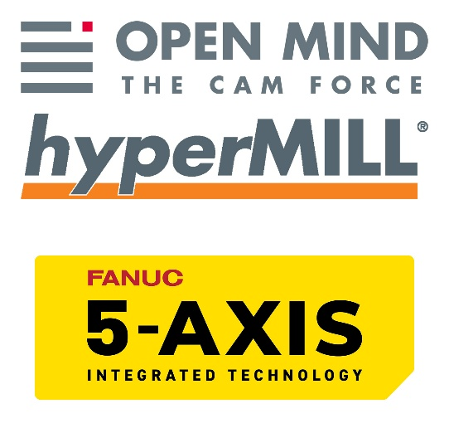
NEEDHAM, MA U.S.A. (September 3, 2026) – OPEN MIND Technologies, a leading developer of CAD/CAM software solutions worldwide, has announced it has become a founding member of the FANUC 5-Axis Integrated Technology Initiative. The initiative is a program organized by FANUC that involves collaboration with machine tool builders and CAD/CAM technology companies that will enable end-user manufacturers to achieve high-performance machining and premium surface finishes. Though providing benefits to manufacturers in all markets, the motivation of the FANUC Initiative is to improve efficiency, accuracy, and repeatability in the production of complex parts, which will be especially beneficial for the U.S. aerospace market.
The hyperMILL® CAD/CAM software solution, developed by OPEN MIND Technologies, is well known for its innovative, advanced 5-axis processing. Though this technology has been available in the market for many years, customers can now benefit from increased knowledge, guidance, and access to the technologies via the partnership. The FANUC control system is used on many key machine tools in the metalworking manufacturing industry. The FANUC 5-Axis Integrated Technology Initiative for CAD/CAM and postprocessor guides best practices for the use of code structure and data standards to interact with the machine tools in order to achieve smooth and safe programs, and streamline and optimize 5-axis machining workflows.
Alan Levine, Managing Director of OPEN MIND Technologies USA, Inc. stated, “We are pleased to be part of the FANUC 5-Axis Integrated Technology Initiative to bring total solutions for end-users that seek to grow their business and more effectively manage risk”.
Rick Schultz, Executive Director of Aerospace at FANUC America said, “We are excited to have OPEN MIND join the FANUC 5-Axis Integrated Technology Initiative program. The hyperMILL® CAD/CAM Software solution is an industry leading program that is well respected worldwide. We look forward to collaborating with OPEN MIND on this initiative.”
The OPEN MIND hyperMILL® CAD/CAM solution provides VIRTUAL Machining utilities that go beyond postprocessing. The VIRTUAL Machine provides process security with full collision detection against all items in the machining work area, and the NC Optimizer module of the program simplifies programming tasks and improves machining results by managing link connections and fitting parts within axis limits.
At IMTS 2026, manufacturing professionals are encouraged to visit OPEN MIND Technologies in Booth #133351, and FANUC America in Booth #338900 to learn more about the initiative.
About OPEN MIND Technologies AG
OPEN MIND Technologies AG is one of the world’s leading developers of powerful CAD/CAM software solutions for machine and controller-independent programming. OPEN MIND develops optimized CAD/CAM solutions that include innovative and unique features that can deliver significantly higher performance in both programming and machining. hyperMILL® is a completely modular CAD/CAM solution that provides state-of-the-art CAM technologies on its own CAD platform: from 2.5D, 3D and 5-axis machining as well as turning strategies and solutions for additive manufacturing, HSC and HPC machining. Whether automation, simulation or virtual machine, trendsetting technologies expand the product range and enable continuous digital process chains. Special applications, seamless interaction with all popular CAD solutions and exceptional customer service rounds out the company’s products and capabilities.
According to the "NC Market Analysis Report 2026" compiled by CIMdata, hyperMILL® is a leading, worldwide CAD/CAM solution. Innovative CAD/CAM technologies fulfill the highest demands in the automotive, tool and mold manufacturing, production machining, medical, job shops, energy, semiconductor and aerospace industries. OPEN MIND is a Mensch und Maschine company and has subsidiaries and qualified sales partners on all continents. You can find more information at https://www.openmind-tech.com/en-us.
Follow OPEN MIND Technologies on LinkedIn, Facebook, YouTube, Instagram.
About FANUC America Corporation
FANUC America Corporation is a subsidiary of FANUC CORPORATION in Japan, and provides industry-leading CNC systems, robotics and ROBOMACHINEs. FANUC’s innovative technologies and proven expertise help manufacturers in the Americas maximize productivity, reliability and profitability. Headquartered in Rochester Hills, MI, FANUC America has facilities throughout North and South America. Visit www.fanucamerica.com for more information or explore the CRX line of cobots at CRX.FANUCAmerica.com.
Connect with FANUC America on YouTube, X, Facebook, LinkedIn and Instagram.

# # # # #

