FOR THE MEDIA
ASMPT automates product changeovers on DEK TQ printer platform
Over 80 percent less operator time during a changeover
Shanghai (China), September 3, 2026 – With the new option for automated setup changeover, ASMPT is adding an automated solution for stencil and squeegee changeovers to its DEK TQ printer platform. Instead of changing stencils and squeegees one after the other, operators merely need to insert a prepared setup and let the printer handle all further steps automatically. This reduces operator time at the printer during a changeover from roughly four minutes to about 30 seconds.
“Solder paste printing is one of the processes that require lots of operator involvement on an SMT line. With a new, innovative solution for automated setup changeover, we reduce the need for manual assists considerably while also lowering the risk of operator errors,” explains Martin Moggeridge, Senior Product Manager at ASMPT SMT Solutions.
The new solution is based on a prepared setup in which the consumable cartridge containing the squeegees are combined with the stencil. All that’s left for the operator to do is to insert the new setup into the printer. The print head localizes the squeegees and the consumable cartridge, picks them up and prepares the printing process. While the machine prints, the consumables unit stays in the printer and carries out the automatic paste transfer during the next stencil change by transferring the paste roll to the new stencil, which the printer’s integrated camera can automatically identify and verify using the Camera Barcode Reader option. Alternatively, the barcode can be scanned in the setup area to verify the prepared setup in advance.
Faster changeovers with less operator time at the printer
With traditional product changeovers, operators must remain at the printer during the entire procedure. They remove the squeegees and the stencil, check the arrangement of the support pins for PCB support, insert the new stencil and verify it before manually mounting the new stencils. This typically takes around four minutes. With the automated setup changeover, the manual part is limited to opening the printer, removing the stencil and the squeegees placed on the stencil by the print head, inserting the prepared setup, and closing the hood. The rest of the changeover process runs automatically, which reduces the operator intervention time at the printer during a changeover to roughly 30 seconds.
For manually placed support pins, the new solution also makes it significantly easier and faster to verify their correct position, while DEK Smart Pin Placement handles positioning automatically.
The new solution also improves the overall process reliability. By following the poka-yoke principle, the adapter’s construction prevents faulty adapter assemblies. In addition, the automatic pickup of the squeegees reduces the risk of operator errors and ensures a reproducible changeover process.
The automated setup changeover consists of a new print head, new squeegees, the consumable cartridge, the adapter, and the necessary software. The option is available for new DEK TQ printers as well as for retrofitting existing systems.

Illustrations for downloading
The following print-ready artwork is available on the internet for downloading:
https://kk.htcm.de/press-releases/asmpt/

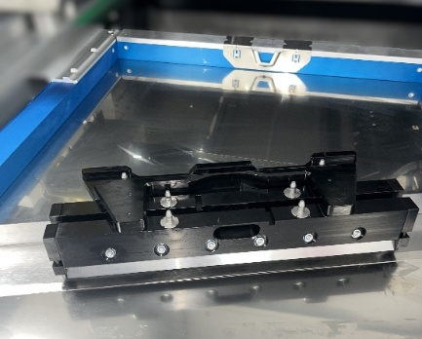 | 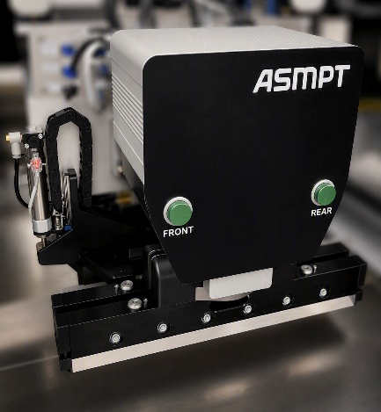
A pre-configured setup consisting of squeegees, consumable cartridge, adapter, and stencil enables automated setup changover on the DEK TQ printer – quickly and easily.  Image credit: ASMPT | The new print head on the DEK TQ printer, featuring sensor technology, automatically picks up the squeegees and consumable cartridge.  Image credit: ASMPT

About ASMPT Limited (“ASMPT”)
ASMPT Limited is a leading global supplier of hardware and software solutions for the manufacture of semiconductors and electronics. Headquartered in Singapore, ASMPT’s offerings encompass the semiconductor assembly & packaging, and SMT (surface mount technology) industries, providing various solutions that organize, assemble and package delicate electronic components into a vast range of end-user devices. ASMPT partners with customers very closely, with continuous investment in R&D helping to provide cost-effective, industry-shaping solutions that achieve higher productivity, greater reliability, and enhanced quality. ASMPT is a founding member of the Semiconductor Climate Consortium.
To learn more about ASMPT, please visit www.asmpt.com.

The ASMPT SMT Solutions segment
The mission of the SMT Solutions segment within ASMPT is to implement and support the Intelligent Factory at electronics manufacturers worldwide.
ASMPT solutions support the networking, automation, and optimization of central workflows with hardware, software and services that enable electronics manufacturers to transition to the Intelligent Factory in stages and enjoy dramatic improvements in productivity, flexibility, and quality. With its integrated open automation concept, ASMPT opens the door for its customers to economically feasible automation, entirely in accordance with their individual requirements – modular, flexible, and vendor-independent.
The product range includes hardware and software such as SIPLACE placement solutions, DEK printing solutions, the Process Lens SPI solution, and the WORKS Software Suite. With WORKS, ASMPT offers electronics manufacturers high-quality software for planning, controlling, analyzing and optimizing all processes on the shop floor. Maintaining close relationships with customers and technology partners is a central component of ASMPT’s strategy.
For more information about ASMPT SMT Solutions, visit smt.asmpt.com.
Media contacts:
China ASMPT Press Office
SMT Solutions
Guan Jing
Phone: +86 (755) 26934550-2109
E-mail: jing.guan@asmpt.com
Website: smt.asmpt.com

Global ASMPT Press Office
ASMPT Limited
Susanne Oswald
Rupert-Mayer-Strasse 48
81379 Munich
Germany
Tel: +49 89 20800-26439
E-mail: susanne.oswald@asmpt.com
Website: asmpt.com

