PRESS RELEASE
Würth Elektronik extends its optocoupler range
High-Speed Optocouplers for Fast and Interference-Resistant Signal Transmission
Waldenburg (Germany), September 1, 2026 – Würth Elektronik is expanding its optoelectronics portfolio with the WL-OCHS high-speed optocoupler. This component is designed for high-speed digital signal transmission between galvanically isolated circuit sections. The optocoupler supports data rates from 1 MBd to 10 MBd and provides an isolation voltage of up to 5000 V_{RMS} and high EMC immunity.
Optocouplers offer galvanic isolation of high voltages and potential differences. However, the short switching times (tpHL/tpLH) of 100 ns to 1500 ns enable the high-speed optocoupler to transmit signals with significantly lower delay than conventional optocouplers. Thanks to its high CMTI (common-mode transient immunity), the optocoupler ensures reliable signal transmission even during rapid input/output voltage changes in demanding, electrically noisy environments. In addition, a copper leadframe improves resistance to corrosion and environmental influences, significantly enhancing the robustness of the new optocoupler series.
Broad range of applications
The Würth Elektronik high-speed optocoupler is suitable for microcontroller, FPGA, and DSP interfaces, as well as serial communication interfaces such as UART, SPI, and RS-232/RS-485. Typical applications therefore include measurement and control technology, industrial electronics in high-interference environments, medical devices requiring safe electrical isolation, in addition to PLC and automation systems.
The new optocoupler is now available from stock. Developers can receive free samples on request.

Available images
The following images can be downloaded from the Internet in printable quality: https://kk.htcm.de/press-releases/wuerth/

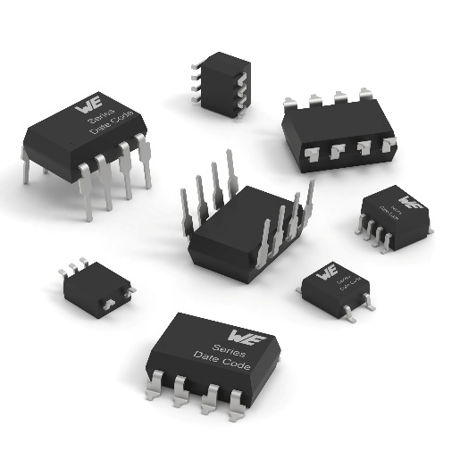
Image source: Würth Elektronik
WL-OCHS high-speed optocoupler: High-speed digital signal transmission between galvanically isolated circuit sections.

About the Würth Elektronik eiSos Group
Würth Elektronik eiSos Group is a manufacturer of electronic and electromechanical components for the electronics industry and a technology company that spearheads pioneering electronic solutions. Würth Elektronik eiSos is one of the largest European manufacturers of passive components and is active in 50 countries. Production sites in Europe, Asia and North America supply a growing number of customers worldwide.
The product range includes passive components, power modules, digital isolators, optoelectronics, electromechanical components, thermal management solutions, sensors and wireless modules. The portfolio is rounded off by customer-specific solutions.
The unrivaled service orientation of the company is characterized by the availability of all catalog components from stock without minimum order quantity, free samples and extensive support through technical sales staff and selection tools.
Würth Elektronik is part of the Würth Group, the global market leader in the development, production, and sale of fastening and assembly materials, and employs around 7,300 people. In 2025, the Würth Elektronik Group generated sales of 1.06 Billion Euro.
Würth Elektronik: more than you expect!
Further information at www.we-online.com

Further information:  Würth Elektronik eiSos GmbH & Co. KG  Sarah Hurst  Clarita-Bernhard-Strasse 9  81249 Munich  Germany  Phone: +49 7942 945-5186  E-mail: sarah.hurst@we-online.de  www.we-online.com | Press contact:  HighTech communications GmbH  Brigitte Basilio  Brunhamstrasse 21  81249 Munich  Germany  Phone: +49 89 500778-20  E-mail: b.basilio@htcm.de  www.htcm.de

