FOR THE MEDIA
ASMPT at SEMICON Taiwan
Strengthening Advanced Packaging Innovation and Engagement in Taiwan
Singapore, August 26 2026 – Global technology and innovation leader ASMPT will showcase its advanced packaging portfolio at SEMICON Taiwan 2026, taking place from September 2 to 4 in Taipei. At Booth L0716 (TaiNEX 1, Level 4). ASMPT will be presenting technologies supporting next-generation AI, High-Performance Computing (HPC), Co-Packaged Optics (CPO) and photonics applications under the theme "Empower the Intelligence Revolution." Reflecting its continued commitment to Taiwan, one of the world's leading semiconductor hubs, ASMPT is also strengthening its local leadership and customer engagement capabilities.
Taiwan remains a key center for semiconductor innovation and advanced packaging. Working closely with customers across the region, ASMPT supports the industrialization of next-generation semiconductor technologies, helping bring advanced concepts into reliable, high-volume manufacturing and enabling the innovations that power the AI era.
As part of its continued investment in Taiwan, ASMPT appointed Johnny Fan as General Manager, Country Head & Head of Sales, Semiconductor Solutions Taiwan, further strengthening its local leadership and customer support.
"Taiwan is at the forefront of semiconductor innovation, particularly in advanced packaging technologies that are enabling the AI era," said Johnny Fan. "Our customers are driving some of the world's most advanced semiconductor innovations in AI, HPC and photonics. The challenge is turning those innovations into production-ready solutions at scale, and that's where ASMPT helps its customers succeed."
As AI applications continue to drive demand for more powerful and efficient semiconductor architectures, advanced packaging is playing an increasingly important role in delivering the required performance, power efficiency and integration. At SEMICON Taiwan 2026, ASMPT will present solutions supporting applications in HPC, AI accelerators, silicon photonics and Co-Packaged Optics (CPO), leveraging technologies such as Thermocompression Bonding (TCB) and Hybrid Bonding.
As an example of these capabilities, ASMPT will showcase its MEGA multi-chip bonding solution. MEGA combines high-precision placement with alignment accuracy of ±2μm and ±0.1°, integrated epoxy dispensing and stamping capabilities, parallel processing of multiple adhesive materials, immediate UV fixation and integrated 3D inspection of the adhesive application. Independently operating pick and bond arms, together with a flip-pick unit and integrated rotation stage, enable flexible process execution for complex multi-chip and photonics applications

Illustrations for downloading
The following images are available for download in printable format at:
https://kk.htcm.de/press-releases/asmpt/

 | 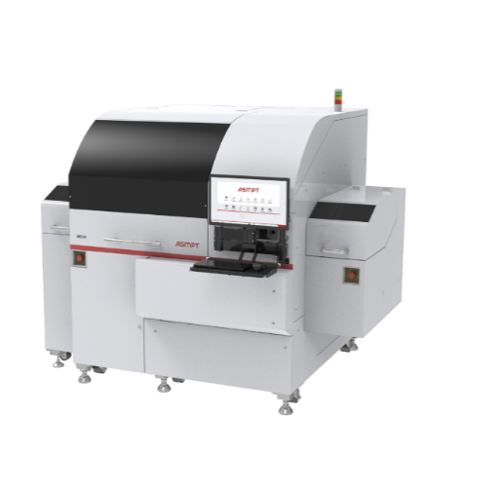
Johnny Fan, General Manager, Country Head & Head of Sales, ASMPT Semiconductor Solutions Taiwan, driving customer engagement and supporting the advancement of Taiwan's semiconductor ecosystem.  Image credit: ASMPT | ASMPT's MEGA multi-chip bonding solution combines ±2 μm placement accuracy and ±0.1° alignment accuracy with integrated dispensing, UV fixation and inspection capabilities to support advanced packaging, silicon photonics and Co-Packaged Optics (CPO) applications.  Image credit: ASMPT

About ASMPT Limited (“ASMPT”)
ASMPT Limited is a leading global supplier of hardware and software solutions for the manufacture of semiconductors and electronics. Headquartered in Singapore, ASMPT’s offerings encompass the semiconductor assembly & packaging, and SMT (surface mount technology) industries, providing various solutions that organise, assemble and package delicate electronic components into a vast range of end-user devices. ASMPT partners with customers very closely, with continuous investment in R&D helping to provide cost-effective, industry-shaping solutions that achieve higher productivity, greater reliability, and enhanced quality. ASMPT is a founding member of the Semiconductor Climate Consortium.
To learn more about ASMPT, please visit us at asmpt.com.

About ASMPT Semiconductor Solutions (“ASMPT SEMI”)
ASMPT SEMI is the leading supplier in advanced packaging and semiconductor assembly solutions. With a commitment to innovation and customer satisfaction, ASMPT SEMI provides a comprehensive range of products and services that cater to the evolving needs of the microelectronics industry. Their expertise spans across areas such as flip-chip and wafer-level packaging, advanced interconnect technologies, and more. ASMPT SEMI's cutting-edge solutions enable customers to achieve higher performance, increased reliability, and improved cost-efficiency when producing their semiconductor devices.
ASMPT SEMI sees itself as a pioneer and driving force of the Intelligence Revolution. With its advanced packaging and assembly technologies, the business segment creates the invisible connections that enable intelligent applications in Artificial Intelligence, Smart Mobility and Hyperconnectivity.
For more information about ASMPT SEMI, visit semi.asmpt.com.
Media contacts:
Global ASMPT Semiconductor Solutions Press Office
ASMPT Limited
Jessica Ho
Semiconductor Solutions
E-Mail: semi_stratmkt@asmpt.com
Website: semi.asmpt.com

Global ASMPT Press Office
ASMPT Limited
Susanne Oswald
Rupert-Mayer-Strasse 48
81379 Munich
Germany
Phone: +49 89 20800-26439
E-Mail: susanne.oswald@asmpt.com
Website: asmpt.com

