FOR THE MEDIA
ASMPT at Productronica India 2026
SIPLACE V makes its India debut
Singapore, August 17, 2026 – ASMPT SMT Solutions, the global market and technology leader in integrated hardware and software solutions for electronics manufacturing, will present its latest solutions for the intelligent factory at Productronica India in Bengaluru from September 16 to 18, 2026. The highlight at Booth H4.E11 will be the launch of the new SIPLACE V placement platform in India. Visitors can also experience a live demonstration of large BGA placement for AI server applications on the SIPLACE SX, complemented by the highly precise DEK TQ printer. Software solutions for monitoring, managing and optimizing SMT production are another focus of the presentation.
Up to 30% more real performance
Developed from the ground up, the SIPLACE V combines significantly higher real performance with flexibility, process excellence and long-term investment protection. A new machine architecture with a highly rigid frame, efficient linear drives and high-resolution measurement systems enables higher acceleration and shorter non-productive movements. Under real production conditions, the platform achieves performance gains of up to 30 percent in key electronics manufacturing sectors. At Productronica India, ASMPT will demonstrate the SIPLACE V at a benchmark placement rate of more than 52,000 components per hour. Single- and dual-lane configurations, Smart Pin Support and compatibility with existing SIPLACE X feeders give manufacturers considerable flexibility in configuring the platform. High-resolution vision systems, individual component inspection and closed-loop sensor technology help ensure consistently high process quality even at high placement speeds. Also on display is the SIPLACE Measuring Feeder, which measures electrical component properties before placement.
Ready for AI server boards
A second live demonstration addresses one of the major challenges facing electronics manufacturers: the production of AI server boards. These combine extremely high component densities with increasingly large and heavy processor BGAs. Component dimensions of up to 150 × 150 millimeters and weights of more than 500 grams are no longer unusual. The SIPLACE SX at the booth will demonstrate the placement of large BGAs for AI server applications. The proven platform can be equipped with the TWIN VHF placement head for large and heavy processor BGAs, while its heavy-duty conveyor handles boards weighing up to ten kilograms. SIPLACE Smart Pin Support automatically positions support pins to prevent large boards from bending during placement. The DEK TQ printer complements the AI server presentation with solder paste printing for large-format boards.
Intelligent data use increases yield and performance
“We boost your intelligent factory” is ASMPT’s key message at Productronica India – and the presentation extends well beyond hardware. The WORKS Software Suite demonstrates how software can make production processes more transparent, support operators in their daily work, and help manufacturers make better use of production data. Real-time production KPIs make deviations and trends visible at an early stage. Combined with data from SPI and AOI systems, AI-based analysis helps identify the causes of printing and placement process deviations, automatically optimizes the printing process, and provides concrete recommendations for improving the placement process.
Additionally ASMPT will showcase its Factory Solutions, with SMT Analytics demonstrating how intelligent data use can help increase yield and performance. Another highlight is the latest version of Virtual Assist, ASMPT’s AI-based expert system for onboarding, service and maintenance. Its enhanced AI chat function now enables a continuous dialogue, allowing users to ask follow-up questions and refine their queries. A new image-based spare-parts recognition function also identifies likely matches from a smartphone photo of a disassembled part. ASMPT will also present its new Customer Portal at the booth.
“With the launch of the SIPLACE V in India, our live demonstration production of AI server boards and our latest software solutions, we are showing how advanced hardware, software and intelligent data use work together in future-ready electronics manufacturing,” says Mr Neeraj Bhardwaj, General Manager for India, Bangladesh & Sri Lanka at ASMPT SMT Solutions India. “Electronics manufacturers need more performance and flexibility, but they also need to make better use of their production data and automate processes where it makes sense. That is exactly what we want to demonstrate at Productronica India.”

Illustrations for downloading
The following images are available for download in printable format at:
https://kk.htcm.de/press-releases/asmpt/

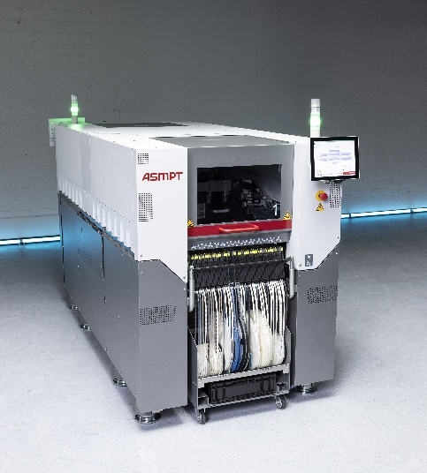 | 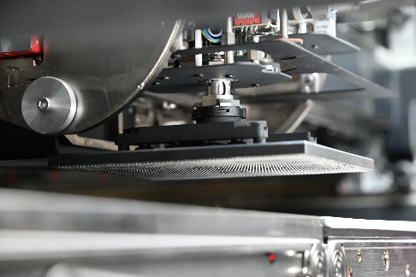
The new SIPLACE V platform handles the entire range of components – from ultra-small 016008M chips to large-format components – and really shines when dealing with challenging or odd-shaped components.  Source: ASMPT | The TWIN VHF (Very High Force) placement head is designed to handle large AI processor BGAs.  Source: ASMPT

About ASMPT Limited (“ASMPT”)
ASMPT Limited is a leading global supplier of hardware and software solutions for the manufacture of semiconductors and electronics. Headquartered in Singapore, ASMPT’s offerings encompass the semiconductor assembly & packaging, and SMT (surface mount technology) industries, providing various solutions that organize, assemble and package delicate electronic components into a vast range of end-user devices. ASMPT partners with customers very closely, with continuous investment in R&D helping to provide cost-effective, industry-shaping solutions that achieve higher productivity, greater reliability, and enhanced quality. ASMPT is a founding member of the Semiconductor Climate Consortium.
To learn more about ASMPT, please visit us at asmpt.com.

The ASMPT SMT Solutions segment
The mission of the SMT Solutions segment within ASMPT is to implement and support the Intelligent Factory at electronics manufacturers worldwide.
ASMPT solutions support the networking, automation, and optimization of central workflows with hardware, software and services that enable electronics manufacturers to transition to the Intelligent Factory in stages and enjoy dramatic improvements in productivity, flexibility, and quality. With its integrated open automation concept, ASMPT opens the door for its customers to economically feasible automation, entirely in accordance with their individual requirements – modular, flexible, and vendor-independent.
The product range includes hardware and software such as SIPLACE placement solutions, DEK printing solutions, inspection and storage solutions, and the Software Suite WORKS. With WORKS, ASMPT offers electronics manufacturers high-quality software for planning, controlling, analyzing and optimizing all processes on the shop floor. Maintaining close relationships with customers and technology partners is a central component of ASMPT’s strategy.
For more information about ASMPT SMT Solutions visit smt.asmpt.com.
Media contacts:
ASMPT ROA Press Office
SMT Solutions
ASMPT SMT Singapore Pte. Ltd.
Janet Loh
Phone: +65 6877 3948
E-mail: Janet.loh@asmpt.com
Website: smt.asmpt.com

Global ASMPT Press Office
ASMPT Limited
Susanne Oswald
Rupert-Mayer-Strasse 48
81379 Munich
Germany
Phone: +49 89 20800-26439
E-Mail: susanne.oswald@asmpt.com
Website: asmpt.com

