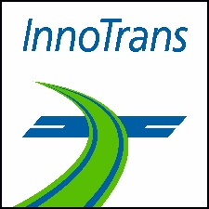
Press Release
Symeo at InnoTrans 2026
Imaging Radar: Symeo Showcases Solutions for the Rail Industry
22–25 Sept. 2026
Hall 27, Booth 210
Neubiberg (Germany), August 12, 2026 – Symeo will showcase its radar technology at InnoTrans 2026. At booth 210 in Hall 27 of the international trade fair for transport technology, the company will demonstrate how radar technology can be effectively deployed in rail infrastructure and rolling stock applications. Visitors will have the opportunity to explore both an evaluation kit and a live demonstrator at the Symeo booth. The company will also contribute to the event's conference program at Messe Berlin.
"Our radar sensor technology has proven itself under the harshest conditions in applications such as bulk material handling and crane safety. With the latest developments we are presenting, radar complements existing sensor technologies in the rail sector, helping to enhance both safety and resilience," says Thomas Hörl-Weinhold, VP Industry Business Development at Symeo. Together with Hakim Kolsi, Senior Field Application Engineer, he will present the session "Radar as a Key Technology: Challenges and Opportunities," explaining which factors determine the success or failure of radar sensor projects. The presentation will take place on September 25, 2026, from 11:30 a.m. to 12:30 p.m. at the Speakers' Corner (Hall 27, Beta Level 3–4).
Imaging Radar: Development Partnerships with Symeo
The wealth of data that can be derived from radar signals in imaging radar applications requires sensor systems to be individually tailored and software-optimized for each use case. To support this process, Symeo offers the AVR-QDM-110 Eval Kit, featuring a powerful MIMO radar evaluation platform. The sensor array is highly flexible and configurable for a wide range of applications. It has already been tested in various customer projects to evaluate imaging radar applications in the rail sector, including railroad crossing monitoring. To demonstrate the versatility of radar technology, Symeo will also present a live demonstrator at its booth, showcasing contactless vibration measurement using a 120 GHz radar sensor.

For more information, visit www.symeo.com/en/.

Available Images
The following high-resolution images are available for download:
https://kk.htcm.de/press-releases/symeo/

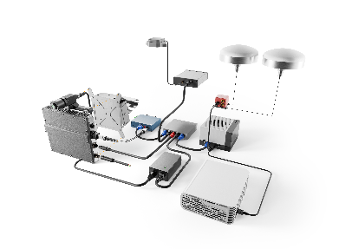  Image source: Symeo  Symeo uses the high-performance AVR-QDM-110 Eval-Kit to test configurations for customer projects. | 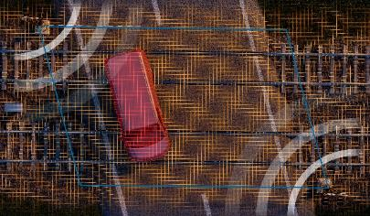Image source: Symeo  A current project involving the use of radar imaging technology in rail transportation is the monitoring of a railroad crossing.
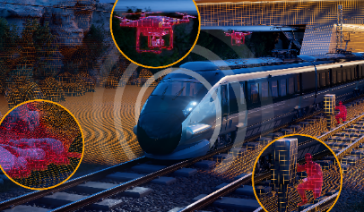Image source: Symeo
Imaging radar on trains can help monitor the tracks.

About Symeo GmbH
For more than 20 years, Symeo has been developing radar solutions for industrial applications. Drawing on extensive experience in delivering large-scale projects for industries with demanding requirements, the company provides solutions for precise, contactless, and maintenance-free position detection, distance measurement, collision avoidance, and infrastructure monitoring.
Symeo's portfolio includes advanced imaging radar technologies that are tailored to customers' specific requirements through close development partnerships, as well as radar systems compliant with the functional safety standard EN ISO 13849 PL d. The radar sensors are specifically designed for reliable operation in harsh industrial environments.
With its LPR® radar sensor technology, Symeo offers a wireless, real-time measurement system ideally suited for industrial applications. The technology is available as standardized products as well as complete solutions for system integrators, original equipment manufacturers (OEMs), and end customers worldwide.
Headquarters: Symeo GmbH, Prof.-Messerschmitt-Straße 3 a, 85579 Neubiberg, Germany
Phone: +49 89 6607796-0, Fax: +49 89 6607796-190
Email: info@symeo.com, Website: www.symeo.com/en/

Press Contact:
HighTech communications GmbH
Marcus Planckh
Brunhamstraße 21 (Building 202 / 2nd Floor)
81249 Munich
Germany
Phone: +49 89 500778-22
Email: m.planckh@htcm.de
Website: www.htcm.de

Disclaimer
The safety functions described are part of a safety-related system and do not replace the application-specific risk assessment, proper system integration, or validation in accordance with the applicable standards by the machine manufacturer or system integrator.
This press release is intended for general information purposes only and does not constitute a binding offer or legal commitment. Technical data, specifications, and product features are subject to change as part of ongoing development.

