PRESS RELEASE

Hufschmied introduces finishing tool Hexator for graphite machining
The Lollipop for electrodes with outstanding surface quality
Bobingen (Germany), August 12, 2026 – Hufschmied Zerspanungssysteme has expanded its portfolio of graphite machining tools to include the Hexator. This is a six-edged tool featuring a lollipop geometry and a specially developed diamond coating. At low spindle speeds that are gentle on the spindle, the Hexator allows for high machining feed rates. Thanks to its shape, both performance and surface finish remain constant across all tool contact points, as the point of contact between the tool and the workpiece remains the same. This is particularly beneficial when machining 90-degree wall surfaces.
Many companies that manufacture graphite electrodes are already benefiting from the specialized Graftor roughing and finishing tool. A customer project highlighted the need for an additional high-performance finishing tool. The completely newly developed Hexator tool is characterized by extremely long tool service life, which significantly reduces tool changes as well as setup and downtime. Using Hufschmied’s tools, including the new high-feed finishing tool, the customer was able to lower production costs by over 60 percent and reduce production time to one-third of the original. Overall, this resulted in significantly lower component costs.
In-house coating
Thanks to the lollipop geometry, the tool’s contact area remains constant even during 90-degree wall machining. Recutting, which occurs with tools featuring a straight cutting edge — even a very small one — is completely eliminated. The Hexator achieves a clean and uniform milling finish with dimensionally and geometrically stable results. Hufschmied offers the Hexator as standard in diameters ranging from 2.0 to 12.0 mm; other sizes are made available upon request.
“Our specialists have once again proven that every aspect of a tool can be optimized for a specific process — from the shape to the cutting-edge distribution and geometry, right down to the coating,” explains Christel Hufschmied, Managing Director of Hufschmied Zerspanungssysteme GmbH. “We are in the fortunate position of having not only the technical expertise and experience but also all the necessary technical facilities in-house. This gives us the freedom to develop exceptional tools and significantly improve our customers’ processes.”

The Hexator will be on display at Booth 3D64 in Hall 3 at the AMB in Stuttgart from September 15 to 19, 2026.

Available images
The following images can be downloaded from the Internet in printable quality:
https://kk.htcm.de/press-releases/hufschmied/
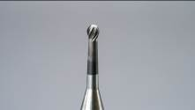 Image source:
Hufschmied Zerspanungssysteme
The Hexator is a high-feed finishing tool for machining graphite that features a process-optimized cutting geometry and a diamond coating.

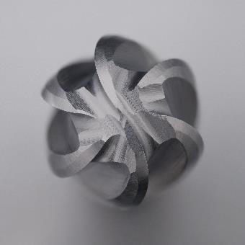 Image source:  Hufschmied Zerspanungssysteme  Six cutting edges make the Hexator particularly powerful. | 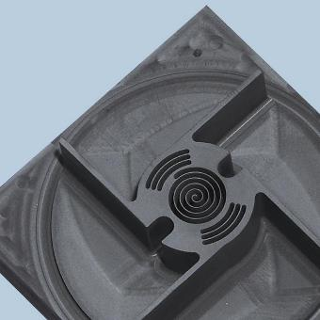 Image source:  Hufschmied Zerspanungssysteme  Thanks to the Hexator’s shape, both performance and surface finish remain constant across all tool contact points. This is particularly beneficial when machining 90-degree wall surfaces.

Available videos
You can find the following videos on our YouTube channel:
https://www.youtube.com/watch?v=E60UshZJGiI
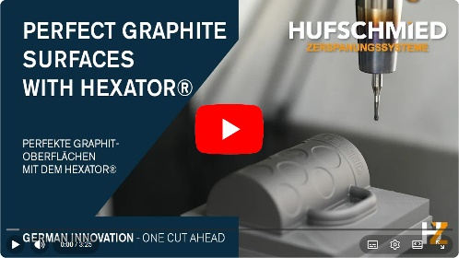Source: Hufschmied Zerspanungssysteme
Video about the Hexator

About Hufschmied Zerspanungssysteme GmbH
Established in 1991 and headquartered in Bobingen near Augsburg, Hufschmied Zerspanungssysteme GmbH is a manufacturer of high-quality tools for machinable production and friction stir welding. By specializing at an early stage in the machining of plastics, fiberglass materials and carbon fiber, Hufschmied has become a leader in Europe in the development of solutions for new materials. The company is an established system supplier to renowned machine tool manufacturers. Tools and manufacturing process consulting from Hufschmied are particularly valued in the automotive and aerospace industries as well as in medical technology. The company is involved in numerous organizations, including Composites United Deutschland e. V. Hufschmied's manufacturing operations are located in Bobingen, Winterlingen and Sigmaringen on the Swabian Alb. Hufschmied is certified according to ISO 9001:2015 (quality management) and ISO 14001:2015 (environmental management).

Hufschmied Zerspanungssysteme GmbH – One Cut Ahead
For more information: www.hufschmied.net

Additional information:  Hufschmied Zerspanungssysteme GmbH  Marco Beigl  Edisonstrasse 11d  86399 Bobingen  Germany  Phone: +49 8234 9664-0  Telefax: +49 8234 9664-99  E-Mail: info@hufschmied.net  www.hufschmied.net | Press contact:  HighTech communications GmbH  Brigitte Basilio  Brunhamstrasse 21  81249 Munich  Germany  Phone: +49 89 500778-20  E-Mail: b.basilio@htcm.de  www.htcm.de

