FOR THE MEDIA
Bassel Haddad Assumes Leadership of ASMPT as Group Chief Executive Officer
Semiconductor technology and business executive to advance ASMPT’s transformation and growth strategy
Singapore, 11 August 2026 – ASMPT (HKEX: 0522), the world’s leading provider of integrated hardware and software solutions for semiconductor and electronics manufacturing, today announced that Bassel Haddad has assumed the roles of Group Chief Executive Officer and Executive Director. The leadership transition, first announced in July, took effect today.
Bassel Haddad succeeds Robin Ng, who retires after more than 20 years with ASMPT, including six years as Group CEO and Executive Director.
John Lok, Chairman of the Board of ASMPT, said: “We are pleased to welcome Bassel Haddad as Group CEO. He assumes leadership of ASMPT with a clear corporate strategy, strong technology capabilities and an experienced global team already in place. Bassel’s deep industry expertise, business leadership and track record of driving innovation and customer success make him the right leader to guide ASMPT through its next phase of growth and deliver solutions to increasingly complex customer requirements.”
“It is an honour to lead ASMPT, a company with a remarkable legacy and a strong foundation for future growth,” said Bassel Haddad, Group Chief Executive Officer of ASMPT. “We have an exceptional opportunity to accelerate and shape the industry´s evolution from traditional Moore´s Law scaling to the “more than Moore” era. I look forward to partnering with the Board of Directors and our talented global team to accelerate innovation, deepen our customer partnerships, and create lasting value for our employees, customers, and shareholders."
Bassel Haddad assumes leadership following ASMPT’s recently reported first-half 2026 results. Group revenue from continuing operations increased 42.5% year on year to US$1.14 billion, while Advanced Packaging delivered record half-year revenue. The performance reflected demand across multiple advanced packaging solutions, including Thermo-Compression Bonding, high-precision SMT and Photonics, alongside growth in mainstream applications.
As semiconductor architectures become more complex, assembly and advanced packaging have become central to delivering system-level performance and manufacturing scalability. Bassel Haddad’s broad experience leading technology development, operations and global businesses positions ASMPT to extend its technology leadership and customer focus.
Before joining ASMPT, Bassel Haddad was Senior Vice President and General Manager of Foundry Solutions and Technology Platforms at SkyWater Technology, where he led business strategy, go-to-market activities and profit-and-loss accountability for its foundry and advanced technology services. He previously led SkyWater’s Advanced Packaging business, with responsibility spanning technology development, engineering, marketing and fab operations. Earlier, Bassel spent 14 years at Intel Corporation in senior leadership roles across product, technology and business management, including edge computing, artificial intelligence and product architecture. He holds bachelor’s and master’s degrees in electrical engineering from the Technion – Israel Institute of Technology.

Illustrations for downloading
The following images are available for download in printable format at:
https://kk.htcm.de/press-releases/asmpt/

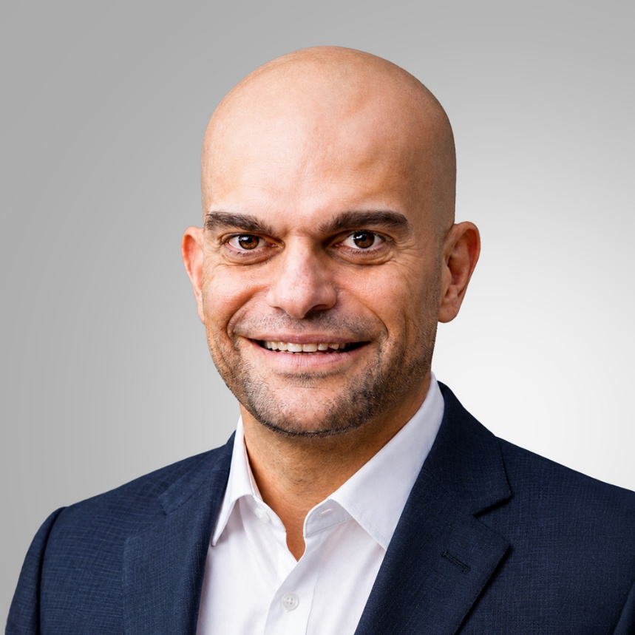

Bassel Haddad, Group Chief Executive Officer and Executive Director, ASMPT

Source: ASMPT

About ASMPT Limited (“ASMPT”)
ASMPT Limited is a leading global supplier of hardware and software solutions for the manufacture of semiconductors and electronics. Headquartered in Singapore, ASMPT’s offerings encompass the semiconductor assembly & packaging, and SMT (surface mount technology) industries, providing various solutions that organise, assemble and package delicate electronic components into a vast range of end-user devices. ASMPT partners with customers very closely, with continuous investment in R&D helping to provide cost-effective, industry-shaping solutions that achieve higher productivity, greater reliability, and enhanced quality. ASMPT is a founding member of the Semiconductor Climate Consortium.
To learn more about ASMPT, please visit us at asmpt.com.

Media contacts:
Global ASMPT Press Office
ASMPT Limited
Susanne Oswald
Rupert-Mayer-Strasse 48
81379 Munich
Germany
Phone: +49 89 20800-26439
E-Mail: susanne.oswald@asmpt.com
Website: asmpt.com

HighTech communications GmbH
Barbara Ostermeier
Brunhamstrasse 21
81249 Munich
Germany
Phone: +49 89 500778-10
E-Mail: b.ostermeier@htcm.de
Website: www.htcm.de

