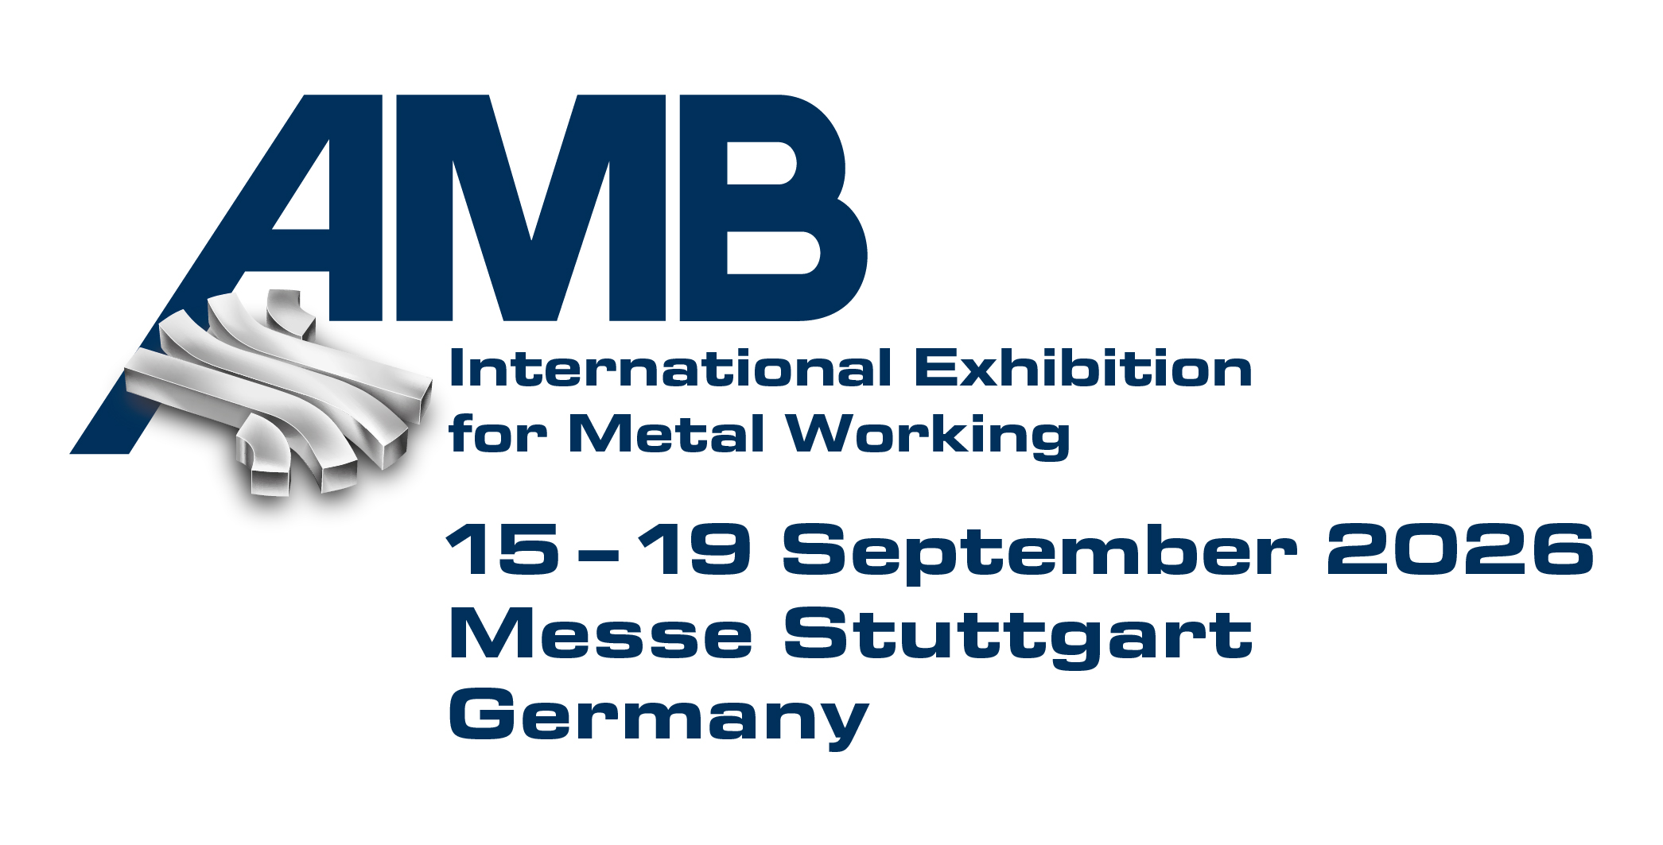PRESS RELEASE

Hufschmied Zerspanungssysteme at AMB
Tools for graphite and ultra-fine structures
Hall 3, Booth 3D64
Bobingen (Germany), August 6, 2026 – Hufschmied, a manufacturer of material- and process-optimized cutting tools, will be exhibiting at the AMB in Stuttgart from September 15 to 19, 2026. At Booth 3D64 in Hall 3 of the international metalworking exhibition, the focus this time will be on the production of EDM electrodes and high-precision embossing dies.
Many companies that manufacture graphite electrodes are already benefiting from the specialized roughing and finishing tool, the Graftor. At AMB, Hufschmied is now unveiling another graphite machining tool for the first time: the high-feed finishing tool, the Hexator. It features a process-optimized cutting geometry and a diamond coating that produces outstanding surface finishes on graphite. The tool, with its “lollipop” geometry, really shows its strengths when machining 90-degree wall surfaces.
Micro-machining
Under the name Bumble-Bi, Hufschmied Zerspanungssysteme introduces a family of micro-machining tools that includes high-feed roughing tools as well as ball-end and torus tools for roughing and finishing operations. The name is derived from the application for which the tools were originally developed: the machining of stamping dies for the cost-effective production of bipolar plates for fuel cells. The successful mass production of bipolar plate stacks depends on these stamping dies, which must have burr-free surfaces with a flatness of < 20 μm. The Bumble-Bi tools enable machining strategies with very high cutting pressure and are, of course, also suitable for any other comparable micro-machining tasks.

Available images
The following images can be downloaded from the Internet in printable quality:
https://kk.htcm.de/press-releases/hufschmied/
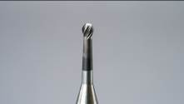Image source:  Hufschmied Zerspanungssysteme  The Hexator is a high-feed finishing tool for machining graphite. | 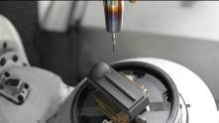Image source:  Hufschmied Zerspanungssysteme  The Hexator features a process-optimized cutting geometry and a diamond coating that produces outstanding surface finishes on graphite.
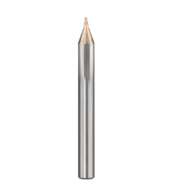
Image source:
Hufschmied Zerspanungssysteme
Bumble-Bi is Hufschmied's solution to the challenges posed by fuel cell technology in mold making.

About Hufschmied Zerspanungssysteme GmbH
Established in 1991 and headquartered in Bobingen near Augsburg, Hufschmied Zerspanungssysteme GmbH is a manufacturer of high-quality tools for machinable production and friction stir welding. By specializing at an early stage in the machining of plastics, fiberglass materials and carbon fiber, Hufschmied has become a leader in Europe in the development of solutions for new materials. The company is an established system supplier to renowned machine tool manufacturers. Tools and manufacturing process consulting from Hufschmied are particularly valued in the automotive and aerospace industries as well as in medical technology. The company is involved in numerous organizations, including Composites United Deutschland e. V. Hufschmied's manufacturing operations are located in Bobingen, Winterlingen and Sigmaringen on the Swabian Alb. Hufschmied is certified according to ISO 9001:2015 (quality management) and ISO 14001:2015 (environmental management).

Hufschmied Zerspanungssysteme GmbH – One Cut Ahead
For more information: www.hufschmied.net

Additional information:  Hufschmied Zerspanungssysteme GmbH  Marco Beigl  Edisonstrasse 11d  86399 Bobingen  Germany  Phone: +49 8234 9664-0  Telefax: +49 8234 9664-99  E-Mail: info@hufschmied.net  www.hufschmied.net | Press contact:  HighTech communications GmbH  Brigitte Basilio  Brunhamstrasse 21  81249 Munich  Germany  Phone: +49 89 500778-20  E-Mail: b.basilio@htcm.de  www.htcm.de

