FOR THE MEDIA
ASMPT SMT Solutions at
EFX Expo for Electronics Manufacturing
Solutions for intelligent
production operations
Singapore, August 5, 2026 – ASMPT SMT Solutions will exhibit at the first EFX Expo for Electronics Manufacturing in Stuttgart, Germany. From October 6 to 8, the global technology and market leader for integrated hardware and software solutions for the electronics manufacturing industry will present its latest products and services for intelligent SMT production at Booth 9D52 in Hall 9. The focus will be on innovations around the new SIPLACE V assembly platform, the DEK TQ L stencil printer, and the WORKS Software Suite for connecting and optimizing workflows on the shop floor.
“With its focus on personal interactions and networking, the EFX provides an ideal supplement to the Productronica by creating a new meeting place for electronics manufacturers every two years,” explained Bernhard Fritz, Head of Global Marketing, ASMPT SMT Solutions. “AI applications are currently changing the requirements for electronics manufacturing faster than ever before. The EFX presents an ideal platform for discussing with customers and partners how integrated hardware and software solutions help companies to respond flexibly to these developments and prepare their factories for the future.”
SIPLACE V L: Ready for demanding AI server boards
With the SIPLACE V, ASMPT has developed a new generation of placement machines that enables productivity increases of up to 30 percent under real-life conditions in several key industries while also meeting the rising requirements of modern electronics applications, such as AI server boards. It can handle large and heavy high-performance BGAs, oversized circuit boards and highly miniaturized components down to the 016008M size factor reliably, precisely, and efficiently.
At EFX, ASMPT will demonstrate with the SIPLACE V L how maximum productivity and quality can be combined with outstanding flexibility. With a compact footprint of just 1.5 × 2.4 m, the placement platform processes odd-shaped components (OSCs) up to 55 mm in height. Existing SIPLACE X feeders and even changeover tables from the SIPLACE SX can continue to be used, providing electronics manufacturers with a high level of investment protection. An enhanced Smart Pin Support, increased maximum PCB size and a flexibly interchangeable tray changer further expand application versatility and simplify adaptation to changing production requirements.
Top productivity and quality in solder paste printing
With the DEK TQ L, ASMPT will present its stencil printer for mid-size boards that has been designed from the ground up for productivity, precision and automation. It combines maximum precision (up to ±17.0 µm @ 2 cpk wet-print accuracy) with a core cycle time of only 6.5 seconds. Many automation functions increase the machine’s productivity and process reliability. The understencil cleaning system runs for a whole shift without any user assists, the Dual Access Cover makes it possible to switch out paste cartridges without having to stop the machine, and Automated Paste Transfer can transfer the paste to a new stencil completely on its own. A new mechanism cuts the time required to change squeegees by up to 20 percent. And with the DEK TQ GO, even squeegee and stencil changeovers can be fully automated in the future.
With WORKS Automation, ASMPT will show how printing processes can be automatically optimized even further. The software continuously captures and analyzes process data from the printer and the SPI system, recognizes potential improvements, and helps with intelligent and increasingly AI-supported functions to improve print quality, process stability, and productivity.
Intelligent use of data
With the WORKS Software Suite, ASMPT will showcase its integrated software platform for intelligent SMT manufacturing. It connects machines, processes and production data in real time to create total production transparency. Based on this information, users can optimize specific workflows, deploy resources more efficiently, and make decisions more quickly. The WORKS applications support all workflows on the shop floor in terms of material management, process optimization along the SMT line, and efficient personnel deployment. Thanks to open interfaces according to industry standards IPC-HERMES-9852 and IPC-CFX, users can easily integrate machines, software solutions and autonomous mobile robots (AMRs) from other manufacturers and build a coordinated manufacturing environment.

Illustrations for downloading
The following print-ready artwork is available on the internet for downloading:
https://kk.htcm.de/press-releases/asmpt/

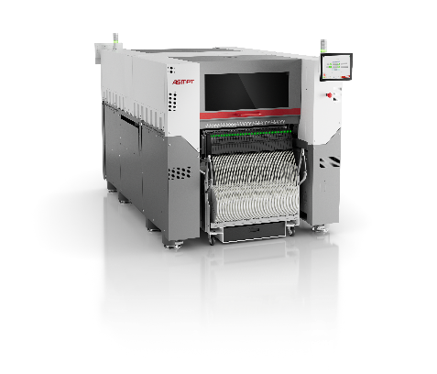 | 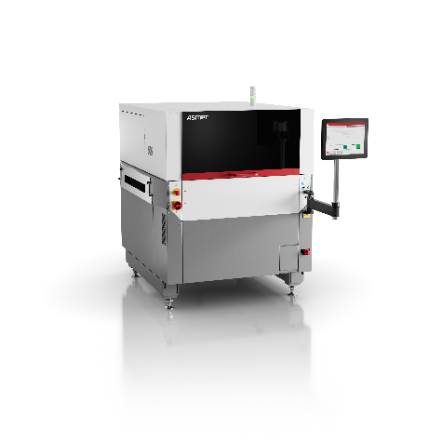
The SIPLACE V L placement platform combines high precision, productivity and flexibility.  Image credit: ASMPT | The DEK TQ L stencil printer combines maximum print quality with extensive automation features for the stable solder paste printing of mid-size boards.  Image credit: ASMPT
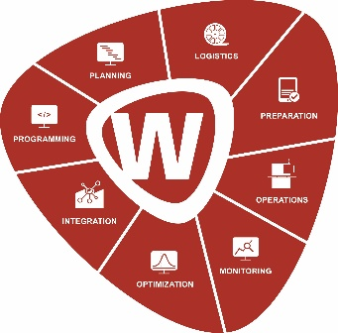

The WORKS Software Suite supports transparent and efficient SMT production operations by digitizing and connecting central workflows.

Image credit: ASMPT

About ASMPT Limited (“ASMPT”)
ASMPT Limited is a leading global supplier of hardware and software solutions for the manufacture of semiconductors and electronics. Headquartered in Singapore, ASMPT’s offerings encompass the semiconductor assembly & packaging, and SMT (surface mount technology) industries, providing various solutions that organize, assemble and package delicate electronic components into a vast range of end-user devices. ASMPT partners with customers very closely, with continuous investment in R&D helping to provide cost-effective, industry-shaping solutions that achieve higher productivity, greater reliability, and enhanced quality. ASMPT is a founding member of the Semiconductor Climate Consortium.
To learn more about ASMPT, please visit www.asmpt.com.

The ASMPT SMT Solutions segment
The mission of the SMT Solutions segment within ASMPT is to implement and support the Intelligent Factory at electronics manufacturers worldwide.
ASMPT solutions support the networking, automation, and optimization of central workflows with hardware, software and services that enable electronics manufacturers to transition to the Intelligent Factory in stages and enjoy dramatic improvements in productivity, flexibility, and quality. With its integrated open automation concept, ASMPT opens the door for its customers to economically feasible automation, entirely in accordance with their individual requirements – modular, flexible, and vendor-independent.
The product range includes hardware and software such as SIPLACE placement solutions, DEK printing solutions, inspection and storage solutions, and the WORKS Software Suite. With WORKS, ASMPT offers electronics manufacturers high-quality software for planning, controlling, analyzing and optimizing all processes on the shop floor. Maintaining close relationships with customers and technology partners is a central component of ASMPT’s strategy.
For more information about ASMPT SMT Solutions, visit smt.asmpt.com.
Media contacts:
ASMPT ROA Press Office
SMT Solutions
ASMPT SMT Singapore Pte. Ltd.
Janet Loh
Phone: +65 6877 3948
E-mail: Janet.loh@asmpt.com
Website: smt.asmpt.com

Global ASMPT Press Office
ASMPT Limited
Susanne Oswald
Rupert-Mayer-Strasse 48
81379 Munich
Germany
Tel: +49 89 20800-26439
E-mail: susanne.oswald@asmpt.com
Website: asmpt.com

