PRESS RELEASE

Würth Elektronik expands its program of coupled power inductors
Harnessing Leakage Inductance
Waldenburg (Germany), July 29, 2026 – Würth Elektronik is expanding its WE-MCRI product series with the new 1090HL variant (HL = High Leakage), a coupled inductor specifically designed to improve the performance of SEPIC, ZETA and Ćuk converters. This unique double choke takes an unconventional approach by deliberately harnessing leakage inductance, which is normally treated as a parasitic element in conventional designs. The coupled inductor enables more effective filtering for improved EMC performance with a far more compact design.
By using the molded double choke, which measures just 11 × 10 × 9 mm, ripple current reduction can be achieved with a lower inductance value. Cost and space are reduced compared with using two separate inductors. This special component also requires a smaller AC coupling capacitor, without sacrificing efficiency. This also enables a more compact design. As a molded coupled inductor, this component delivers temperature-stable and soft saturation performance.
Samples now available
Würth Elektronik, unlike other manufacturers, specifies tolerances for the coupling factor and leakage inductance. Developers can also obtain support with design and EMC-related questions. The new model in the SMT molded coupled inductor series is now available from stock with no minimum order quantity. Free samples can be requested.

Available images
The following images can be downloaded from the Internet in printable quality: https://kk.htcm.de/press-releases/wuerth/

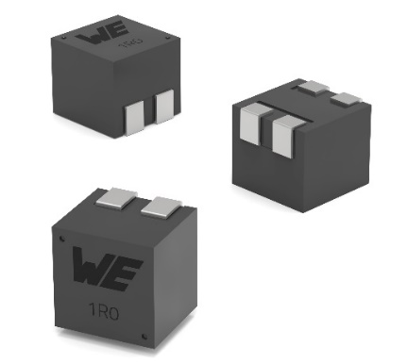
Image source: Würth Elektronik
WE-MCRI HL, a coupled inductor especially designed for SEPIC, ZETA and Ćuk converters

About the Würth Elektronik eiSos Group
Würth Elektronik eiSos Group is a manufacturer of electronic and electromechanical components for the electronics industry and a technology company that spearheads pioneering electronic solutions. Würth Elektronik eiSos is one of the largest European manufacturers of passive components and is active in 50 countries. Production sites in Europe, Asia and North America supply a growing number of customers worldwide.
The product range includes passive components, power modules, digital isolators, optoelectronics, electromechanical components, thermal management solutions, sensors and wireless modules. The portfolio is rounded off by customer-specific solutions.
The unrivaled service orientation of the company is characterized by the availability of all catalog components from stock without minimum order quantity, free samples and extensive support through technical sales staff and selection tools.
Würth Elektronik is part of the Würth Group, the global market leader in the development, production, and sale of fastening and assembly materials, and employs around 7,300 people. In 2025, the Würth Elektronik Group generated sales of 1.06 Billion Euro.
Würth Elektronik: more than you expect!
Further information at www.we-online.com

Further information:  Würth Elektronik eiSos GmbH & Co. KG  Sarah Hurst  Clarita-Bernhard-Strasse 9  81249 Munich  Germany  Phone: +49 7942 945-5186  E-mail: sarah.hurst@we-online.de  www.we-online.com | Press contact:  HighTech communications GmbH  Brigitte Basilio  Brunhamstrasse 21  81249 Munich  Germany  Phone: +49 89 500778-20  E-mail: b.basilio@htcm.de  www.htcm.de

