PRESS RELEASE
Würth Elektronik ICS introduces DC/DC converters for vehicle applications
Robust, efficient, and optimized for demanding environments
Niedernhall (Germany), July 28, 2026 – Würth Elektronik ICS is introducing a new product family of DC/DC Converters designed specifically for use in mobile machinery and commercial vehicles. With these new power converters, the company expands its portfolio of electronic power supply and onboard power distribution solutions, addressing the increasing demand for stable and efficient power management in modern vehicle architectures.
Modern vehicle and machine platforms operate with multiple voltage levels and an ever‑growing number of electronic components. Even minor deviations in voltage can lead to malfunctions such as sensor errors, unstable displays, reset control units, or starting issues. As a specialist in robust vehicle electrics and control systems, Würth Elektronik ICS understands these challenges and provides reliable solutions with its DC/DC converters.
The DC/DC converters are designed to withstand the demanding environmental conditions typical of mobile machinery and commercial vehicles. As encapsulated modules, they meet the IP67 protection rating and are designed for harsh operating conditions involving vibration and temperatures up to 85 °C. They ensure reliable voltage adaptation between different battery systems while maintaining a stable output voltage—even under dynamic load conditions. The converters integrate comprehensive protection functions, including overcurrent, overvoltage, short‑circuit, and temperature monitoring. Their high‑efficiency power conversion significantly contributes to overall system efficiency, increasing operational safety and system stability in both off‑highway and on‑road applications.
Standard solutions and custom variants
The standard modules are designed as 24/12 V buck converters for switch‑mode operation; other variants such as boost and flyback converters can be implemented at any time. The converters feature electronic overload and overtemperature protection as well as reverse‑polarity protection at the input. Depending on the variant, the input voltage range of the standard modules lies between 16 or 18 V and 32 V DC. Nominal output currents are 2, 25, or 40 A. While the 25 A and 40 A converters are designed as robust standalone modules, the 2 A version features a relay‑style design intended for direct mounting on printed circuit boards.
In addition to the standard modules, the company develops customized DC/DC converters. “Every machine is different – and every application has its own requirements for the onboard power system,” says Daniel Wilder, Product Manager for DC/DC converters. “With our new DC/DC converters, we offer both robust standard products and tailored solutions that are perfectly matched to our customers’ needs.”

Available images
The following images can be downloaded from the Internet in printable quality: https://kk.htcm.de/press-releases/wuerth-ics/

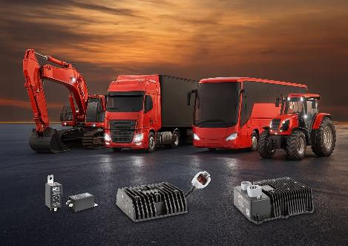
Image source: Würth Elektronik ICS

In addition to these standard DC/DC converters, Würth Elektronik ICS can also provide customised variants at short notice.

About Würth Elektronik ICS GmbH & Co. KG
Würth Elektronik ICS is a system supplier for electromechanical and electronic solutions for signal and power distribution, control, and display and operating solutions. The company’s key customers include well-known manufacturers of construction and agricultural machinery as well as commercial vehicles. Sectors such as industrial technology or renewable energies also benefit from products and services provided by ICS. The company is headquartered in Niedernhall-Waldzimmern (Germany). Further subsidiaries are located in France, Great Britain, Italy, the USA, and India.
Würth Elektronik is part of the Würth Group, the global market leader in the development, production, and sale of fastening and assembly materials, and employs around 7,300 people. In 2025, the Würth Elektronik Group generated sales of €1.06 billion.
Würth Elektronik: more than you expect!
Further info at www.we-online.com/ics

More information:  Würth Elektronik ICS GmbH & Co. KG  Sandra Herter  Gewerbepark Waldzimmern  Würthstrasse 1  74676 Niedernhall  Germany  Phone: +49 7940 9810-1503  E-mail: sandra.herter@we-online.de  www.we-online.com/ics | Press contact:  HighTech communications GmbH  Marcus Planckh  Brunhamstrasse 21  81249 Munich  Germany  Phone: +49 89 500778-22  E-mail: m.planckh@htcm.de  www.htcm.de

