

NEWS RELEASE

For Release: IMMEDIATELY With Art: Digital Images
Editorial Michael McCue OPEN MIND Alan Levine
Contact: McCue & Associates LLC Contact: OPEN MIND Technologies USA, Inc.
978-733-1353 339-225-4557 mmccue@mccueassociates.com alan.levine@openmind-tech.com

OPEN MIND to Highlight hyperMILL® 2026 CAD/CAM Software Suite at IMTS 2026
New CAM Strategies and Programming Enhancements Deliver Greater Accuracy,
Reliability and Efficiency
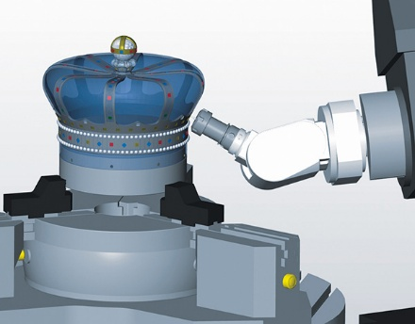
NEEDHAM, MA U.S.A. (June 15, 2026) – OPEN MIND Technologies, a leading developer of CAD/CAM software solutions worldwide, announced it will highlight the latest hyperMILL® 2026 CAD/CAM Software Suite for machining, additive and hybrid applications at the International Manufacturing Technology Show (IMTS) Booth #133351 located in the Software Sector, East Building at McCormick Place in Chicago, IL from September 14 – 19, 2026.
OPEN MIND will be showcasing the recently introduced hyperMILL® 2026, featuring a broad range of new and enhanced machining strategies and programming capabilities designed to increase programming speed, machining reliability and surface quality. The latest software suite delivers significant advancements for 2.5D, 3D, precision 5-axis and mill/turn machining applications, enabling manufacturers to achieve greater productivity and process control and many partner booths.
Angle head support in hyperMILL® and hyperMILL® VIRTUAL Machining enables reliable programming and verification of angle head machining operations.
Attendees visiting OPEN MIND at IMTS 2026 will be able to see tutorial demonstrations of hyperMILL® 2026 technologies and learn how the latest CAD/CAM innovations can improve productivity, process reliability and machining performance across a wide range of manufacturing applications. Unique parts made using hyperMILL® will also be on display in the booth.
New and Enhanced Finishing Technologies
hyperMILL® 2026 introduces major advancements in Rest Machining technology that optimize toolpaths and create smoother machining transitions by automatically detecting rest material while accounting for clearance and feed specifications. The 5-axis Rest Machining strategy has been completely redesigned with new calculation algorithms for “Z-Level,” “Parallel” and “Normal” machining strategies, ensuring precise and reliable machining of complex geometries.
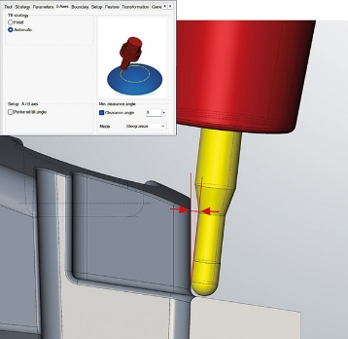
Further improvements include optimized 5-axis cutter orientation determination and enhanced collision avoidance for smoother simultaneous movements. A new “Minimum Clearance Angle” option gives programmers even greater tool control by ensuring machining is performed with a defined clearance angle between the tool shank and workpiece.
Reliable 5-axis machining with defined clearance angle between the tool chank and workpiece.
For more reliable deburring of cross holes and internal threads, a newly designed “Hole Brush” tool improves the “Hole Brushing” strategy. New capabilities automatically alternate spindle rotation direction during multiple brushing passes to further improve process reliability. In addition, both the 5-axis Deburring and 5-axis Hole Deburring strategies now automatically optimize contour sequences and milling directions, significantly reducing programming time.
When performing 5-axis multi-blade point milling, hyperMILL® 2026 delivers more robust toolpaths and smoother machine movements for complex impeller and blisk geometries. The completely redesigned camberline mode for tool orientation determination now supports additional applications including fuel pump and inducer geometries.
A new “2D Hale Machining” strategy produces flawless surfaces without processing marks across the sealing direction, making it ideal for scratch-free finishing applications such as semiconductor and watch manufacturing. The strategy provides an alternative to conventional milling because material removal occurs without active spindle speed while the spindle axis continuously aligns the tool edge to the contour. Hale Machining is currently available for machines equipped with Siemens controls.
Expanded Programming and Automation Capabilities
Programming in hyperMILL® 2026 has also been significantly enhanced with new capabilities for complex machining applications. For the first time in hyperMILL® and hyperMILL® VIRTUAL Machining, programmers can easily program right-angle heads in hyperMILL® TOOL Builder while avoiding costly collisions through detailed simulation and collision tracking.
New tool types with complex geometries can now be created more quickly and reliably using enhanced automation features in TOOL Builder. New tool types include Hole Brush, Hale Tool, Indexable Cutter with Shoulder Mill Inserts, Indexable Cutter with Face Mill Inserts, Helical Thread Drill/Mill Cutter and Front/Back Chamfered Cutter.
The new “Minimum Clearance Angle” capability in hyperMILL® “5-axis Automatic Mode” also further simplifies reliable 5-axis programming by automatically determining optimal tool positions and efficiently utilizing indexed and simultaneous machine movements based on analysis of the complete toolpath.
Also new in hyperMILL® 2026, the enhanced “CAM Plan Turning” strategy for turned and mill-turned parts significantly reduces programming time and increases accuracy. CAM Plan Turning automatically generates production-ready contours, recognizes machining features and provides the required machining areas for NC programming, allowing programmers to consistently enrich turning contours with all relevant manufacturing information.
“OPEN MIND continuously invests in research and development based on customer feedback and evolving market requirements,” said Alan Levine, Managing Director of OPEN MIND Technologies USA, Inc. “With hyperMILL® 2026, we are providing customers with powerful new programming technologies, enhanced finishing strategies and improved automation capabilities that significantly increase machining efficiency, accuracy and reliability.”
For more information about hyperMILL® 2026, visit https://www.openmind-tech.com/en-us/.
To see hyperMILL® 2026 Tutorial Videos, click here.
Follow OPEN MIND on LinkedIn, Facebook, YouTube, Instagram.
About OPEN MIND Technologies AG
OPEN MIND Technologies AG is one of the world’s leading developers of powerful CAD/CAM software solutions for machine and controller-independent programming. OPEN MIND develops optimized CAD/CAM solutions that include innovative and unique features that can deliver significantly higher performance in both programming and machining. hyperMILL® is a completely modular CAD/CAM solution that provides state-of-the-art CAM technologies on its own CAD platform: from 2.5D, 3D and 5-axis machining as well as turning strategies and solutions for additive manufacturing, HSC and HPC machining. Whether automation, simulation or virtual machine, trendsetting technologies expand the product range and enable continuous digital process chains. Special applications, seamless interaction with all popular CAD solutions and exceptional customer service rounds out the company’s products and capabilities.
According to the "NC Market Analysis Report 2025" compiled by CIMdata, hyperMILL® is a leading, worldwide CAD/CAM solution. Innovative CAD/CAM technologies fulfill the highest demands in the automotive, tool and mold manufacturing, production machining, medical, job shops, energy, semiconductor and aerospace industries. OPEN MIND is a Mensch und Maschine company and has subsidiaries and qualified sales partners on all continents. You can find more information at https://www.openmind-tech.com/en-us.
# # # # #

