PRESS RELEASE
How much artificial intelligence (AI) can Europe's hardware support?
GITEX AI Europe 2026: In the Age of AI, Every Watt Counts
Waldenburg/Berlin (Germany), July 10, 2026 – The public debate on artificial intelligence tends to focus on models, parameters, and use cases. At GITEX AI Europe 2026 (Messe Berlin, June 30–July 1, 2026), the Würth Elektronik eiSos Group shifted attention to a more fundamental question: Is the physical infrastructure sufficient to meet these expectations? On stage, Alexander Gerfer, Chief Technology Officer (CTO) of the group, discussed with moderator Massimo Marioni, form Fortune editor, where the real limits to scaling lie. Their conclusion: the bottleneck is not software, but power supply and the components that make it possible.
According to the International Energy Agency’s “Energy and AI” analysis, data centers worldwide consumed approximately 415 terawatt-hours in 2024, accounting for about 1.5% of global electricity demand. By 2030, that figure is expected to nearly double to about 945 terawatt-hours, or just under 3% of the global electricity demand, more than Japan’s total current consumption. Artificial intelligence is a major driver of this trend, although the energy impact of individual queries varies widely: while a simple text prompt consumes comparatively little power, agent-based and reasoning-intensive applications require significantly more computing power.
Gerfer made it clear that this gap cannot be closed simply by expanding generation capacity. New power plants and grid infrastructure take years to build, but demand is growing month by month. That makes hardware-level efficiency—as close to the computing chip as possible—critical. According to an estimate by Würth Elektronik based on IEA (International Energy Agency) data, even a 1% reduction in energy consumption during power conversion in a data center is equivalent to the electricity supply for two to four million European households. Gerfer used this comparison to show why the biggest lever often lies in components that receive little public attention. The spotlight is usually on the “brain” of AI—the models and the GPUs (graphics processing units). But a brain without circulation is just inert silicon. It is the power supply, the inductors, and the capacitors that deliver power to where the computing takes place. “The most important innovations are often the ones no one sees,” said the CTO.
Efficiency starts with the component
That is exactly where the manufacturer’s product portfolio comes into play. The components support switching frequencies of up to 40 megahertz with significantly reduced losses. The vertical power delivery shifts the conversion directly above or below the chip, minimizing parasitic losses, while integrated passive components combine inductors and filters into compact units designed for server racks with power loads exceeding 100 kilowatts.
Edge AI distributes the load
Not every computing task belongs in a large, centralized data center. Moving intelligence closer to where data is generated—in factories, vehicles, medical devices, and connected infrastructure—reduces latency and energy consumption by eliminating unnecessary trips to the cloud. At the same time, it strengthens the protection of sensitive data. For these applications, Würth Elektronik provides compact power supply modules, solutions for electromagnetic compatibility and shielding, wireless modules for BLE, Wi-Fi, and LoRa, fanless components for thermal management, and sensor technology for signal processing.
According to Gerfer, progress must happen in three areas at once: better components in the form of advanced passive and power electronic components, better chips with optimized architectures, and better models enabled by more efficient algorithms. No single company or technology can tackle this challenge on its own. Würth Elektronik sees itself as a partner that combines component expertise with system innovation and works closely with chip manufacturers, AI developers, and data center planners.
Europe's Location Question
According to another conclusion from the panel, Europe lags behind in both AI adoption and, above all, available computing capacity. Data from the Brussels Competition Report show that the European Union accounts for only about 5% of global computing capacity, compared with about 74% for the United States and 14% for China. Gerfer believes this gap in models can be narrowed; the decisive factor lies elsewhere. Europe’s real strength, he argued, is industrial AI: predictive maintenance, autonomous factories, smart grids, and robotics. In these fields, power electronics, precision manufacturing, and decades of accumulated industrial data combined to create a distinctive advantage that few other regions can match. Those who provide the most efficient physical building blocks for these applications will become indispensable to the global AI supply chain, regardless of who trains the models.
The potential is enormous. According to an analysis by Implement Consulting, widespread AI adoption could boost the EU’s economic output by about 8%—or 1.2 to 1.4 trillion euros—over ten years. A broad consensus from the discussion was that Europe’s position in the global AI race will also depend on an efficient, sovereign infrastructure built on European expertise in components. Technology should not only create economic value, but also help address societal challenges. In that sense, building a sustainable AI infrastructure is also a matter of responsibility. “The task is not to apply old solutions to new problems, but to rethink the power supply from the ground up,” Gerfer concluded.

Available images
The following images can be downloaded from the Internet in printable quality: https://kk.htcm.de/press-releases/wuerth/
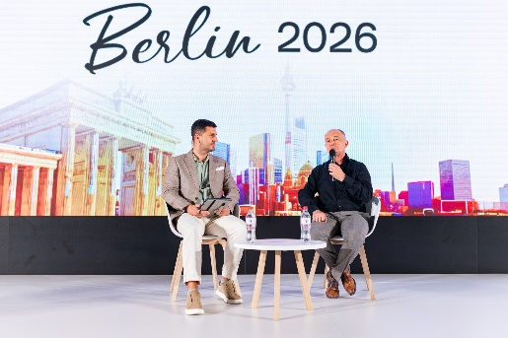  Image source: Deliman Cristian  At GITEX AI Europe 2026, Alexander Gerfer, CTO of the Würth Elektronik eiSos Group (right), discussed with moderator Massimo Marioni, formerly an editor at Fortune, where the real limits of artificial intelligence development lie. | 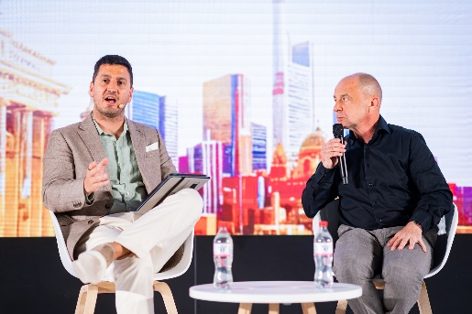  Image source: Deliman Cristian  Massimo and Gerfer agree: The limits to expansion lie in the energy supply and the underlying components.

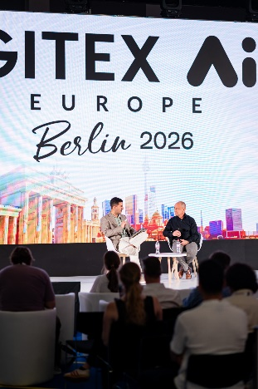Image source:  Deliman Cristian  Gerfer (right): “The most important innovations are often the ones no one sees.” | 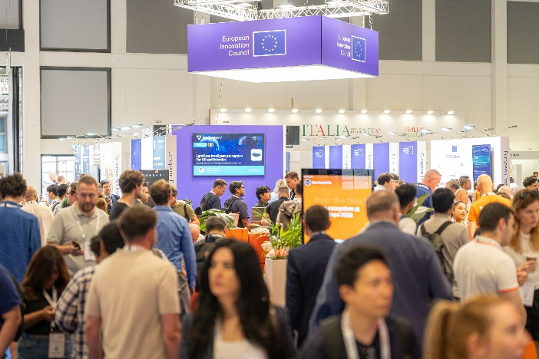  Image source:  Lights in Motion  GITEX AI Europe 2026, a tech and startup event, at the Berlin Exhibition Grounds

About the Würth Elektronik eiSos Group
Würth Elektronik eiSos Group is a manufacturer of electronic and electromechanical components for the electronics industry and a technology company that spearheads pioneering electronic solutions. Würth Elektronik eiSos is one of the largest European manufacturers of passive components and is active in 50 countries. Production sites in Europe, Asia and North America supply a growing number of customers worldwide.
The product range includes passive components, power modules, digital isolators, optoelectronics, electromechanical components, thermal management solutions, sensors and wireless modules. The portfolio is rounded off by customer-specific solutions.
The unrivaled service orientation of the company is characterized by the availability of all catalog components from stock without minimum order quantity, free samples and extensive support through technical sales staff and selection tools.
Würth Elektronik is part of the Würth Group, the global market leader in the development, production, and sale of fastening and assembly materials, and employs around 7,300 people. In 2025, the Würth Elektronik Group generated sales of 1.06 Billion Euro.
Würth Elektronik: more than you expect!
Further information at www.we-online.com

Further information:  Würth Elektronik eiSos GmbH & Co. KG  Sarah Hurst  Clarita-Bernhard-Strasse 9  81249 Munich  Germany  Phone: +49 7942 945-5186  E-mail: sarah.hurst@we-online.de  www.we-online.com | Press contact:  HighTech communications GmbH  Brigitte Basilio  Brunhamstrasse 21  81249 Munich  Germany  Phone: +49 89 500778-20  E-mail: b.basilio@htcm.de  www.htcm.de

