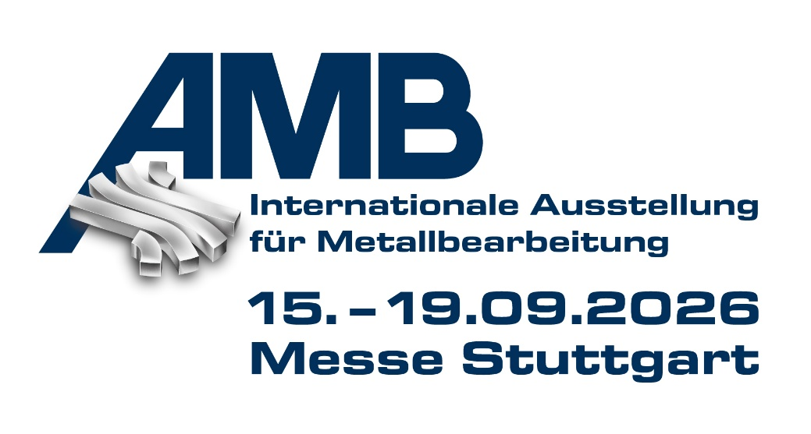PRESS RELEASE
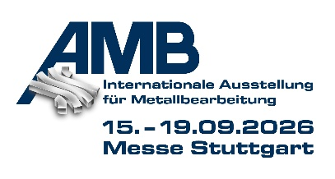
OPEN MIND and Hummingbird at AMB
CAM and MES for More Efficient Manufacturing
Hall 2, Booth 2B21
Wessling (Germany), July 6, 2026 – OPEN MIND Technologies AG will be exhibiting at AMB in Stuttgart from September 15–19, 2026. At Booth 2B21 in Hall 2 of the international metalworking exhibition, the company will present the latest enhancements to the hyperMILL® CAD/CAM suite as well as the Hummingbird Manufacturing Execution System.
Among the new features in hyperMILL® is 2D hale machining, also known as contour planing. This is supported by both machining strategies and simulation to enable scratch-free surface finishes. It is suitable, for example, for sealing surfaces in battery manufacturing. Also on display at AMB are enhancements to the hyperMILL® TURNING Solutions, which simplify the programming of turning programs and ensure support for new, complex turret-type turning during collision checking.
Deburring Feature Package
Burrs in hard-to-reach areas have often required significant effort during manual post-processing. With three efficient strategies for hole brushing, hole deburring, and component edge deburring, hyperMILL® offers a comprehensive solution. All strategies can be executed as both 3-axis and 5-axis machining and ensure burr-free part edges directly on the machine.
hyperMILL® INTELLIGENCE
Under the term “hyperMILL® INTELLIGENCE,” OPEN MIND presents its concept for effectively combining human expertise, smart automation, digital optimization, and artificial intelligence. In CAM programming, rule-based automation, proven logic, and access to company-specific knowledge deliver consistent, transparent results. OPEN MIND also uses AI to analyze data, identify patterns, and make existing expertise available more quickly.
Tool Management in MES and CAM
Also on show will be Hummingbird MES. This modular suite consists of four main components: planning and control, machine data acquisition (MDE), CAM/CNC integration, and tool logistics. Thanks to the seamless integration of OPEN MIND’s CAD/CAM suite and MES, tool management also offers significant advantages. Centralized tool management saves time and money by streamlining work and making tool data available company-wide.
At its booth at AMB, OPEN MIND will present a selection of workpieces machined with hyperMILL® from various industries as practical examples.

Available Image Material
The following images are available for download in print-ready format on the Internet:
https://kk.htcm.de/press-releases/open-mind/
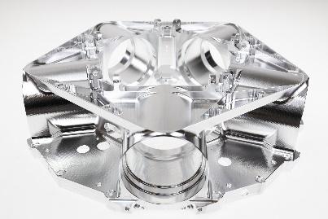  Source: OPEN MIND  OPEN MIND is showcasing a series of complex workpieces produced using hyperMILL® as illustrative examples at AMB. Here is a propeller hub. | 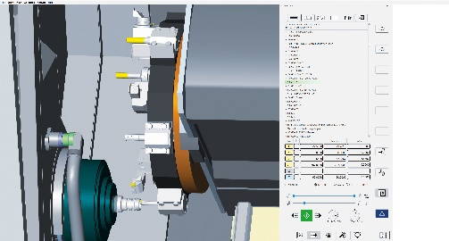  Source: OPEN MIND  hyperMILL® TURNING Solutions: accurate simulation and reliable collision detection for complex turret configurations.

About OPEN MIND Technologies AG
OPEN MIND Technologies AG is one of the world’s leading developers of powerful CAD/CAM solutions for machine and controller-independent programming.
OPEN MIND develops optimized CAD/CAM solutions that include innovative and unique features that can deliver significantly higher performance in both programming and machining.
hyperMILL® is a completely modular CAD/CAM solution that provides state-of-the-art CAM technologies on its own CAD platform: from 2.5D, 3D and 5-axis machining as well as turning strategies and solutions for additive manufacturing, HSC and HPC machining. Whether automation, simulation or virtual machine – trendsetting technologies expand the product range and enable continuous digital process chains. Special applications, seamless interaction with all popular CAD solutions and exceptional customer service rounds out the company’s products and capabilities.
According to the “NC Market Analysis Report 2026” compiled by CIMdata, hyperMILL® is a leading, worldwide CAD/CAM solution. Innovative CAD/CAM technologies fulfill the highest demands in aerospace, automotive, tool and mold manufacturing, production machining, medical, job shops, energy and semiconductor industries.
OPEN MIND's majority stake in manufacturing execution system (MES) developer Hummingbird expands the CAD/CAM manufacturer's product portfolio and enhances the range of connected digitalized manufacturing technologies.
OPEN MIND is a Mensch und Maschine company and has subsidiaries and qualified sales partners on all continents.
You can find more information at www.openmind-tech.com.

OPEN MIND Technologies UK Ltd., Oxford
Unit 3
Bicester Business Park
Telford Road
Bicester
Oxfordshire OX26 4LN
England
Phone: +44 1869 290 003
Fax: +44 1869 369 429
E-mail: Info.UK@openmind-tech.com

OPEN MIND Technologies USA, Inc.
1492 Highland Avenue, Unit 3
Needham MA 02492
USA
Phone: +1 339 225 4557 office
Phone: +1 888 516 1232 x0 toll-free
Fax: +1 270 912 5822
E-mail: Info.Americas@openmind-tech.com

OPEN MIND Technologies Asia Pacific Pte Ltd
MOVA Building, 22 Jalan Kilang #03-00
Singapore 159419
Phone: +65 6742 95-56
E-mail. Info.Asia@openmind-tech.com

OPEN MIND CADCAM Technologies India Private Ltd
No.610 & 611, 6th Floor, ‘B’ Wing, No.6, Mittal Tower
M.G. Road, Bangalore
560001, Karnataka
Phone: +91 80 2676 6999
E-mail: Info.India@openmind-tech.com

Head office:
OPEN MIND Technologies AG, Argelsrieder Feld 5, 82234 Wessling, Germany
Tel.: (+49-8153) 933-500, Fax: (+49-8153) 933-501
E-mail: Info@openmind-tech.com, website: www.openmind-tech.com

Press contact:
HighTech communications GmbH
Brigitte Basilio
Brunhamstrasse 21
81249 Munich
Germany
Tel.: (+49-89) 500778-20
E-mail: b.basilio@htcm.de
Website: www.htcm.de

