PRESS RELEASE

Würth Elektronik ICS presents the Splitter C2-PE4
Robust solution for permanently reliable ground connections

Niedernhall (Germany), 30 June 2026 – Loose or corroded ground connections repeatedly cause problems in commercial vehicles and mobile machines. With the Splitter C2-PE4, Würth Elektronik ICS offers an easy way to connect a wide range of ground signals at a single contact point with the vehicle chassis. Instead of complex wiring and multiple grounding points, this compact module enables all ground connections to be brought together at one location and at the same level, ensuring clean and reliable power distribution.
Corrosion, vibration, and wiring errors are the most common causes of loose and unstable ground connections in vehicles. The PCB-based splitters from Würth Elektronik ICS help reduce or even eliminate these issues. The specialist for power distribution system solutions in mobile machines and commercial vehicles focuses on reducing chassis interfaces, particularly by eliminating small screw connections and minimising splices in the wiring harness. The Splitter C2-PE4 is also an optimal solution when no metal chassis is available for ground signal collection − for example, when manufacturers of electric vehicles opt for non-metallic chassis to reduce weight.
The new Splitter C2-PE4 allows the connection of up to 70 signal lines and up to four power lines. Each pin can handle up to 15 A, and the Splitter is designed for continuous currents of up to 200 A. It can be used for both GND and +BATT signal distribution. Würth Elektronik ICS also offers customised solutions tailored to the requirements of vehicle manufacturers.
With protection classes IP66 and IP69K, the Splitter C2-PE4 is designed to be extremely robust and durable. Easy installation and maintenance make this 155 × 115 × 45 mm module a long-term cost-saving solution. With this PCB-based module, Würth Elektronik ICS enables the simplification of vehicle electrical systems and the reduction of wiring harnesses. At the same time, avoiding issues caused by loose or corroded ground connections increases the safety of mobile machines and commercial vehicles.

Available images
The following images can be downloaded from the Internet in printable quality: https://kk.htcm.de/press-releases/wuerth-ics/
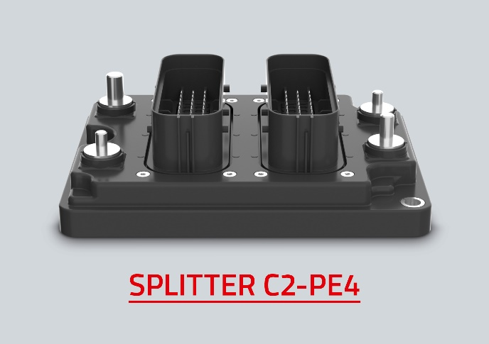
Bildquelle: Würth Elektronik ICS
The Ground Splitter C2-PE4 from Würth Elektronik ICS is the new standard solution for integrating ground connections and serves as a starting point for customised solutions.

About Würth Elektronik ICS GmbH & Co. KG
Würth Elektronik ICS is a system supplier for electromechanical and electronic solutions for signal and power distribution, control, and display and operating solutions. The company's key customers include well-known manufacturers of construction and agricultural machinery as well as commercial vehicles. Sectors such as industrial technology or renewable energies also benefit from products and services provided by ICS. The company is headquartered in Niedernhall-Waldzimmern (Germany). Further subsidiaries are located in France, Great Britain, Italy, the USA, and India.
Würth Elektronik is part of the Würth Group, the global market leader in the development, production and sale of fastening and assembly materials, and employs 7,300 people. In 2025, the Würth Elektronik Group generated sales of EUR 1.06 billion.
Würth Elektronik: more than you expect!
Further info at www.we-online.com/ics

More information:  Würth Elektronik ICS GmbH & Co. KG  Sandra Herter  Gewerbepark Waldzimmern  Würthstraße 1  74676 Niedernhall  Telefon: +49 7940 9810-1503  E-Mail: sandra.herter@we-online.de  www.we-online.de/ics | Press contact:  HighTech communications GmbH  Marcus Planckh  Brunhamstraße 21  81249 München  Telefon: +49 89 500778-22  E-Mail: m.planckh@htcm.de  www.htcm.de

