FOR THE MEDIA
ASMPT at NEPCON Thailand 2026
SIPLACE V draws strong interest at NEPCON Thailand
Singapore, June 30, 2026 – ASMPT, the global market and technology leader in integrated hardware and software solutions for electronics manufacturing, looks back on a highly successful participation at NEPCON Thailand 2026. A key highlight was the first presentation of the new SIPLACE V placement platform in Thailand, which attracted strong interest from electronics manufacturers. In numerous discussions at the booth, ASMPT demonstrated how intelligent hardware, software and AI-powered applications work together to support the intelligent factory and help manufacturers improve productivity, quality and operational efficiency.
“The SIPLACE V is truly a game changer in SMT manufacturing. The platform combines high speed, precision and flexibility while remaining fully compatible with existing ASMPT hardware and software environments, making upgrades and capacity expansions straightforward for our customers,” explains Sopchock Yuttawong, General Manager at ASMPT SMT Solutions Thailand. “The strong response confirms that manufacturers are increasingly looking for integrated solutions that combine automation, data transparency and AI-driven optimization.”
SIPLACE V demonstrates productivity potential
Throughout the exhibition, the SIPLACE V platform attracted considerable attention from visitors looking to improve productivity, quality and flexibility in their SMT production environment. Featuring an innovative machine frame, highly efficient linear drives and enhanced measurement systems, the platform delivers both higher acceleration and greater placement accuracy.
The SIPLACE V supports single- and dual-lane configurations, Smart Pin Support and the high-density placement of complex boards. Independent field tests conducted under real-world production conditions have demonstrated productivity gains of up to 30 percent in key electronics manufacturing sectors, including automotive and industrial electronics, consumer electronics, smartphones, and IT and network infrastructure.
Beyond hardware: intelligent factory solutions
While the SIPLACE V platform was the main attraction at the ASMPT booth, visitors also showed strong interest in ASMPT’s software and intelligent factory solutions. Demonstrations of the WORKS Software Suite and SMT Analytics provided practical insights into data-driven manufacturing and line-wide process optimization.
Discussions focused particularly on AI infrastructure, AI server applications and opportunities to increase productivity through intelligent automation. Visitors were particularly interested in how AI-powered analytics transform production data into actionable insights.
By collecting and analyzing data across the SMT line, ASMPT solutions help manufacturers identify optimization potential, improve process stability and make better-informed decisions.
Intelligent closed-loop nozzle management
Another highlight at the ASMPT booth was the closed-loop nozzle management solution. Using RFID-equipped Smart Nozzles and intelligent condition monitoring, the system automatically controls maintenance, cleaning and nozzle replacement based on actual operating conditions.
Combined with the Factory Equipment Center and the Smart Nozzle Station, the solution helps improve process stability, increase equipment availability and reduce unplanned downtime.
Positive momentum for ASMPT
The strong response from visitors at NEPCON Thailand reflects broader developments in the electronics manufacturing industry also in Thailand. Driven by growing market potential, substantial investments in AI infrastructure and AI server applications, demand for highly productive and intelligent manufacturing solutions continues to grow.

Illustrations for downloading
The following print-ready artwork is available on the internet for downloading:
https://kk.htcm.de/press-releases/asmpt/

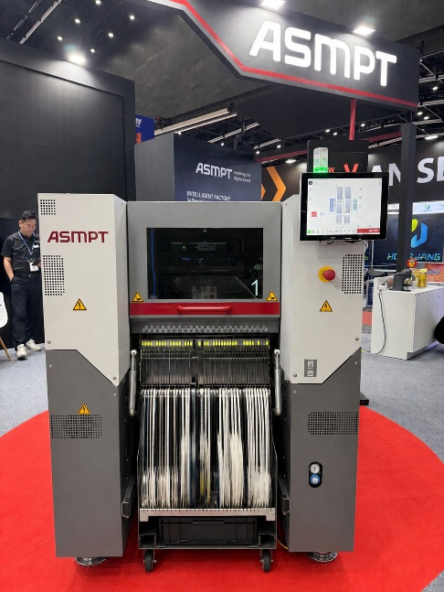 | 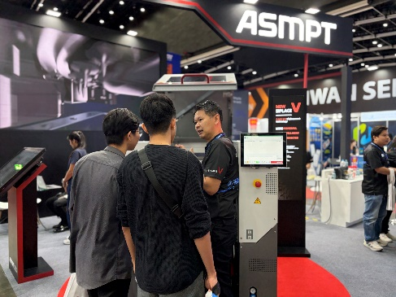
The new SIPLACE V platform handles the entire component spectrum – from ultra-small 016008M chips to large-format and challenging odd-shaped components.  Image credit: ASMPT | The SIPLACE V platform attracted strong interest from visitors throughout NEPCON Thailand 2026.  Image credit: ASMPT
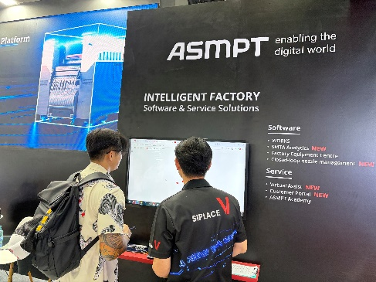 | 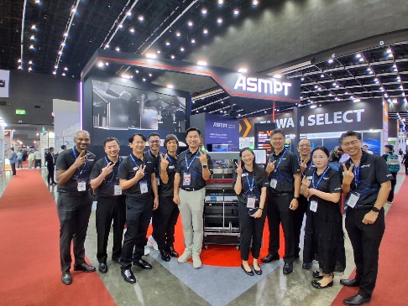
The WORKS Software Suite and SMT Analytics provided visitors with practical insights into ASMPT’s intelligent factory concept.  Image credit: ASMPT | The ASMPT team looks back on a successful NEPCON Thailand 2026, marked by strong interest in the SIPLACE V platform and intelligent factory solutions  Image credit: ASMPT

About ASMPT Limited (“ASMPT”)
ASMPT Limited is a leading global supplier of hardware and software solutions for the manufacture of semiconductors and electronics. Headquartered in Singapore, ASMPT’s offerings encompass the semiconductor assembly & packaging, and SMT (surface mount technology) industries, ranging from wafer deposition to the various solutions that organize, assemble and package delicate electronic components into a vast range of end-user devices. ASMPT partners with customers very closely, with continuous investments in R&D helping to provide cost-effective, industry-shaping solutions that achieve higher productivity, greater reliability, and enhanced quality. ASMPT is a founding member of the Semiconductor Climate Consortium.
To learn more about ASMPT, please visit www.asmpt.com.

The ASMPT SMT Solutions segment
The mission of the SMT Solutions segment within ASMPT is to implement and support the Intelligent Factory at electronics manufacturers worldwide.
ASMPT solutions support the networking, automation, and optimization of central workflows with hardware, software and services that enable electronics manufacturers to transition to the Intelligent Factory in stages and enjoy dramatic improvements in productivity, flexibility, and quality. With its integrated open automation concept, ASMPT opens the door for its customers to economically feasible automation, entirely in accordance with their individual requirements – modular, flexible, and vendor-independent.
The product range includes hardware and software such as SIPLACE placement solutions, DEK printing solutions, inspection and storage solutions, and the WORKS Software Suite. With WORKS, ASMPT offers electronics manufacturers high-quality software for planning, controlling, analyzing and optimizing all processes on the shop floor. Maintaining close relationships with customers and technology partners is a central component of ASMPT’s strategy.
For more information about ASMPT SMT Solutions, visit smt.asmpt.com.
Media contacts:
ASMPT ROA Press Office
SMT Solutions
ASMPT SMT Singapore Pte. Ltd.
Janet Loh
Phone: +65 6877 3948
E-mail: Janet.loh@asmpt.com
Website: smt.asmpt.com

Global ASMPT Press Office
ASMPT Limited
Susanne Oswald
Rupert-Mayer-Strasse 48
81379 Munich
Germany
Phone: +49 89 20800-26439
E-Mail: susanne.oswald@asmpt.com
Website: asmpt.com

