Press release
A New Approach from noris network, KEEQuant, and Collaider
Quantum-Sovereign AI – from critical risk to trusted solution
KEEQuant, Collaider and noris network demonstrate a sovereign AI model that combines quantum-secured communication, trusted German infrastructure and application-ready AI for confidentiality-sensitive use cases.
Fürth / Nuremberg (Germany), June 19, 2026 – Many organizations want to use AI for real work, but stop short when sensitive information has to leave their environment under a conventional cloud model. Questions around confidentiality, governance and long-term exposure often make ChatGPT-like tools difficult to justify for security-sensitive workflows.
KEEQuant, Collaider and noris network have now demonstrated a different approach: a sovereign AI architecture that combines trusted German infrastructure, specialized AI applications and quantum-secured communication. The demonstrator shows how advanced AI can become more usable for organizations that previously could not risk it in sensitive contexts. This is especially relevant for public-sector organizations, critical infrastructure operators, healthcare providers, financial institutions, professional-secrecy environments and enterprises working with confidential data or valuable intellectual property.
Many of these organizations do not want to operate advanced AI fully on site, yet also cannot rely on a standard public-cloud trust model for sensitive work. The joint demonstrator addresses that gap by bringing AI closer to the user in a more controlled operating model. Instead of forcing a choice between no AI at all and a deployment model they are reluctant to use, it provides a stronger basis for practical AI adoption in environments where trust, accountability and infrastructure locality matter.
“For many organizations, AI has not been blocked by lack of interest, but by lack of a model they can responsibly use for sensitive work,” said Imran Khan, Managing Director at KEEQuant. “This demonstrator shows that advanced AI can be delivered nearby, in trusted infrastructure, with quantum-secured communication as a real enabler.”
KEEQuant contributed the quantum-secured communication and key-management layer at the foundation of the demonstrator. In the implemented setup, via quantum key distribution-generated keys were fed into KEEQuant’s key-management system and used to provision the protected access path between a browser-based client and the server-side large language model (LLM). This translates quantum-safe communication from an abstract infrastructure promise into a concrete AI access architecture.
Collaider contributed the application-layer perspective, showing how this architecture can support specialized AI use cases rather than a generic chatbot scenario alone. That matters because sensitive organizations rarely adopt AI as a stand-alone novelty. They adopt it when it can be embedded into real workflows, guarded contexts and domain-specific applications.
“At the application layer, the question is not simply whether AI works, but whether it can be used in a way that respects how organizations actually handle sensitive processes and information,” said Michael Klieber, Managing Director & Co-Founder at Collaider. “This demonstrator shows how advanced AI can be brought into that reality more credibly.”
noris network contributed the infrastructure and operating-environment perspective required to move such a model beyond a purely technical exercise. As an IT service provider for organizations with demanding requirements in security and availability — including sectors such as banking, insurance, public administration, critical infrastructure and healthcare — noris brings the operational credibility needed to host advanced AI workloads in a controlled environment. Certifications and frameworks such as ISO 27001, BSI Grundschutz, BSI C5 and EN 50600 further underline that positioning. At the same time, noris is expanding AI-ready infrastructure in Germany, strengthening the practical outlook for sovereign AI services that combine modern compute capacity with strong security and availability requirements.
“This project builds on a much longer shared history,” said Joachim Astel, Founder and CRO at noris network. “We already worked together in earlier quantum-cryptography initiatives, including the HQS project, and it is exciting to see that foundation now evolve into a practical AI architecture. Organizations in security-sensitive sectors need more than access to a model. They need an operating environment they can trust.”
The partners see the demonstrator as a basis for future sovereign AI offerings aimed at organizations that need modern AI capability without giving up control over where workloads run and how sensitive access paths are secured. The work does not replace governance or compliance processes on its own, but it addresses one of the central blockers that has kept many organizations from using generative AI more broadly: the absence of a credible security and infrastructure model for sensitive use cases.

______________________________________________________________
Available images
The following images are available for download in printable format at:
http://www.htcm.de/kk/noris

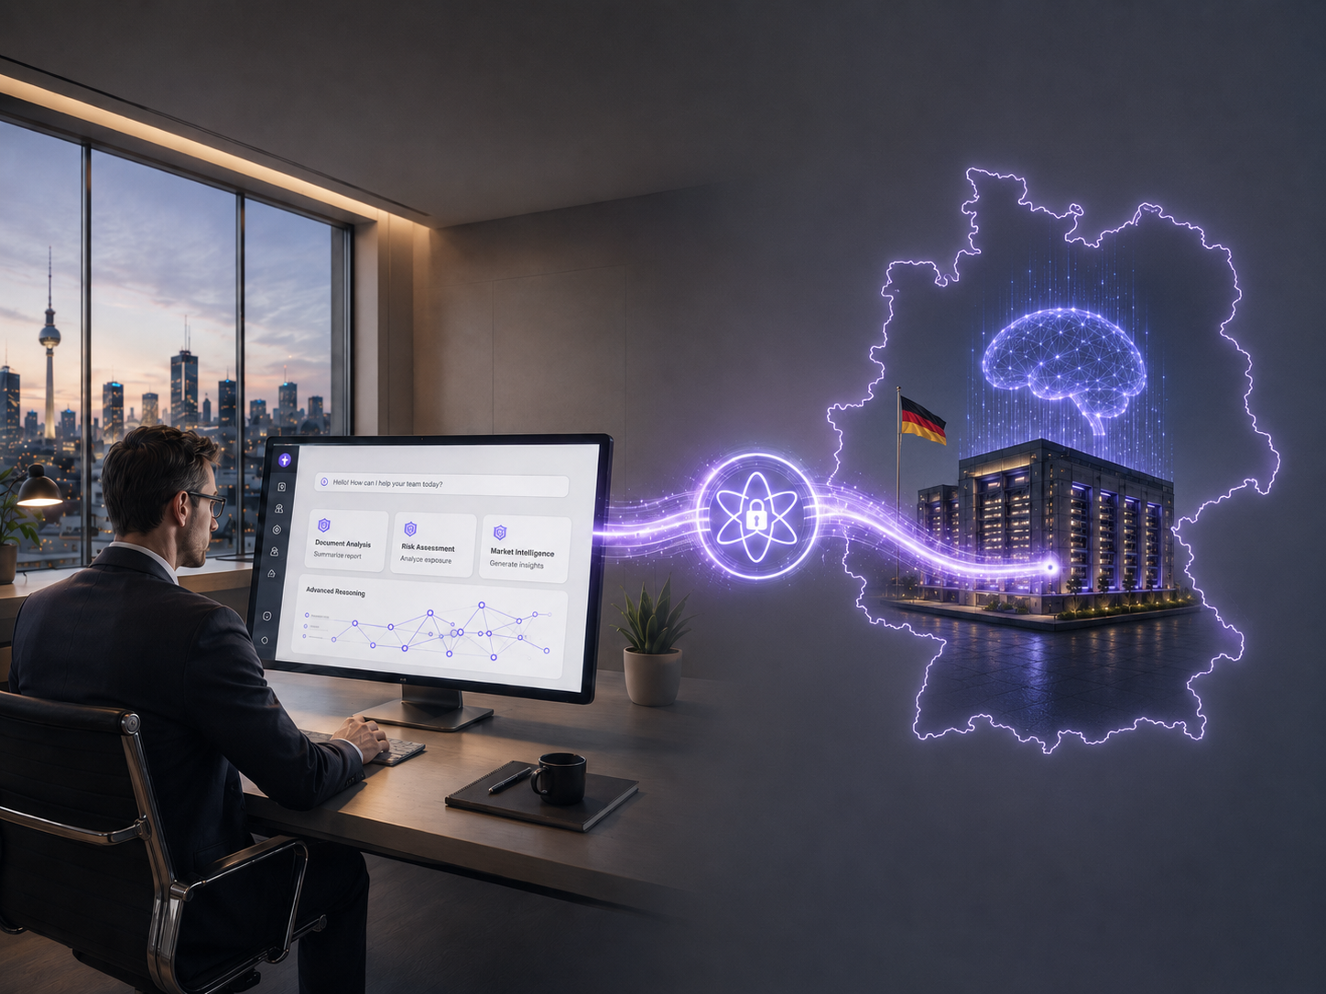 Image source: KEEQuant GmbH, AI-generated with ChatGPT
Illustrative view of a sovereign AI architecture in which users access advanced AI services through trusted German infrastructure and quantum-secured connectivity.

Consortium and contacts

KEEQuant GmbH
KEEQuant develops deployable quantum-security technologies including quantum key distribution, key management and secure networking solutions for confidentiality-sensitive infrastructures.
Contact / Press contact:
KEEQuant GmbH
Imran Khan
GS26 – 6th floor
Gebhardtstr. 28
90762 Fürth
Germany
E-mail: press@keequant.com
Homepage: www.keequant.com
Press kit: https://www.keequant.com/press-release-quantum-secured-ai/
Press release: https://www.keequant.com/quantum-secured-ai-for-organizations/

Collaider
Collaider develops secure AI applications and workflow-oriented AI environments for organizations that need practical and privacy-aware AI adoption.
Contact / Press contact:
Collaider UG
Florian Klaus
Project Management
Pirkheimerstr. 36
90408 Nuremberg
Germany
E-mail: florian.klaus@collaider.com
Homepage: www.collaider.com

noris network AG
Nuremberg-based noris network AG offers companies and organizations in the finance, public sector, and enterprise sectors customized IT solutions in the areas of IT outsourcing, managed services, cloud services, and network and security.
In addition to standard products and services for traditional, virtualized IT infrastructures, noris network offers managed PaaS environments for container solutions on its own cloud platforms. The technological foundation is a high-performance IT infrastructure featuring noris network’s own high-security data centers—including Nuremberg South and Munich East, two of the most recognized as the most modern, secure, and energy-efficient data centers in Europe.
noris network AG is certified for consistent quality and security in its service and information security management across all business operations in accordance with ISO 20000-1, ISO/IEC 27001, and ISO 9001. In the area of “Security Management for Buildings,” noris network is the first data center operator to be certified according to VdS Guideline 3406. In addition, the Munich East data center has been certified to meet the highest availability, protection, and energy efficiency classes as defined by EN 50600. The Nuremberg Central, Nuremberg South, and Munich East data centers have received ISO 27001 certification based on the BSI’s IT-Grundschutz standard. At the Nuremberg South location, noris network offers the unique opportunity to use a colocation data center that meets the highest security standards: EN 50600, TSI.STANDARD V4.6 Level 4, and ISO/IEC 22237. Other certifications held by the IT service provider include PCI DSS, TISAX, and ISO 14001 Environmental Management.
noris network AG was founded in 1993 and is now one of Germany’s pioneers in the field of modern IT services. It serves renowned companies such as adidas AG, Bayerncard, Consorsbank, Finanz Informatik Technologie Service, the Max Bögl Group, Flughafen Nürnberg GmbH, Nürnberger Versicherung, paydirekt, RCI Banque, Senacor Technologies AG, TeamBank AG, and many more.

Headquarters:
noris network AG, Thomas-Mann-Strasse 16–20, 90471 Nuremberg, Germany
Phone: (+49-911) 935-20, Fax: (+49-911) 9352-100
E-mail: vertrieb@noris.de; Website: www.noris.de

Contact  noris network AG  Udo Kürzdörfer  Thomas-Mann-Strasse 16–20  90471 Nuremberg, Germany  Tel.: (+49-911) 9352-0  Fax: (+49-911) 9352-100  E-mail: udo.kuerzdoerfer@noris.de  Website: www.noris.de | Press contact:  HighTech communications GmbH  Brigitte Basilio  Brunhamstrasse 21  81249 Munich, Germany  Tel.: (+49-89) 5007-7820  Fax: (+49-89) 5007-7877  E-mail: b.basilio@htcm.de  Website: www.htcm.de

