FOR THE MEDIA
ASMPT at NEPCON Thailand 2026
A first for Thailand: SIPLACE V ushers in a new era of SMT manufacturing
Singapore, June 9, 2026 – ASMPT, a global market and technology leader in integrated hardware and software solutions for electronics manufacturing, will be exhibiting at NEPCON Thailand in Bangkok International Trade & Exhibition Centre (BITEC). The event is a leading trade fair for assembly, measurement and testing technologies in electronics manufacturing and will take place from June 17 to 20, 2026. ASMPT will be showcasing innovative solutions for the intelligent factory at Booth 0D11 in Hall 100. As a special highlight, the new SIPLACE V placement platform will be unveiled for the first time in Thailand.
With the SIPLACE V platform, newly-developed from the ground up, ASMPT is once again setting new standards in performance, flexibility, and process quality. Independent field tests conducted under real-world production conditions have demonstrated performance gains of up to 30 percent in key sectors of electronics manufacturing, including automotive, consumer electronics, smartphones, and IT and network infrastructure. The SIPLACE V combines maximum speed with high precision and flexibility.
More speed and precision
The SIPLACE V features an innovative machine frame and highly efficient linear drives as well as measurement systems with enhanced resolution. This enables higher acceleration and even more accuracy. The platform supports both single- and dual-lane configurations, Smart Pin support, and high-density placement of complex assemblies.
“With the new SIPLACE V, we are providing electronics manufacturers with a platform that integrates seamlessly into existing production environments while laying the groundwork for future automation and AI applications,” explains Sopchock Yuttawong, General Manager at ASMPT SMT Solutions Thailand. “This enables companies to modernize their manufacturing in a targeted manner while ensuring that their investments remain secure in the long term.”
Software and intelligent connectivity
In addition to hardware, ASMPT is showcasing the latest software and service solutions for intelligent manufacturing with applications from the WORKS Software Suite as well as the Factory Solution SMT Analytics. These solutions collect and analyze production data in real time, identify deviations early on, and help electronics manufacturers to improve productivity, quality, and line performance.
WORKS Optimization integrates data from printing, placement, SPI, and AOI processes across the entire SMT line, detects process deviations and recurring defect patterns at an early stage, and provides actionable recommendations. In solder paste printing, optimizations can be carried out fully automatically to stabilize processes and reduce scrap. WORKS Monitoring visualizes all relevant production metrics in real time and provides detailed views down to the line or machine level. This is complemented by SMT Analytics, which compares production data from different lines, identifies bottlenecks, and reveals additional optimization potential using AI-powered analyses.
Intelligent closed-loop nozzle management
Another highlight is ASMPT’s new closed-loop nozzle management system. Using RFID-equipped “smart nozzles” and intelligent condition monitoring, the application controls maintenance, cleaning, and nozzle replacement automatically and as needed. When combined with the Factory Equipment Center and the Smart Nozzle Station, it helps improve process stability and product quality while reducing unplanned downtime.
Digital services and AI-powered support
In the service area, ASMPT is showcasing offerings such as the newly launched Customer Portal and the Virtual Assist application, an AI-powered expert system designed to support service and maintenance technicians.
During the trade show, daily live presentations will be held showcasing the SIPLACE V. Visitors will gain practical insights into modern placement processes, intelligent software functions, and solutions for demanding high-mix and high-throughput manufacturing environments whilst at the ASMPT Booth.

Illustrations for downloading
The following print-ready artwork is available on the internet for downloading:
https://kk.htcm.de/press-releases/asmpt/

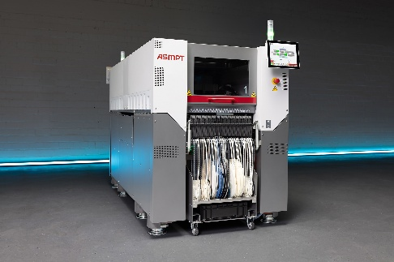 | 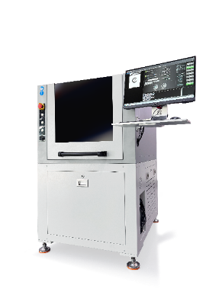
The new SIPLACE V platform handles the entire range of components – from ultra-small 016008M chips to large-format components – and really shines when dealing with challenging or odd-shaped components.  Image credit: ASMPT | The automated Smart Nozzle Station is an integral part of the end-to-end closed-loop nozzle management system.  Image credit: ASMPT

About ASMPT Limited (“ASMPT”)
ASMPT Limited is a leading global supplier of hardware and software solutions for the manufacture of semiconductors and electronics. Headquartered in Singapore, ASMPT’s offerings encompass the semiconductor assembly & packaging, and SMT (surface mount technology) industries, ranging from wafer deposition to the various solutions that organize, assemble and package delicate electronic components into a vast range of end-user devices. ASMPT partners with customers very closely, with continuous investments in R&D helping to provide cost-effective, industry-shaping solutions that achieve higher productivity, greater reliability, and enhanced quality. ASMPT is a founding member of the Semiconductor Climate Consortium.
To learn more about ASMPT, please visit www.asmpt.com.

The ASMPT SMT Solutions segment
The mission of the SMT Solutions segment within ASMPT is to implement and support the Intelligent Factory at electronics manufacturers worldwide.
ASMPT solutions support the networking, automation, and optimization of central workflows with hardware, software and services that enable electronics manufacturers to transition to the Intelligent Factory in stages and enjoy dramatic improvements in productivity, flexibility, and quality. With its integrated open automation concept, ASMPT opens the door for its customers to economically feasible automation, entirely in accordance with their individual requirements – modular, flexible, and vendor-independent.
The product range includes hardware and software such as SIPLACE placement solutions, DEK printing solutions, inspection and storage solutions, and the WORKS Software Suite. With WORKS, ASMPT offers electronics manufacturers high-quality software for planning, controlling, analyzing and optimizing all processes on the shop floor. Maintaining close relationships with customers and technology partners is a central component of ASMPT’s strategy.
For more information about ASMPT SMT Solutions, visit smt.asmpt.com.
Media contacts:
ASMPT ROA Press Office
SMT Solutions
ASMPT SMT Singapore Pte. Ltd.
Janet Loh
Phone: +65 6877 3948
E-mail: Janet.loh@asmpt.com
Website: smt.asmpt.com

Global ASMPT Press Office
ASMPT Limited
Susanne Oswald
Rupert-Mayer-Strasse 48
81379 Munich
Germany
Phone: +49 89 20800-26439
E-Mail: susanne.oswald@asmpt.com
Website: asmpt.com

