
PRESS RELEASE
OPEN MIND at ILA 2026 in Berlin
hyperMILL® CAD/CAM solution for the aerospace industry
June 10–14, 2026
Hall A, Booth 411
Wessling (Germany), May 27, 2026 – OPEN MIND Technologies AG will be making its exhibition debut at the ILA show in Berlin. At Booth 411 in Hall A, OPEN MIND will showcase what the hyperMILL® CAD/CAM suite has to offer the aerospace industry. OPEN MIND will demonstrate how modern CAD/CAM technology supports the efficient, precise manufacturing of complex aerospace components and integrates seamlessly into secure processes. Components such as a shrouded impeller and a propeller hub will be displayed at the booth.
The aerospace industry places the highest demands on machining with complex geometries and strict quality specifications. Whether engine and landing gear components, structural parts, eVTOL components, or parts for rocket construction, such as thrust frames, connecting elements, tank and structural parts, the tasks are diverse. At ILA, OPEN MIND will demonstrate how hyperMILL® can support manufacturers with unique 5-axis strategies, powerful turning and milling strategies, and specialized solution packages for blisks and impellers, enabling them to reliably program and manufacture even the most demanding components. Challenges posed by additive and hybrid manufacturing can also be overcome with hyperMILL®.
Efficiency and Control
For difficult-to-machine materials such as titanium, Inconel, superalloys, and fiber-reinforced composites, hyperMILL® can reduce tool wear through optimized high-performance cutting (HPC) strategies. “With hyperMILL®, we address many typical technical challenges in the industry, but companies new to the sector are also confronted with the extremely high safety and documentation standards of the aerospace industry. hyperMILL® is perfectly suited for this. It can be seamlessly integrated into AS9100/EN9100-compliant processes,” explains Dirk Lehmann, Team Leader Sales North at OPEN MIND Technologies AG. An important aspect of quality management here is, for example, the NC code-based pre-simulation of machining processes with hyperMILL VIRTUAL Machining.
Well-connected and established
Although this is OPEN MIND’s first time at ILA, the company is by no means a newcomer to the industry. It maintains close ties with the international aerospace research community and collaborates with renowned research institutes worldwide. These partnerships ensure access to the latest manufacturing methods. In addition, OPEN MIND maintains close partnerships with leading machine and cutting tool manufacturers to optimally tailor machining strategies to the material, tool, and machine. This results in consistently validated processes for the highest precision, maximum efficiency, and reliable process reliability.
Already on Mission
Globally renowned aerospace companies already rely on hyperMILL® and successfully use the software in safety-critical manufacturing environments. hyperMILL® is also part of real-world missions in the space sector: components manufactured with hyperMILL® are successfully in use in space, including in communication satellites.

Available images
The following images are available for download in printable format at:
https://kk.htcm.de/press-releases/open-mind/
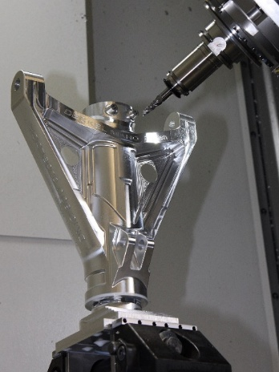

With the HPC strategies in hyperMILL®, landing gear components made of high-strength titanium can be manufactured reliably.

Source: OPEN MIND

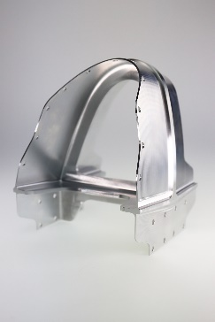
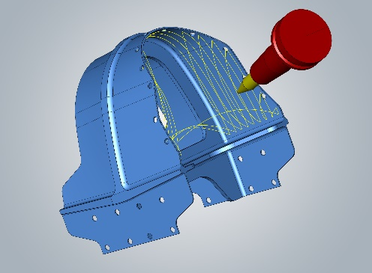
Source: OPEN MIND

Thin-walled structural components place the highest demands on programming and machining, as well as requiring maximum precision in terms of dimensional accuracy and surface quality.

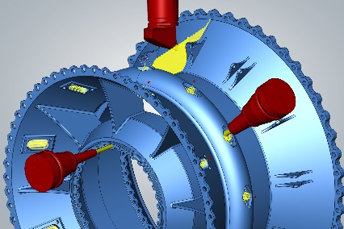
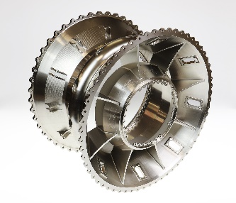
Source: OPEN MIND

Powerful hyperMILL® milling and turning strategies ensure maximum process reliability, even with materials that are difficult to machine.
Available videos
You can find the following videos on our YouTube channel:
https://youtu.be/OATsrNzXyEU?si=A8kQ06uADMKaaCD

Source: OPEN MIND

Reliably manufacture components for the next generation of aerospace technology with hyperMILL®.

About OPEN MIND Technologies AG
OPEN MIND Technologies AG is one of the world’s leading developers of powerful CAD/CAM solutions for machine and controller-independent programming.
OPEN MIND develops optimized CAD/CAM solutions that include innovative and unique features that can deliver significantly higher performance in both programming and machining.
hyperMILL® is a completely modular CAD/CAM solution that provides state-of-the-art CAM technologies on its own CAD platform: from 2.5D, 3D and 5-axis machining as well as turning strategies and solutions for additive manufacturing, HSC and HPC machining. Whether automation, simulation or virtual machine – trendsetting technologies expand the product range and enable continuous digital process chains. Special applications, seamless interaction with all popular CAD solutions and exceptional customer service rounds out the company’s products and capabilities.
According to the “NC Market Analysis Report 2025” compiled by CIMdata, hyperMILL® is a leading, worldwide CAD/CAM solution. Innovative CAD/CAM technologies fulfill the highest demands in aerospace, automotive, tool and mold manufacturing, production machining, medical, job shops, energy and semiconductor industries.
OPEN MIND's majority stake in manufacturing execution system (MES) developer Hummingbird expands the CAD/CAM manufacturer's product portfolio and enhances the range of connected digitalized manufacturing technologies.
OPEN MIND is a Mensch und Maschine company and has subsidiaries and qualified sales partners on all continents.

You can find more information at www.openmind-tech.com.

OPEN MIND Technologies UK Ltd., Oxford
Unit 3
Bicester Business Park
Telford Road
Bicester
Oxfordshire OX26 4LN
England
Phone: +44 1869 290 003
Fax: +44 1869 369 429
E-mail: Info.UK@openmind-tech.com

OPEN MIND Technologies USA, Inc.
1492 Highland Avenue, Unit 3
Needham MA 02492
USA
Phone: +1 339 225 4557 office
Phone: +1 888 516 1232 x0 toll-free
Fax: +1 270 912 5822
E-mail: Info.Americas@openmind-tech.com

OPEN MIND Technologies Asia Pacific Pte Ltd
MOVA Building, 22 Jalan Kilang #03-00
Singapore 159419
Phone: +65 6742 95-56
E-mail. Info.Asia@openmind-tech.com

OPEN MIND CADCAM Technologies India Private Ltd
No.610 & 611, 6th Floor, ‘B’ Wing, No.6, Mittal Tower
M.G. Road, Bangalore
560001, Karnataka
Phone: +91 80 2676 6999
E-mail: Info.India@openmind-tech.com

Head office:
OPEN MIND Technologies AG, Argelsrieder Feld 5, 82234 Wessling, Germany
Tel.: (+49-8153) 933-500, Fax: (+49-8153) 933-501
E-mail: Info@openmind-tech.com, website: www.openmind-tech.com

Press contact:
HighTech communications GmbH
Brigitte Basilio
Brunhamstrasse 21
81249 Munich
Germany
Tel.: (+49-89) 500778-20
E-mail: b.basilio@htcm.de
Website: www.htcm.de

