FOR THE MEDIA
ASMPT Semiconductor Solutions at PCIM Expo 2026
Enabling Smart Mobility
Regensburg (Germany), May 20, 2026 – ASMPT Semiconductor Solutions will present technologies for modern power electronics and semiconductor manufacturing at PCIM Expo 2026, taking place in Nuremberg from June 9 to 11. Under the theme “Empower the Intelligence Revolution,” the company will showcase solutions for silver sintering, laser dicing and grooving, and multi-chip bonding at Booth 339 in Hall 6, with a focus on smart mobility.
As modern vehicles become increasingly electrified and digitalized, the requirements for power density, thermal management, reliability, and integration density of electronic systems continue to rise. ASMPT addresses these challenges with technologies for key process steps in semiconductor manufacturing and packaging.
Exclusive Oxidation-Free Vacuum Sintering Solution
SilverSAM PRO, a silver sintering platform for the production of highly reliable power module packages, will be presented for the first time. The solution offers an oxidation-free, copper-friendly process environment as well as a new temperature control system for power-box sintering, meaning the sintering of molded packages onto heat sinks. SilverSAM PRO supports scalable production configurations with 1 to 4 presses and processes various substrate formats, ranging from DBC / AMB panels and singulated DBC / AMB substrates to wafer-level and leadframe-based power discrete applications. Thanks to their high electrical and thermal conductivity, sintered silver interconnects are particularly well suited for power modules used in electric drivetrains and fast-charging infrastructure.
Laser Dicing and Grooving for Advanced Packaging
With the ALSI LASER1206, ASMPT presents a platform for the singulation of bare wafers under Class 1000 cleanroom conditions. The laser dicing and grooving solution combines multi-beam technology with fully automated handling of film-framed and bare wafers. The patented UV laser technology enables maximum precision with minimal heat input, thereby reducing burr formation and thermal stress on the die. The platform is suited for advanced packaging applications in automotive power electronics as well as for AI and mobile applications.
Automatic High-Precision Multi-Chip Bonder
The MEGA multi-chip bonder supports a broad range of multi-chip packages with its modular architecture. The platform provides high-precision die bonding technology for compact high-end electronics and supports stable processes with consistent process quality. MEGA processes large-format substrates up to 280 × 300 mm and combines speed, flexibility, and high placement accuracy. The platform is suited for MCM, SiP, and flip-chip applications for the production of compact computing modules.
Semiconductor Packaging Innovations for Smart Mobility
“Power electronics, electric drivetrains, advanced driver assistance systems, and connected vehicle platforms are placing increasingly demanding requirements on power density, thermal management, and compact form factors in the automotive sector. We provide cutting-edge technologies for advanced packaging and semiconductor manufacturing that drive innovation in artificial intelligence, smart mobility, and hyperconnectivity,” says Dr. Johann Weinhändler, Regional Head ASMPT Semiconductor Solutions Europe and Managing Director of ASMPT AMICRA in Regensburg, describing the company’s strategy.

Illustrations for downloading
The following images are available for download in printable format at:
https://kk.htcm.de/press-releases/asmpt/
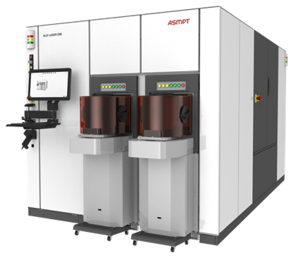 | 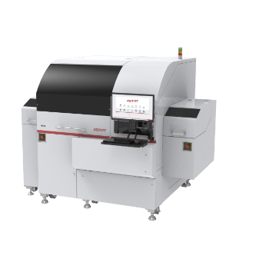
ALSI LASER1206, the fully automated laser dicing and grooving solution from ASMPT.  Image source: ASMPT | As a multi-chip bonding solution, the MEGA perfectly meets the requirements of the next generation of smart chips, for example for advanced driver-assistance systems (ADAS).  Image source: ASMPT
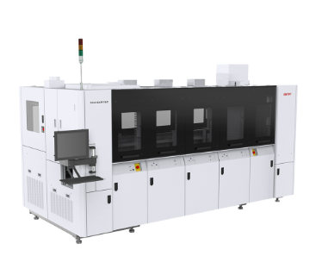
SilverSAM PRO, a next-generation sintering platform, particularly suitable for power modules in the powertrain of electric vehicles and in fast-charging infrastructure.

Image source: ASMPT

About ASMPT Limited (“ASMPT”)
ASMPT Limited is a leading global supplier of hardware and software solutions for the manufacture of semiconductors and electronics. Headquartered in Singapore, ASMPT’s offerings encompass the semiconductor assembly & packaging, and SMT (surface mount technology) industries, ranging from wafer deposition to the various solutions that organise, assemble and package delicate electronic components into a vast range of end-user devices. ASMPT partners with customers very closely, with continuous investment in R&D helping to provide cost-effective, industry-shaping solutions that achieve higher productivity, greater reliability, and enhanced quality. ASMPT is also a founding member of the Semiconductor Climate Consortium.
To learn more about ASMPT, please visit us at asmpt.com.

About ASMPT Semiconductor Solutions (“ASMPT SEMI”)
ASMPT SEMI is the leading supplier in advanced packaging and semiconductor assembly solutions. With a commitment to innovation and customer satisfaction, ASMPT SEMI provides a comprehensive range of products and services that cater to the evolving needs of the microelectronics industry. Their expertise spans across areas such as flip-chip and wafer-level packaging, advanced interconnect technologies, and more. ASMPT SEMI's cutting-edge solutions enable customers to achieve higher performance, increased reliability, and improved cost-efficiency when producing their semiconductor devices.
ASMPT SEMI sees itself as a pioneer and driving force of the Intelligence Revolution. With its advanced packaging and assembly technologies, the business segment creates the invisible connections that enable intelligent applications in Artificial Intelligence, Smart Mobility and Hyperconnectivity.
For more information about ASMPT SEMI, visit semi.asmpt.com.
Media contacts:
Global ASMPT Press Office
ASMPT Limited
Susanne Oswald
Rupert-Mayer-Strasse 48
81379 Munich
Germany
Phone: +49 89 20800-26439
E-Mail: susanne.oswald@asmpt.com
Website: asmpt.com

HighTech communications GmbH
Barbara Ostermeier
Brunhamstrasse 21
81249 Munich
Germany
Phone: +49 89 500778-10
E-Mail: b.ostermeier@htcm.de
Website: www.htcm.de

