PRESS RELEASE
OPEN MIND Releases hyperMILL® 2026
For optimal performance and process reliability
Wessling (Germany), May 20, 2026 – With version 2026 of the CAD/CAM suite hyperMILL®, OPEN MIND Technologies AG is increasing both the speed at which NC programs can be created and process reliability. For the first time, the software and its NC code-based simulation in hyperMILL® VIRTUAL Machining will support additional tool types and angle heads.
Version 2026, makes it possible to seamlessly integrate angle heads into hyperMILL® CAM programming. The angle head is defined as part of the NC tool and configured via the hyperMILL® TOOL Builder. The virtual machine consistently accounts for angle heads during NC code generation, toolpath optimization, simulation, and collision checking. Even critical phases such as the angle head approach and retraction are completely and reliably simulated. The hyperMILL® VIRTUAL Machining Optimizer automatically optimizes toolpaths for angle head machining. Approaching via a curve also enables safe access to hard-to-reach areas of the component. The function is initially available for Siemens (SINUMERIK 840D) and Heidenhain controls.
2D Hale Machining for Perfect Sealing Surfaces
2D Hale machining, also known as contour planing is another tooling option supported by both machining strategies and in the simulation. This enables impeccable scratch-free surface finishes, as required for sealing surfaces in battery manufacturing, the semiconductor or the mold and die industry. As a trailing axis, the spindle axis functions ensure that the tool is continuously guided perpendicular to the contour.
Reliable 3D and 5-axis Rest Machining
Rest material machining has been further automated in version 2026 of hyperMILL®. The calculation algorithms for the “Z-level,” “Parallel,” and “Normal” machining strategies - have been redesigned to make processing of rest material areas more reliable and efficient. As a result, rest material areas are detected much more precisely and machined more reliably. Feed specifications are reliably taken into account, resulting in more uniform toolpaths. Additionally, the system automatically integrates a smooth overlap in steep, flat and transitional areas during entry and exit movements. This automation applies to both 3D and 5-axis machining. In the latter case, users can use the new “Minimum Clearance Angle” option to specify a minimum distance between the tool shank and the part, ensuring that machining is performed with a defined clearance angle.
Turning with hyperMILL®: reduced programming time and increased process reliability
With “CAM Plan Turning,” hyperMILL® offers end-to-end programming support for turned and mill-turned parts. Often, turning programming only includes geometries without tolerances, fits, or manufacturing information. Until now, this data had to be added manually - a time-consuming and error-prone process. “CAM Plan Turning” enables turning contours to be quickly and consistently enriched with all relevant manufacturing information. This significantly reduces programming time and provides greater process reliability for turned and mill-turned parts. The hyperMILL® TURNING Solutions have also been expanded to include new complex turret type machine configurations for improved collision checking.
Optimized control of eroding paths
In the hyperMILL® Electrode module, the control of eroding paths has been improved, for more flexible use of feed and rapid movements that optimize eroding paths and shorten machining times.

Available image material
The following images are available for download in print-ready format on the Internet:
https://kk.htcm.de/press-releases/open-mind/
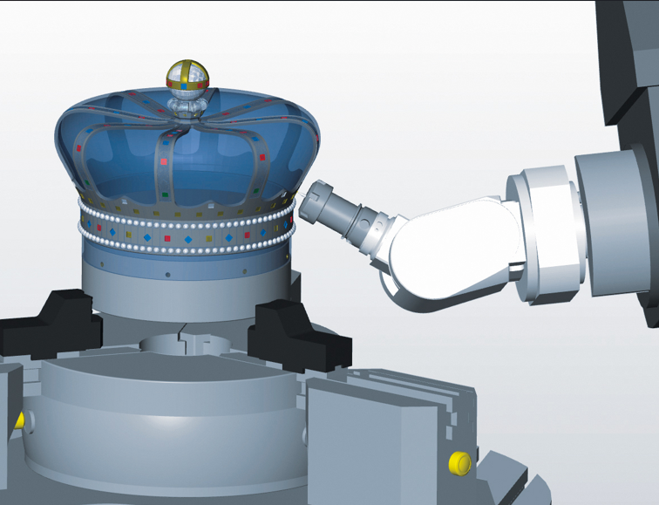  Source: OPEN MIND  Angle head support in hyperMILL® and hyperMILL® VIRTUAL Machining enables reliable programming and verification of angle head machining operations. | 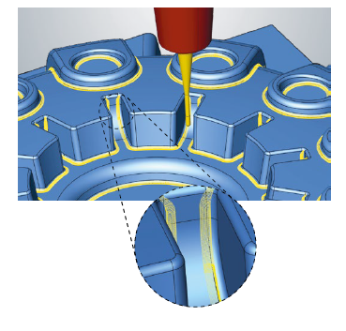  Source: OPEN MIND  New 3D strategies for even more reliable and efficient machining of rest material areas.
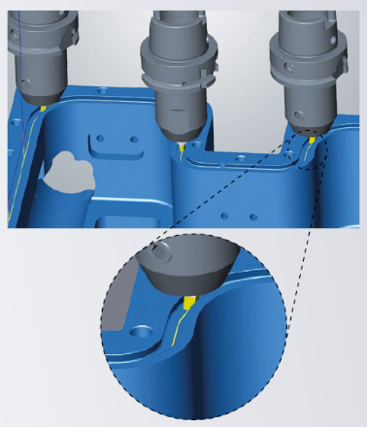  Source: OPEN MIND  2D Hale machining ensures perfect surfaces without processing marks across the sealing direction. | 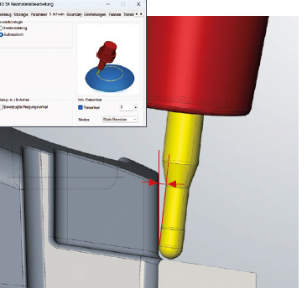  Source: OPEN MIND  Reliable 5-axis machining with a defined clearance angle between the tool shank and the workpiece.

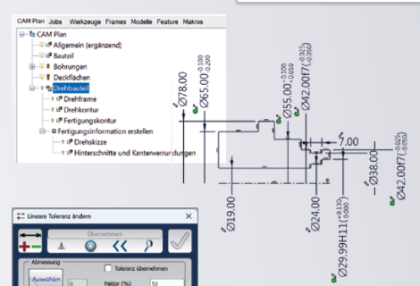  Source: OPEN MIND  “CAM Plan Turning,” can quickly and consistently enrich turning contours with all relevant manufacturing information. | 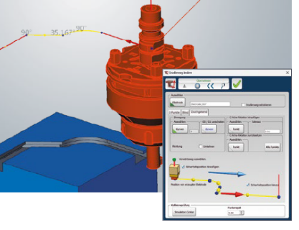  Source: OPEN MIND  Optimized control of eroding paths: Define feed or rapid movements precisely.

Available video material
You can find the following video material on our YouTube channel:
https://shorturl.at/ohRB1

Source: OPEN MIND

Video tutorial: hyperMILL® 2026 – What’s new?

About OPEN MIND Technologies AG
OPEN MIND Technologies AG is one of the world’s leading developers of powerful CAD/CAM solutions for machine and controller-independent programming.
OPEN MIND develops optimized CAD/CAM solutions that include innovative and unique features that can deliver significantly higher performance in both programming and machining.

hyperMILL® is a completely modular CAD/CAM solution that provides state-of-the-art CAM technologies on its own CAD platform: from 2.5D, 3D and 5-axis machining as well as turning strategies and solutions for additive manufacturing, HSC and HPC machining. Whether automation, simulation or virtual machine – trendsetting technologies expand the product range and enable continuous digital process chains. Special applications, seamless interaction with all popular CAD solutions and exceptional customer service rounds out the company’s products and capabilities.
According to the “NC Market Analysis Report 2025” compiled by CIMdata, hyperMILL® is a leading, worldwide CAD/CAM solution. Innovative CAD/CAM technologies fulfill the highest demands in aerospace, automotive, tool and mold manufacturing, production machining, medical, job shops, energy and semiconductor industries.
OPEN MIND's majority stake in manufacturing execution system (MES) developer Hummingbird expands the CAD/CAM manufacturer's product portfolio and enhances the range of connected digitalized manufacturing technologies.
OPEN MIND is a Mensch und Maschine company and has subsidiaries and qualified sales partners on all continents.

You can find more information at www.openmind-tech.com.

OPEN MIND Technologies UK Ltd., Oxford
Unit 3
Bicester Business Park
Telford Road
Bicester
Oxfordshire OX26 4LN
England
Phone: +44 1869 290 003
Fax: +44 1869 369 429
E-mail: Info.UK@openmind-tech.com

OPEN MIND Technologies USA, Inc.
1492 Highland Avenue, Unit 3
Needham MA 02492
USA
Phone: +1 339 225 4557 office
Phone: +1 888 516 1232 x0 toll-free
Fax: +1 270 912 5822
E-mail: Info.Americas@openmind-tech.com

OPEN MIND Technologies Asia Pacific Pte Ltd
MOVA Building, 22 Jalan Kilang #03-00
Singapore 159419
Phone: +65 6742 95-56
E-mail. Info.Asia@openmind-tech.com

OPEN MIND CADCAM Technologies India Private Ltd
No.610 & 611, 6th Floor, ‘B’ Wing, No.6, Mittal Tower
M.G. Road, Bangalore
560001, Karnataka
Phone: +91 80 2676 6999
E-mail: Info.India@openmind-tech.com

Head office:
OPEN MIND Technologies AG, Argelsrieder Feld 5, 82234 Wessling, Germany
Tel.: (+49-8153) 933-500, Fax: (+49-8153) 933-501
E-mail: Info@openmind-tech.com, website: www.openmind-tech.com

Press contact:
HighTech communications GmbH
Brigitte Basilio
Brunhamstrasse 21
81249 Munich
Germany
Tel.: (+49-89) 500778-20
E-mail: b.basilio@htcm.de
Website: www.htcm.de

