FOR THE MEDIA
ASMPT showcases AP innovations for AI and HPC at ECTC 2026
Advanced Bonding Solutions for HBM and Chiplets
Billerica, USA, May 13, 2026 – ASMPT will present advanced packaging solutions for AI and high-performance computing (HPC) at Booth 100 during the IEEE 76th Electronic Components and Technology Conference (ECTC) 2026, taking place May 26–29 in Orlando, Florida, USA. Under the theme “Empower the Intelligence,” ASMPT will demonstrate advanced packaging technologies addressing the increasing complexity of AI accelerators, high-bandwidth memory integration and heterogeneous chiplet architectures.
As AI accelerators, GPUs and advanced memory architectures continue to evolve, semiconductor manufacturers are facing growing challenges related to interconnect density, thermal management, bonding precision and scalable manufacturing. ASMPT’s portfolio supports these requirements from R&D through to high-volume production.
At ECTC 2026, ASMPT will highlight its FIREBIRD thermocompression bonding platform series and LITHOBOLT™ die-to-wafer (D2W) bonding solution, designed to support next-generation AI accelerators, HBM integration and chiplet-based heterogeneous architectures. As AI infrastructure drives increasing demand for bandwidth, interconnect density and power efficiency, these platforms enable the precision and scalability required for advanced 2.5D and 3D integration.
Thermocompression Bonding for Advanced HBM Integration
The FIREBIRD platform supports residue-free fluxless bonding through ASMPT’s Active Oxide Removal (AOR) technology, helping to eliminate flux-related cleaning steps while improving process reliability and lowering the cost of ownership. Proven for 16-layer HBM stacks, the platform delivers 2.0 µm placement accuracy for fine-pitch, high-I/O-density applications. With more than 500 TCB systems deployed in mass production worldwide, the FIREBIRD family combines scalability, throughput and process stability for advanced AI packaging applications.

Die-to-Wafer Bonding for Next-Generation AI Architectures
ASMPT’s LITHOBOLT die-to-wafer (D2W) bonding solution is engineered for 3D integration and the high-density copper-to-copper interconnects required by next-generation AI and HPC devices. Designed for contamination-controlled environments, the platform supports void-free bonding interfaces, tight overlay accuracy and ultra-fine-pitch integration for applications requiring 10,000+ interconnects/mm², addressing the increasing complexity of advanced logic-memory integration and chiplet architectures.
“Advanced packaging is becoming a critical enabling technology for the AI era,” said Jean Marc Peallat, Regional Head, ASMPT Semiconductor Solutions Americas. “At ECTC 2026, ASMPT will demonstrate how our technologies help manufacturers scale increasingly complex AI and HPC architectures for high-volume production.”
With deep process expertise and a broad portfolio of semiconductor assembly and packaging solutions, ASMPT supports customers worldwide in accelerating innovation across AI, HPC and data-centric computing applications.

Illustrations for downloading
The following images are available for download in printable format at:
https://kk.htcm.de/press-releases/asmpt/
 | 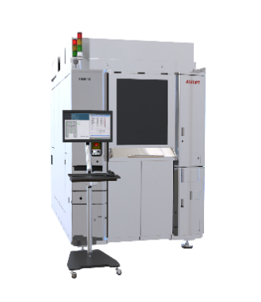
Jean-Marc Peallat, PhD, Regional Head ASMPT Semiconductor Solutions Americas  Image credit: ASMPT | FIREBIRD Series – enable advanced tech node semiconductor device for HPC data center  Image credit: ASMPT
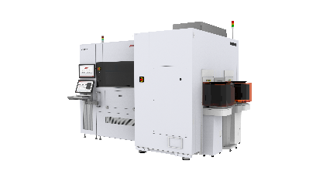
LITHOBOLT™ G2 – ultra-high precision die bonder for die-to-wafer (D2W) bonding

Image credit: ASMPT
About ASMPT Limited (“ASMPT”)
ASMPT Limited is a leading global supplier of hardware and software solutions for the manufacture of semiconductors and electronics. Headquartered in Singapore, ASMPT’s offerings encompass the semiconductor assembly & packaging, and SMT (surface mount technology) industries, ranging from wafer deposition to the various solutions that organise, assemble and package delicate electronic components into a vast range of end-user devices. ASMPT partners with customers very closely, with continuous investment in R&D helping to provide cost-effective, industry-shaping solutions that achieve higher productivity, greater reliability, and enhanced quality. ASMPT is also a founding member of the Semiconductor Climate Consortium.
To learn more about ASMPT, please visit us at asmpt.com.

About ASMPT Semiconductor Solutions (“ASMPT SEMI”)
ASMPT SEMI is the leading supplier in advanced packaging and semiconductor assembly solutions. With a commitment to innovation and customer satisfaction, ASMPT SEMI provides a comprehensive range of products and services that cater to the evolving needs of the microelectronics industry. Their expertise spans across areas such as flip-chip and wafer-level packaging, advanced interconnect technologies, and more. ASMPT SEMI's cutting-edge solutions enable customers to achieve higher performance, increased reliability, and improved cost-efficiency when producing their semiconductor devices.
ASMPT SEMI sees itself as a pioneer and driving force of the Intelligence Revolution. With its advanced packaging and assembly technologies, the business segment creates the invisible connections that enable intelligent applications in Artificial Intelligence, Smart Mobility and Hyperconnectivity.
For more information about ASMPT SEMI, visit semi.asmpt.com.
Media contacts:
Global ASMPT Press Office
ASMPT Limited
Susanne Oswald
Rupert-Mayer-Strasse 48
81379 Munich
Germany
Phone: +49 89 20800-26439
E-Mail: susanne.oswald@asmpt.com
Website: asmpt.com

HighTech communications GmbH
Barbara Ostermeier
Brunhamstrasse 21
81249 Munich
Germany
Phone: +49 89 500778-10
E-Mail: b.ostermeier@htcm.de
Website: www.htcm.de

