FOR THE MEDIA
Closed-loop nozzle management in
SMT manufacturing
Intelligent life cycle monitoring down to the smallest detail
Atlanta (USA), May 12, 2026 – ASMPT SMT Solutions, the market and technology leader for integrated hardware and software solutions for the electronics manufacturing industry, presents a new system for the demand-oriented and continuously monitored management of SMT placement nozzles. With this factory-encompassing solution, SIPLACE placement machines, an automated nozzle cleaning and inspection system as well as an asset and maintenance management application work closely together in an intelligent production network.
In high-speed placement heads, nozzles are the only components that come into direct contact with the components being placed, which is why their condition is a crucial factor for process stability and product quality. In many larger factories, it is not unusual to have more than 10,000 nozzles in use, with service lives ranging from a few months to one year, depending on the application. To clearly evaluate and track the condition of each nozzle, ASMPT equips its “smart nozzles” with their own RFID tags and individual IDs. For each nozzle that the placement head picks up, the machine automatically reads the unique nozzle ID and transmits it to ASMPT’s Factory Equipment Center asset and maintenance management software, which creates a record that gets updated over the entire life cycle of the respective nozzle.
Continuously updated status data
During the placement process, SIPLACE placement machines continuously record the number of placement processes and conduct optical nozzle inspections to immediately detect and remove damaged nozzles from the process. In the event of contamination or when defined maintenance thresholds are exceeded, the machine blocks the nozzle for the entire factory. All status and event data gets transmitted to the Factory Equipment Center software, where it is fully documented in each nozzle’s data set.
Demand-oriented cleaning in a closed control loop
Based on the data provided by the SIPLACE placement machines, the Factory Equipment Center software instructs operators to remove magazines with nozzles requiring maintenance and replace them with new magazines. The removed magazines are then taken to the Smart Nozzle Station, an intelligent cleaning and inspection system, where the nozzles are cleaned exclusively with water and ultrasound before undergoing a final inspection.
If a nozzle is deemed suitable for production after the cleaning process, it is marked as deployable. The Smart Nozzle Station automatically replaces damaged or worn nozzles with nozzles from an integrated depot to make sure that each magazine leaving the station is fully deployable again. It reports the updated status data back to the Factory Equipment Center software, which releases the nozzles or keeps them blocked, depending on the results. This closes the maintenance loop.
The Smart Nozzle Station processes up to 20 magazines holding smart nozzles as well as conventional nozzles from the 4xxx, 6xxx or 20xx series. The cleaning and inspection cycle takes 20 seconds per nozzle on average, and the integrated depot has room for up to 120 new nozzles. Since the cleaning process does not involve any solvents, no special measures are needed to dispose of the accumulated wastewater.
The closed-loop nozzle management system can also be used with cleaning and inspection systems from other vendors, provided that their nozzle condition data is transferred to the Factory Equipment Center application. In this way, ASMPT supports its end-to-end, manufacturer-independent intelligent factory concept down to the smallest detail – including the placement nozzles.

Illustrations for downloading
The following print-ready artwork is available on the internet for downloading:
https://kk.htcm.de/press-releases/asmpt/

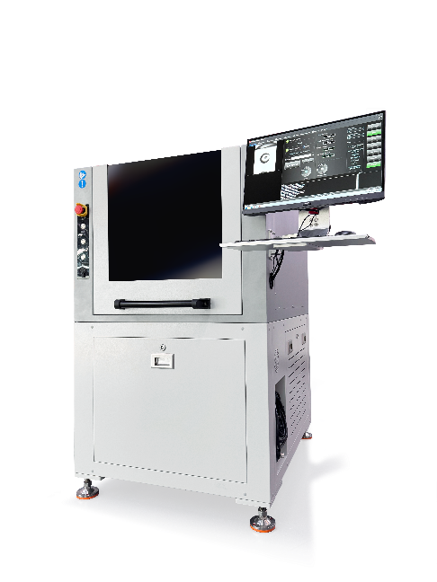 | 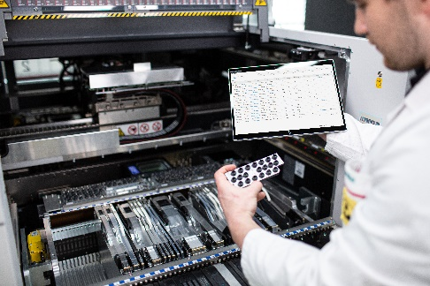
The automated Smart Nozzle Station is an integral part of an end-to-end, closed-loop nozzle management system.  Image credit: ASMPT | Operators can see at all times where individual nozzles are located, how many placement processes they have executed, their maintenance status, their errors and error rates, when their last check was performed, and whether they are currently being blocked.  Image credit: ASMPT

About ASMPT Limited (“ASMPT”)
ASMPT Limited is a leading global supplier of hardware and software solutions for the manufacture of semiconductors and electronics. Headquartered in Singapore, ASMPT’s offerings encompass the semiconductor assembly & packaging, and SMT (surface mount technology) industries, ranging from wafer deposition to the various solutions that organize, assemble and package delicate electronic components into a vast range of end-user devices. ASMPT partners with customers very closely, with continuous investments in R&D helping to provide cost-effective, industry-shaping solutions that achieve higher productivity, greater reliability, and enhanced quality. ASMPT is a founding member of the Semiconductor Climate Consortium.
To learn more about ASMPT, please visit www.asmpt.com.

The ASMPT SMT Solutions segment
The mission of the SMT Solutions segment within ASMPT is to implement and support the Intelligent Factory at electronics manufacturers worldwide.
ASMPT solutions support the networking, automation, and optimization of central workflows with hardware, software and services that enable electronics manufacturers to transition to the Intelligent Factory in stages and enjoy dramatic improvements in productivity, flexibility, and quality. With its integrated open automation concept, ASMPT opens the door for its customers to economically feasible automation, entirely in accordance with their individual requirements – modular, flexible, and vendor-independent.
The product range includes hardware and software such as SIPLACE placement solutions, DEK printing solutions, inspection and storage solutions, and the WORKS Software Suite. With WORKS, ASMPT offers electronics manufacturers high-quality software for planning, controlling, analyzing and optimizing all processes on the shop floor. Maintaining close relationships with customers and technology partners is a central component of ASMPT’s strategy.
For more information about ASMPT SMT Solutions, visit smt.asmpt.com.
Media contacts:
AMCAS ASMPT Press Office
SMT Solutions
Mark Ogden
Phone: +1 (770) 797 3189
E-mail: ogden.mark@asmpt.com
Website: smt.asmpt.com

Global ASMPT Press Office
ASMPT Limited
Susanne Oswald
Rupert-Mayer-Strasse 48
81379 Munich
Germany
Phone: +49 89 20800-26439
E-Mail: susanne.oswald@asmpt.com
Website: asmpt.com

