PRESS RELEASE

SMT flat-wire inductor for automotive electronics
Flat Wire and High Efficiency
Waldenburg (Germany), May 5, 2026 – Würth Elektronik introduces its new WE-SFIA series of flat-wire inductors in 2010, 2013, and 2016 packages. The inductors feature exceptionally low DC resistance and extended operating temperature range from -40°C to +180°C. The WE-SFIA series is available as catalogue components but can also be adapted to meet customer-specific requirements.
The WE-SFIA inductors are designed for high-efficiency DC/DC converters in the automotive field, such as single- and multiphase converters, as well as buck and boost converters with high saturation currents of up to 150 A. Other filter choke applications include battery management, motor, audio, and infotainment systems.
Flat-wire technology used in the chokes offers a host of advantages: It is mechanically more robust and enables tighter, more even windings as well as improved heat dissipation. Flat-wire windings also offer a larger cross-sectional area, thus reducing electrical resistance. This results in a higher current-carrying capacity, which provides significant advantages in handling transient current peaks. AC losses, such as the skin effect, are also significantly lower in high-frequency applications than in comparable round-wire variants.
Compact and efficient
Thanks to the optimized core material, Würth Elektronik achieves improved magnetic saturation performance with its WE-SFIA inductors compared to other commercial products. The WE-SFIA product series is characterized by its compact design, high temperature resistance, and energy efficiency. This opens up new design possibilities for developers. The flat-wire inductors are available with values from 0.33 µH to 4.7 µH. Further inductance values are available on request.

Available images
The following images can be downloaded from the Internet in printable quality: https://kk.htcm.de/press-releases/wuerth/
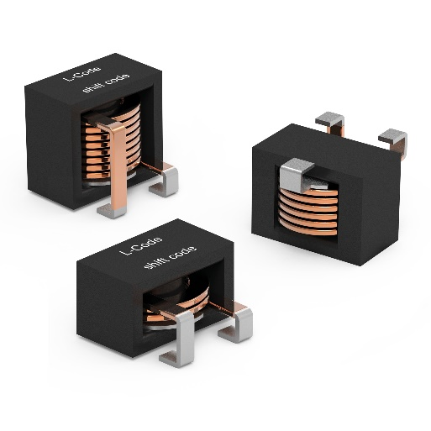
Image source: Würth Elektronik
The three standard sizes of the WE-SFIA flat-wire inductor

About the Würth Elektronik eiSos Group
Würth Elektronik eiSos Group is a manufacturer of electronic and electromechanical components for the electronics industry and a technology company that spearheads pioneering electronic solutions. Würth Elektronik eiSos is one of the largest European manufacturers of passive components and is active in 50 countries. Production sites in Europe, Asia and North America supply a growing number of customers worldwide.
The product range includes passive components, power modules, digital isolators, optoelectronics, electromechanical components, thermal management solutions, sensors and wireless modules. The portfolio is rounded off by customer-specific solutions.
The unrivaled service orientation of the company is characterized by the availability of all catalog components from stock without minimum order quantity, free samples and extensive support through technical sales staff and selection tools.

Würth Elektronik is part of the Würth Group, the global market leader in the development, production, and sale of fastening and assembly materials, and employs around 7,300 people. In 2025, the Würth Elektronik Group generated sales of 1.06 Billion Euro.
Würth Elektronik: more than you expect!
Further information at www.we-online.com

Further information:  Würth Elektronik eiSos GmbH & Co. KG  Sarah Hurst  Clarita-Bernhard-Strasse 9  81249 Munich  Germany  Phone: +49 7942 945-5186  E-mail: sarah.hurst@we-online.de  www.we-online.com | Press contact:  HighTech communications GmbH  Brigitte Basilio  Brunhamstrasse 21  81249 Munich  Germany  Phone: +49 89 500778-20  E-mail: b.basilio@htcm.de  www.htcm.de

