FOR THE MEDIA
ASMPT at SEMICON Southeast Asia 2026
From Advanced Packaging to Intelligent Factories
Singapore, April 28, 2026 – ASMPT will exhibit at SEMICON Southeast Asia 2026 from May 5 to 7, 2026, at Booth #1164 at the MITEC Exhibition Centre in Kuala Lumpur, Malaysia. Under the theme “Empower the Intelligence Revolution,” ASMPT will showcase how advanced semiconductor packaging, intelligent SMT assembly, and intelligent factory technologies enable next-generation applications in Artificial Intelligence, Smart Mobility, and Hyperconnectivity.
At SEMICON Southeast Asia 2026, ASMPT will demonstrate how the integration of semiconductor and electronics manufacturing technologies supports production-ready implementation across the manufacturing value chain. Exhibits from ASMPT Semiconductor Solutions, ASMPT SMT Solutions, and Critical Manufacturing illustrate a combined approach spanning advanced packaging, precision assembly, and factory-level information flow.
Packaging and assembly solutions for Intelligence Revolution
The ASMPT booth will showcase advanced packaging and assembly technologies for co-packaged optical and photonic components, high-performance computing, energy management, computer systems, imaging and sensor technology, and automotive lighting. These solutions address current industry challenges, such as fine-pitch interconnects, the complexity of integration, and scalable manufacturing in semiconductor and electronics production.
In addition, ASMPT will also contribute to the Advanced Packaging & Heterogeneous Integration Summit during the exhibition. On May 4, Lim Choon Khoon, Senior Vice President and Chief Counsel for Advanced Packaging at ASMPT SEMI, will discuss how a holistic approach to bonding and integration, covering materials readiness, process integration, and in-line metrology, supports the industrialization of advanced packaging for AI applications.

SMDs and dies on an intelligent SMT production line
ASMPT SMT Solutions will demonstrate how advanced packaging capabilities are converging with SMT assembly. The award-winning SIPLACE CA2 combines high-speed die assembly directly from wafer with classic SMT placement in a single platform, achieving throughput rates of up to 54,000 dies and 76,000 SMDs per hour with placement accuracy of up to ±10 µm @ 3σ. SIPLACE TX micron delivers placement accuracy of up to ±10 µm at throughput rates of up to 93,000 components per hour for System-in-Package and advanced module applications. ASMPT WORKS Software and Factory Solutions complement the placement platforms with intelligent automation and production transparency.
From assembly to intelligent factory
Beyond individual assembly and packaging technologies, ASMPT will also present the MES-powered industrial operations platform for AI-ready manufacturing from its software subsidiary, Critical Manufacturing, demonstrating how manufacturers can move from connected operations to intelligent, AI-driven production environments.

Illustrations for downloading
The following images are available for download in printable format at:
https://kk.htcm.de/press-releases/asmpt/

 | 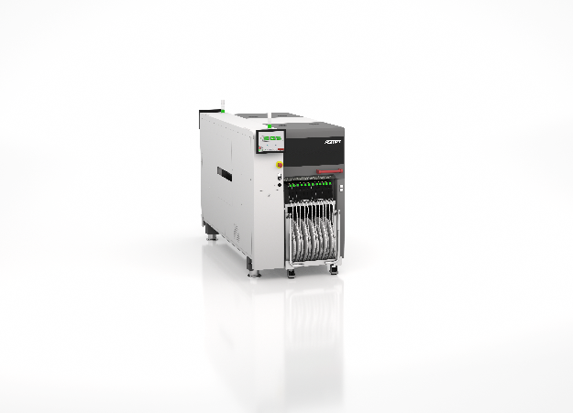
Lim Choon Khoon, Senior Vice President and Chief Counsel for Advanced Packaging, ASMPT SEMI, speaking at SEMICON SEA 2026  Image credit: ASMPT | The advanced packaging technology of the SIPLACE TX micron assembles dies, bare semiconductor chips, as well as classic SMT components.  Image credit: ASMPT
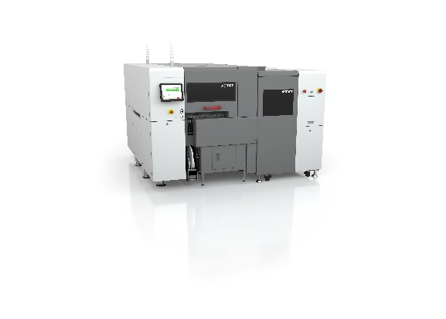
The award-winning SIPLACE CA2 boosts productivity in advanced packaging by combining classic surface-mount technology with die-attach and flip-chip assembly.

Image credit: ASMPT

About ASMPT Limited (“ASMPT”)
ASMPT Limited is a leading global supplier of hardware and software solutions for the manufacture of semiconductors and electronics. Headquartered in Singapore, ASMPT’s offerings encompass the semiconductor assembly & packaging, and SMT (surface mount technology) industries, ranging from wafer deposition to the various solutions that organise, assemble and package delicate electronic components into a vast range of end-user devices. ASMPT partners with customers very closely, with continuous investment in R&D helping to provide cost-effective, industry-shaping solutions that achieve higher productivity, greater reliability, and enhanced quality. ASMPT is also a founding member of the Semiconductor Climate Consortium.
To learn more about ASMPT, please visit us at asmpt.com.

About ASMPT Semiconductor Solutions (“ASMPT SEMI”)
ASMPT SEMI is the leading supplier in advanced packaging and semiconductor assembly solutions. With a commitment to innovation and customer satisfaction, ASMPT SEMI provides a comprehensive range of products and services that cater to the evolving needs of the microelectronics industry. Their expertise spans across areas such as flip-chip and wafer-level packaging, advanced interconnect technologies, and more. ASMPT SEMI's cutting-edge solutions enable customers to achieve higher performance, increased reliability, and improved cost-efficiency when producing their semiconductor devices.
ASMPT SEMI sees itself as a pioneer and driving force of the Intelligence Revolution. With its advanced packaging and assembly technologies, the business segment creates the invisible connections that enable intelligent applications in Artificial Intelligence, Smart Mobility and Hyperconnectivity.
For more information about ASMPT SEMI, visit semi.asmpt.com.
Media contacts:
Global ASMPT Semiconductor Solutions Press Office
ASMPT Limited
Jessica Ho
Semiconductor Solutions
E-Mail: semi_stratmkt@asmpt.com
Website: semi.asmpt.com

Global ASMPT Press Office
ASMPT Limited
Susanne Oswald
Rupert-Mayer-Strasse 48
81379 Munich
Germany
Phone: +49 89 20800-26439
E-Mail: susanne.oswald@asmpt.com
Website: asmpt.com

