PRESS RELEASE

Hufschmied tool for post-processing additives
Injection mold with conformal cooling only completed thanks to special tooling
Bobingen (Germany), May 5, 2026 – A new, additively manufactured injection mold proved difficult to rework. The hard machining tool previously preferred by the toolmaking department at Erich Rothe GmbH & Co. KG broke after just five minutes. The experiment with a new tool paid off: Using the HC643FB milling tool from Hufschmied Zerspanungssysteme, finishing the injection mold part made of Uddeholm Tyrax ESR proved to be a reliable solution.
Reducing cycle times in injection molding has always been an important optimization goal in plastics processing. “We tested various versions of the standard steel insert for the injection molding tool used to produce the reels on which the component tapes are delivered in electronics manufacturing. We then decided to try out conformal cooling,” explains Bernd Gruber, Head of Toolmaking at Rothe. Gruber found a service provider who was able to manufacture his new design using the laser powder bed fusion (LPBF) process and Uddeholm Tyrax ESR, a corrosion-resistant premium plastic mold steel with high ductility, wear resistance, and a hardness of 58 HRC. Additive-manufactured workpieces always show their layer-by-layer generation, and the rough surface must be reworked. This became a challenge in this case.
Alternative tool
"We followed the material supplier's specifications when finishing the blank, but the result was frustrating. The cutting edges of the tool broke off after five minutes," recalls Max Hahn, the CNC technician who wanted to bring the blank into its final shape on a Micron HEM 500U. An offer from Hufschmied came at just the right time and provided the solution with a tool life of at least 18 hours. HC643FB is a 3D finishing cutter for hard machining above 40 HRC and up to 72 HRC. It has three unequally divided cutting edges and the contour of a flattened ball, which allows 35 percent more feed than a ball cutter. The tool consists of an ultra-fine-grain carbide substrate and has a special micro-edge geometry. The in-house 3 µm thick TL12 coating made of TiAlSi has a hardness of 3800 HV.
Perfect fit for this material
Hufschmied's hard machining tool proved to be the perfect choice for Voestalpine's special tool steel. “We examined one of the Hufschmied tools under a microscope after 15 hours of use, and it was like new,” recalls Max Hahn. The service life was ultimately at least 18 hours. “We really appreciate that Hufschmied's hard machining tools give us this process reliability,” says Bernd Gruber.
Thomas Wohlfromm, technical consultant and sales representative at Hufschmied Zerspanungssysteme GmbH, is delighted with the regular orders now coming in from Rothe: “We are much better known for our tools for machining composite materials. So I am all the more pleased that we have encountered a challenge here in connection with a hard material for additive manufacturing and have passed it with flying colors. Finishing such blanks is a task that many users will be encountering, and it is good to know that we already have the solution.”

Available images
The following images can be downloaded from the Internet in printable quality:
https://kk.htcm.de/press-releases/hufschmied/
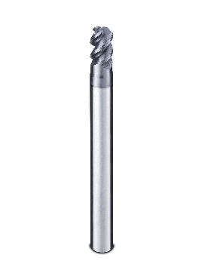  Image source: Hufschmied Zerspanungssysteme  The HC643FB tool from Hufschmied proved to be perfectly suited for finishing an additively manufactured workpiece made of Uddeholm Tyrax ESR. | 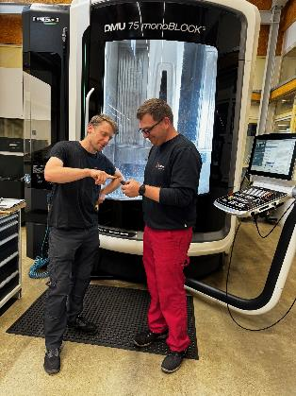  Image source: Erich Rothe GmbH & Co. KG  CNC technicians Max Hahn (left) and René Pfeuffer with the hard machining tool from Hufschmied
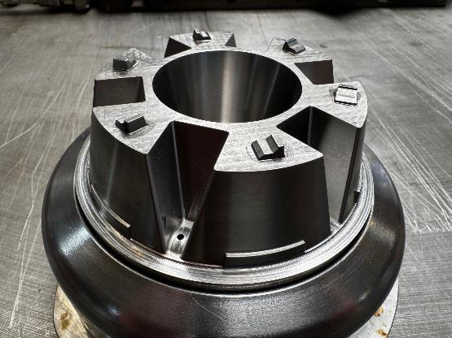
Image source: Erich Rothe GmbH & Co. KG
The new tool insert, which provides conformal cooling, after machining with the Hufschmied tool

About Erich Rothe GmbH & Co. KG
Rothe was founded in Chemnitz in 1907 and has been based in Kitzingen since 1964. The company manufactures industrial plastic products using thermoforming, extrusion and injection moulding processes. Rothe was one of the first producers of tthermoformed carrier tapes for electronic assembly and is now one of Europe’s largest manufacturers.
For more information: www.rothe.de

About Hufschmied Zerspanungssysteme GmbH
Established in 1991 and headquartered in Bobingen near Augsburg, Hufschmied Zerspanungssysteme GmbH is a manufacturer of high-quality tools for machinable production and friction stir welding. By specializing at an early stage in the machining of plastics, fiberglass materials and carbon fiber, Hufschmied has become a leader in Europe in the development of solutions for new materials. The company is an established system supplier to renowned machine tool manufacturers. Tools and manufacturing process consulting from Hufschmied are particularly valued in the automotive and aerospace industries as well as in medical technology. The company is involved in numerous organizations, including Composites United Deutschland e. V. Hufschmied's manufacturing operations are located in Bobingen, Winterlingen and Sigmaringen on the Swabian Alb. Hufschmied is certified according to ISO 9001:2015 (quality management) and ISO 14001:2015 (environmental management).

Hufschmied Zerspanungssysteme GmbH – One Cut Ahead
For more information: www.hufschmied.net

Additional information:  Hufschmied Zerspanungssysteme GmbH  Marco Beigl  Edisonstrasse 11d  86399 Bobingen  Germany  Phone: +49 8234 9664-0  Telefax: +49 8234 9664-99  E-Mail: info@hufschmied.net  www.hufschmied.net | Press contact:  HighTech communications GmbH  Brigitte Basilio  Brunhamstrasse 21  81249 Munich  Germany  Phone: +49 89 500778-20  E-Mail: b.basilio@htcm.de  www.htcm.de

