PRESS RELEASE

Würth Elektronik expands its Horticulture LED Portfolio
More Light, Greater Efficiency, Better Growth
Waldenburg (Germany), April 23, 2026 – Würth Elektronik has made a name for itself with LEDs for controlled plant cultivation and has expanded its WL-SMDC Horticulture product line with new LEDs in the 3535 package. These LEDs feature a photon efficacy (PPE) of up to 4.9 µmol/J and a photosynthetic photon flux (PPF) of up to 6.34 µmol/s. The three LEDs – with wavelengths of 450, 660, and 730 nm – set new standards for professional lighting solutions in greenhouses and in Controlled Environmental Agriculture (CEA).
The LEDs are dimmable and controllable, enabling precise adjustment of light intensity and spectrum. The “Horticalculator” on the REDEXPERT online simulation platform can be used to create and optimize customized lighting recipes. Spectral mixes can be precisely matched to different plant species, growth stages, and plant quality parameters.
Scientifically sound
The new series is aimed specifically at developers and manufacturers of lighting systems for greenhouses, vertical farming, controlled-environment agriculture (CEA), container farming, specialty crops, research applications, as well as algae and aquarium lighting. Their high efficiency, increased output, and compact 3535 package make these LEDs ideal for modular, large-scale, and energy-optimized lighting concepts. Würth Elektronik works closely with research institutions, ensuring scientific insights have been incorporated into this new generation of horticulture LEDs.
All Würth Elektronik horticulture LEDs are available from stock without a minimum order quantity. Free samples can be requested for development projects.
“Controlled Environmental Agriculture supports and complements conventional agriculture and horticulture wherever it reaches its limits, such as in the year-round regional supply of fresh produce. Our horticulture LEDs enable this. In view of the growing global population, location-independent food production is set to play a key role in the future,” says Alexander Gerfer, CTO of the Würth Elektronik eiSos Group.

Available images
The following images can be downloaded from the Internet in printable quality: https://kk.htcm.de/press-releases/wuerth/
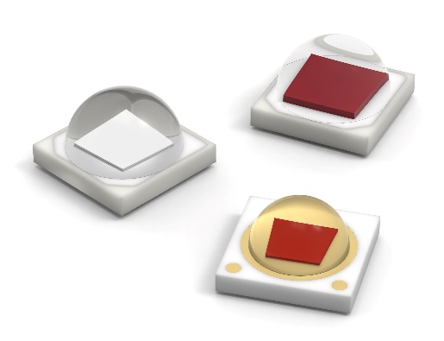
Image source: Würth Elektronik
Würth Elektronik’s new WL-SMDC horticulture LED series in a compact 3535 package.

About the Würth Elektronik eiSos Group
Würth Elektronik eiSos Group is a manufacturer of electronic and electromechanical components for the electronics industry and a technology company that spearheads pioneering electronic solutions. Würth Elektronik eiSos is one of the largest European manufacturers of passive components and is active in 50 countries. Production sites in Europe, Asia and North America supply a growing number of customers worldwide.
The product range includes passive components, power modules, digital isolators, optoelectronics, electromechanical components, thermal management solutions, sensors and wireless modules. The portfolio is rounded off by customer-specific solutions.
The unrivaled service orientation of the company is characterized by the availability of all catalog components from stock without minimum order quantity, free samples and extensive support through technical sales staff and selection tools.

Würth Elektronik is part of the Würth Group, the global market leader in the development, production, and sale of fastening and assembly materials, and employs around 7,300 people. In 2025, the Würth Elektronik Group generated sales of 1.06 Billion Euro.
Würth Elektronik: more than you expect!
Further information at www.we-online.com

Further information:  Würth Elektronik eiSos GmbH & Co. KG  Sarah Hurst  Clarita-Bernhard-Strasse 9  81249 Munich  Germany  Phone: +49 7942 945-5186  E-mail: sarah.hurst@we-online.de  www.we-online.com | Press contact:  HighTech communications GmbH  Brigitte Basilio  Brunhamstrasse 21  81249 Munich  Germany  Phone: +49 89 500778-20  E-mail: b.basilio@htcm.de  www.htcm.de

