PRESS RELEASE
ASMPT SMT Solutions at Productronica India 2026
Great interest in integrated manufacturing solutions
Singapore, April 23, 2026 – ASMPT SMT Solutions was represented at Productronica India 2026 together with its distribution partners Maxim SMT and ALN Tronics. Given the large number of qualified trade show visitors, the global technology and market leader in hardware and software solutions for electronics manufacturing considers its trade show appearance a great success.
Under the motto “We boost your intelligent factory”, ASMPT, Maxim SMT and ALN Tronics used concrete solutions to show how stable, efficient and scalable manufacturing processes can be implemented by having DEK TQ solder paste printers and SIPLACE TX placement machines interact with integrated software solutions. The focus was also on the placement head CP20 for high-speed applications with standard components and the placement head CPP for flexible applications that changes its mode on demand.
Supplementing the hardware, ASMPT provided information about its software solutions WORKS Optimization, WORKS Monitoring, Factory Equipment Center, and SMT Analytics, all of which make it possible to provide end-to-end transparency and make data-based improvements along the entire SMT line up to the factory level.
The discussions at the trade fair made it clear that there is great demand for integrated approaches that integrate seamlessly into existing manufacturing environments and deliver measurable results quickly. Many visitors took the opportunity to learn more about concrete use cases and exchange information about ways to increase line performance, quality and flexibility.
“We gained a very clear picture in many interactions: While the requirements continue to increase, solutions must work reliably in everyday operations. This is precisely where our integrated approach of hardware and software comes into play,” said Neeraj Bhardwaj, General Manager India, Bangladesh & Sri Lanka at ASMPT SMT Solutions. “India is a strategically important market for us that we will continue to develop for the long term with our own local sales and service teams as well as with our strong sales partners.”
With its presence at Productronica India, ASMPT SMT Solutions underscored its strong commitment to the region. The aim is to keep supporting local electronics manufacturers on their journey to the intelligent factory with powerful time-tested solutions.

Illustrations for downloading
The following print-ready artwork is available on the internet for downloading:
https://kk.htcm.de/press-releases/asmpt/

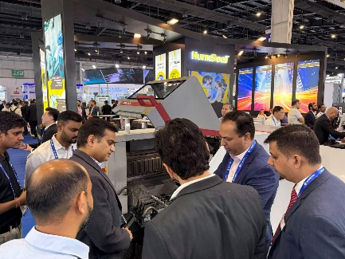 | 
The SIPLACE TX placement platform from ASMPT SMT Solutions was met with great interest by visitors.  Image credit: ASMPT | Neeraj Bhardwaj, General Manager India, Bangladesh & Sri Lanka at ASMPT SMT Solutions  Image credit: ASMPT
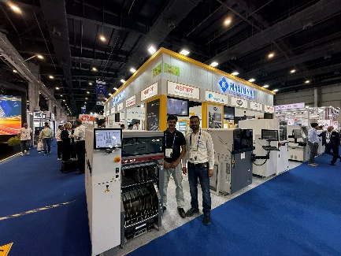 | 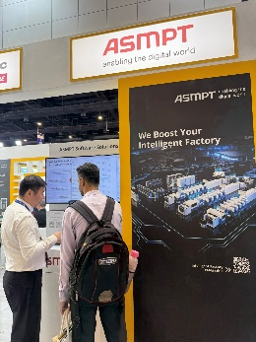
The joint booth of ASMPT SMT Solutions, Maxim SMT, and ALN Tronics featured the DEK TQ printer platform and the SIPLACE TX placement platform.  Image credit: ASMPT | Under the theme “We boost your intelligent factory,” ASMPT SMT Solutions provided information about its integrated hardware and software portfolio.  Image credit: ASMPT

About ASMPT Limited (“ASMPT”)
ASMPT Limited is a leading global supplier of hardware and software solutions for the manufacture of semiconductors and electronics. Headquartered in Singapore, ASMPT’s offerings encompass the semiconductor assembly & packaging and SMT (surface mount technology) industries, ranging from wafer deposition to the various solutions that organize, assemble and package delicate electronic components into a vast range of end-user devices. ASMPT partners with customers very closely, with continuous investments in R&D helping to provide cost-effective, industry-shaping solutions that achieve higher productivity, greater reliability, and enhanced quality. ASMPT is a founding member of the Semiconductor Climate Consortium.
To learn more about ASMPT, please visit www.asmpt.com.

The ASMPT SMT Solutions segment
The mission of the SMT Solutions segment within ASMPT is to implement and support the Intelligent Factory at electronics manufacturers worldwide.
ASMPT solutions support the networking, automation, and optimization of central workflows with hardware, software and services that enable electronics manufacturers to transition to the Intelligent Factory in stages and enjoy dramatic improvements in productivity, flexibility, and quality. With its integrated open automation concept, ASMPT opens the door for its customers to economically feasible automation, entirely in accordance with their individual requirements – modular, flexible, and vendor-independent.
The product range includes hardware and software such as SIPLACE placement solutions, DEK printing solutions, inspection and storage solutions, and the WORKS Software Suite. With WORKS, ASMPT offers electronics manufacturers high-quality software for planning, controlling, analyzing and optimizing all processes on the shop floor. Maintaining close relationships with customers and technology partners is a central component of ASMPT’s strategy.
For more information about ASMPT SMT Solutions, visit smt.asmpt.com.
Media contacts:
ASMPT ROA Press Office
SMT Solutions
ASMPT SMT Singapore Pte. Ltd.
Janet Loh
Phone: +65 6877 3948
E-mail: Janet.loh@asmpt.com
Website: smt.asmpt.com

Global ASMPT Press Office
ASMPT Limited
Susanne Oswald
Rupert-Mayer-Strasse 48
81379 Munich
Germany
Tel: +49 89 20800-26439
E-mail: susanne.oswald@asmpt.com
Website: asmpt.com

