FOR THE MEDIA
ASMPT SMT Solutions continues to expand its sales and service organization in the U.S. market
ASMPT wins JSD as a new distributor
Atlanta (USA), April 21, 2026 – To further expand its activities in the U.S. market, global technology and market leader ASMPT SMT Solutions is entering into a sales and service partnership with JSD America as a new distributor for the Southeast. With this cooperation, ASMPT is increasing its presence in one of the most dynamic electronics manufacturing regions of the country while improving the support options for its local customers.
JSD America will handle the sales and service operations for ASMPT solutions in the Southeastern United States in the future in order to give electronics manufacturers in the region direct access to technologies, process and product know-how, and technical support.
Strengthening the local market presence
With this partnership, ASMPT continues to expand its activities in the North American market. The U.S. electronics industry is currently investing more actively in new production capacities, especially in areas such as AI infrastructure, high-performance computing, communication systems, and automotive and industrial electronics. In this environment, having a strong local presence in sales and service is becoming increasingly important.
“The American market is currently developing very dynamically,” said Alexander Hagenfeldt, General Manager, ASMPT SMT Solutions USA & Canada. “With JSD America, we are gaining an experienced partner who knows the market very well and can support our customers with a high level of technical expertise. At the same time, we are continuing to expand our local sales and service organization since we want to be even closer to our customers and provide them with first-class advice.”
Proven partnership
ASMPT has been working closely and successfully with JSD for more than 14 years, including in Europe. With the new cooperation in the U.S., both companies want to take advantage of the opportunities that the North American market offers. “For us, ASMPT is the clear technology leader in electronics manufacturing, which is why we wanted to expand this partnership. We are impressed by the performance capabilities of ASMPT’s portfolio and its innovative strength. By working together, we will be able to support our customers in the North American market even more effectively,” said Nico Leon, General Manager at JSD America.
Experience and SMT know-how
JSD was founded in 2004 and has more than two decades of experience in the SMT market. The company offers solutions and systems for electronics manufacturers and sells machines, installations and spare parts for various production processes such as SMT assembly, soldering technology, and testing. JSD’s employees regularly attend training seminars at the training centers of its technology partners. JSD America has already hired several SMT engineers and operates from its Suwanee site in the Atlanta metropolitan area.
Service expansion and customer proximity
The collaboration with JSD is part of ASMPT’s strategy to support its customers in North America even more closely. In addition to expanding its network of distributors, the company is also investing in the expansion of its service organization in order to provide electronics manufacturers with rapid support, a high level of technical expertise, and short response times. With the new partnership, ASMPT is strengthening its presence in the American market and creating additional capacities to help electronics manufacturers build high-performance, intelligent manufacturing operations.

Illustrations for downloading
The following print-ready artwork is available on the internet for downloading:
https://kk.htcm.de/press-releases/asmpt/

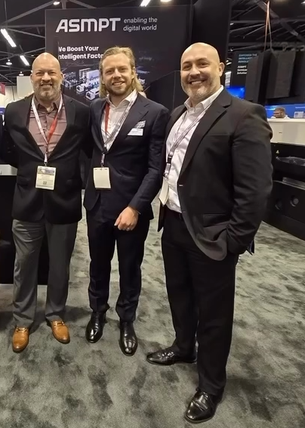
From left to right: Mike Taveras, JSD America, Alexander Hagenfeldt, General Manager, ASMPT SMT Solutions USA & Canada, and Nico Leon, General Manager, JSD America

Image credit: ASMPT

About ASMPT Limited (“ASMPT”)
ASMPT Limited is a leading global supplier of hardware and software solutions for the manufacture of semiconductors and electronics. Headquartered in Singapore, ASMPT’s offerings encompass the semiconductor assembly & packaging, and SMT (surface mount technology) industries, ranging from wafer deposition to the various solutions that organize, assemble and package delicate electronic components into a vast range of end-user devices. ASMPT partners with customers very closely, with continuous investments in R&D helping to provide cost-effective, industry-shaping solutions that achieve higher productivity, greater reliability, and enhanced quality. ASMPT is a founding member of the Semiconductor Climate Consortium.
To learn more about ASMPT, please visit www.asmpt.com.

The ASMPT SMT Solutions segment
The mission of the SMT Solutions segment within ASMPT is to implement and support the Intelligent Factory at electronics manufacturers worldwide.
ASMPT solutions support the networking, automation, and optimization of central workflows with hardware, software and services that enable electronics manufacturers to transition to the Intelligent Factory in stages and enjoy dramatic improvements in productivity, flexibility, and quality. With its integrated open automation concept, ASMPT opens the door for its customers to economically feasible automation, entirely in accordance with their individual requirements – modular, flexible, and vendor-independent.
The product range includes hardware and software such as SIPLACE placement solutions, DEK printing solutions, inspection and storage solutions, and the WORKS Software Suite. With WORKS, ASMPT offers electronics manufacturers high-quality software for planning, controlling, analyzing and optimizing all processes on the shop floor. Maintaining close relationships with customers and technology partners is a central component of ASMPT’s strategy.
For more information about ASMPT SMT Solutions, visit smt.asmpt.com.
Media contacts:
AMCAS ASMPT Press Office
SMT Solutions
Mark Ogden
Phone: +1 (770) 797 3189
E-mail: ogden.mark@asmpt.com
Website: smt.asmpt.com

Global ASMPT Press Office
ASMPT Limited
Susanne Oswald
Rupert-Mayer-Strasse 48
81379 Munich
Germany
Tel: +49 89 20800-26439
E-mail: susanne.oswald@asmpt.com
Website: asmpt.com

