FOR THE MEDIA
WORKS Monitoring from ASMPT
More transparency and accuracy in SMT production
Singapore, April 15, 2026 – ASMPT SMT Solutions, the technology and market leader in integrated hardware and software solutions for electronics manufacturing, presents a new version of WORKS Monitoring. The application, which is part of the WORKS Software Suite, has been further advanced and now features more detailed production data along the SMT line. Thanks to new filter functions and user-friendly visualizations, the software now presents production processes even more transparently and allows operators to recognize deviations at an early stage. WORKS Monitoring displays all relevant performance indicators in real time and shows how stably and efficiently the lines are running.
During their work on the new version of the software, the developers focused especially on advancing its evaluative capabilities. In addition to the well-known KPI overviews, it is now possible to analyze production data down to the detail level. Machine statuses are shown transparently over time, including production phases and downtimes along with their respective durations. Even reject rates can be analyzed and broken down by fault types, components, and lines. Thanks to this information, deviations in ongoing production operations can now be detected earlier and classified more precisely.
More flexible filtering and searching
The new version’s expanded filter and search functions are another major advance. Production data can now be isolated and compared by period, line, machine, order, or placement program. This enables the operators to view even complex production situations in a structured manner and filter out exactly the information they need. Under real production conditions, in which many factors are often at work simultaneously, this degree of flexibility makes it much easier to assess any abnormalities. Instead of manually analyzing large sets of data, critical developments can now be narrowed down to the relevant level step by step. To supplement this capability, new comparison and ranking functions have been added that indicate which faults occur particularly frequently and which components or processes are disproportionately affected.
Clear displays for quick decision-making
In addition to making functional enhancements, the developers also worked on the user interface. New chart types and a clearly structured navigation make it possible to quickly grasp and classify large amounts of data in everyday operations. The presentation is clearly laid out, and relevant information is presented in a way that makes deviations, trends and critical conditions instantly visible so that operators can see at a glance where they need to take action and respond accordingly. Especially in production operations, where decisions must often be made under time pressure, this clear presentation makes orientation easier and creates a reliable basis for quick and well-founded decisions.
Monitoring as the basis for stable processes
“In many production environments, the relevant data is already available but not yet being used consistently,” said Isabell Obst, Director Product Management Software Solutions at ASMPT SMT Solutions. “WORKS Monitoring creates the necessary transparency to make precisely this information usable in everyday operations – from the initial overview down to the smallest details of individual process steps. This creates the foundation for making data-driven decisions in the intelligent factory.”

Illustrations for downloading
The following print-ready artwork is available on the internet for downloading:
https://kk.htcm.de/press-releases/asmpt/

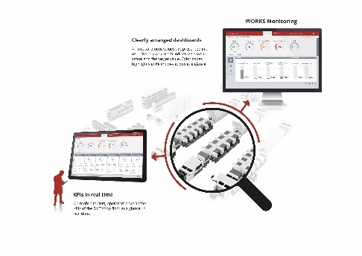 | 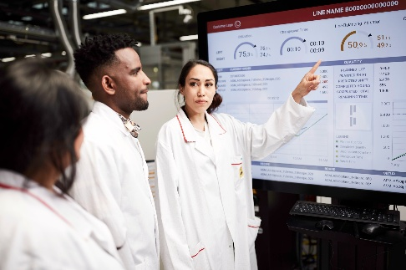
By transparently displaying production data on the line level, WORKS Monitoring delivers the foundation for data-based decision-making in the intelligent factory.  Image credit: ASMPT | The user interface of WORKS Monitoring visualizes key performance indicators and process statuses clearly and in real time.  Image credit: ASMPT

Isabell Obst, Director Product Management Software Solutions at ASMPT SMT Solutions

Image credit: ASMPT

About ASMPT Limited (“ASMPT”)
ASMPT Limited is a leading global supplier of hardware and software solutions for the manufacture of semiconductors and electronics. Headquartered in Singapore, ASMPT’s offerings encompass the semiconductor assembly & packaging, and SMT (surface mount technology) industries, ranging from wafer deposition to the various solutions that organize, assemble and package delicate electronic components into a vast range of end-user devices. ASMPT partners with customers very closely, with continuous investments in R&D helping to provide cost-effective, industry-shaping solutions that achieve higher productivity, greater reliability, and enhanced quality. ASMPT is a founding member of the Semiconductor Climate Consortium.
To learn more about ASMPT, please visit www.asmpt.com.

The ASMPT SMT Solutions segment
The mission of the SMT Solutions segment within ASMPT is to implement and support the Intelligent Factory at electronics manufacturers worldwide.
ASMPT solutions support the networking, automation, and optimization of central workflows with hardware, software and services that enable electronics manufacturers to transition to the Intelligent Factory in stages and enjoy dramatic improvements in productivity, flexibility, and quality. With its integrated open automation concept, ASMPT opens the door for its customers to economically feasible automation, entirely in accordance with their individual requirements – modular, flexible, and vendor-independent.
The product range includes hardware and software such as SIPLACE placement solutions, DEK printing solutions, inspection and storage solutions, and the WORKS Software Suite. With WORKS, ASMPT offers electronics manufacturers high-quality software for planning, controlling, analyzing and optimizing all processes on the shop floor. Maintaining close relationships with customers and technology partners is a central component of ASMPT’s strategy.
For more information about ASMPT SMT Solutions, visit smt.asmpt.com.

Media contacts:
ASMPT ROA Press Office
SMT Solutions
ASMPT SMT Singapore Pte. Ltd.
Janet Loh
Phone: +65 6877 3948
E-mail: Janet.loh@asmpt.com
Website: smt.asmpt.com

Global ASMPT Press Office
ASMPT Limited
Susanne Oswald
Rupert-Mayer-Strasse 48
81379 Munich
Germany
Tel: +49 89 20800-26439
E-mail: susanne.oswald@asmpt.com
Website: asmpt.com

