PRESS RELEASE
ASMPT looking back on a successful
APEX EXPO 2026
SIPLACE V strikes a chord with the U.S. market
Atlanta (USA), March 26, 2026 – ASMPT SMT Solutions is looking back on a thoroughly successful APEX EXPO 2026 in Anaheim. The global market and technology leader’s booth was heavily frequented during all three show days and provided the setting for many meetings with customers, partners and industry experts from all over North America. The company’s new SIPLACE V placement platform was the main attraction, and the positive response confirms the importance of the role that powerful and at the same time flexible SMT solutions play for high-growth applications such as AI servers, high-performance computing and modern data center infrastructures. Against this backdrop, ASMPT is also continuing to expand its service organization in the U.S.
The SIPLACE V platform, which was newly developed from the ground up, had its premiere in the American market at the APEX EXPO 2026 under the motto “A new era begins”. Under real-life production conditions, it delivers performance improvements of up to 30 percent in key electronics manufacturing markets by combining high placement performance with maximum precision and flexibility. It handles a wide range of components ranging from super-small 016008M components to large and complex odd-shaped components and BGAs with maximum process stability.
The SIPLACE V placement platform was also designed to meet the future requirements of electronics manufacturers in terms of its system architecture. Its powerful high-speed data communication over Gigabit Ethernet provides the foundation of end-to-end connectivity, machine-to-machine communication, and data-based production optimization. The open platform concept creates the conditions for further automation as well as for applications in the areas of big-data analytics and artificial intelligence. At the same time, it remains fully compatible with existing hardware and software solutions from ASMPT and can be seamlessly integrated into existing SMT lines.
Growth industries drive demand
The interest in the new machine was particularly strong from manufacturers in industries that are currently experiencing dynamic growth. “The discussions at the APEX event showed how strong the investment dynamics currently are in the North American market,” said Alexander Hagenfeldt, General Manager ASMPT SMT USA & Canada. “Applications in the areas of AI infrastructure, high-performance computing and modern data center operations are the main drivers in the demand for powerful SMT solutions. With the new SIPLACE V platform, we are addressing precisely these requirements.”
Complementing its placement technology, ASMPT presented another innovation for demanding applications with the new DEK TQ XL solder paste printer. The system expands the proven DEK TQ platform and is specifically designed for processing oversized circuit boards. It handles boards up to 850 × 610 mm, with a thickness of up to 8 mm and a weight of up to 12 kilograms, even with warpage of up to 4 mm, while printing across the entire PCB surface.
ASMPT’s integrated software portfolio also attracted a great deal of interest. Many visitors learned how hardware and software can be merged to form a fully connected and data-driven intelligent production network.
Expansion of the U.S. service organization
The strong response at the fair also underscored the growing strategic importance of the American market for ASMPT. To better support local customers with a high level of technical expertise and service quality, ASMPT is expanding its service organization in the U.S.
With these investments, ASMPT is strengthening its presence in the North American market and underscoring its commitment to supporting electronics manufacturers not only with powerful hardware and integrated software, but also with a strong local service organization.

Illustrations for downloading
The following print-ready artwork is available on the internet for downloading:
https://kk.htcm.de/press-releases/asmpt/

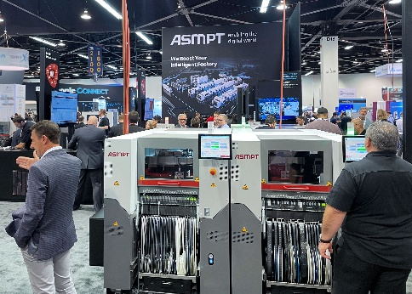 | 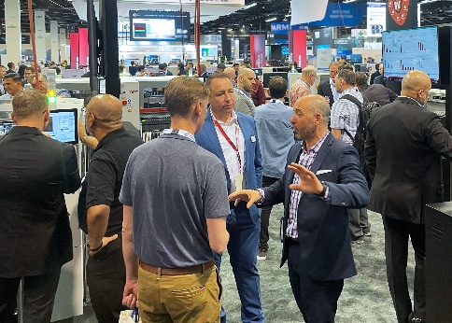
The highlight at the ASMPT booth: With a footprint of just 1.1 × 2.4 meters, the new SIPLACE V gives electronics manufacturing a decisive boost – not only in real performance, but also in quality, flexibility, and future readiness.  Image credit: ASMPT | The ASMPT booth was heavily frequented during all three show days and provided the setting for many meetings with customers, partners and industry experts.  Image credit: ASMPT

Alexander Hagenfeldt, General Manager ASMPT SMT USA & Canada

Image credit: ASMPT

About ASMPT Limited (“ASMPT”)
ASMPT Limited is a leading global supplier of hardware and software solutions for the manufacture of semiconductors and electronics. Headquartered in Singapore, ASMPT’s offerings encompass the semiconductor assembly & packaging, and SMT (surface mount technology) industries, ranging from wafer deposition to the various solutions that organize, assemble and package delicate electronic components into a vast range of end-user devices, which include electronics, mobile communications, computing, automotive, industrial and LED (displays). ASMPT partners with customers very closely, with continuous investments in R&D helping to provide cost-effective, industry-shaping solutions that achieve higher productivity, greater reliability, and enhanced quality. ASMPT is a founding member of the Semiconductor Climate Consortium.
To learn more about ASMPT, please visit www.asmpt.com.

The ASMPT SMT Solutions segment
The mission of the SMT Solutions segment within ASMPT is to implement and support the Intelligent Factory at electronics manufacturers worldwide.
ASMPT solutions support the networking, automation, and optimization of central workflows with hardware, software and services that enable electronics manufacturers to transition to the Intelligent Factory in stages and enjoy dramatic improvements in productivity, flexibility, and quality. With its integrated open automation concept, ASMPT opens the door for its customers to economically feasible automation, entirely in accordance with their individual requirements – modular, flexible, and vendor-independent.
The product range includes hardware and software such as SIPLACE placement solutions, DEK printing solutions, inspection and storage solutions, and the WORKS Software Suite. With WORKS, ASMPT offers electronics manufacturers high-quality software for planning, controlling, analyzing and optimizing all processes on the shop floor. Maintaining close relationships with customers and technology partners is a central component of ASMPT’s strategy.
For more information about ASMPT SMT Solutions, visit smt.asmpt.com.
Media contacts:
AMCAS ASMPT Press Office
SMT Solutions
Mark Ogden
Phone: +1 (770) 797 3189
E-mail: ogden.mark@asmpt.com
Website: smt.asmpt.com

Global ASMPT Press Office
ASMPT Limited
Susanne Oswald
Rupert-Mayer-Strasse 48
81379 Munich
Germany
Tel: +49 89 20800-26439
E-mail: susanne.oswald@asmpt.com
Website: asmpt.com

