FOR THE MEDIA
Active Stencil Storage from ASMPT
SMT stencil handling 4.0
Atlanta (USA), March 31, 2026 – ASMPT’s new Active Stencil Storage offers an efficient and space-saving solution for storing up to 240 DEK VectorGuard™ stencils for the solder paste printing process. An integrated barcode scanner and an LED-based guidance system support operators in selecting stencils quickly and error-free, thus preventing incorrect setups.
“Conventional storage systems for stencils are often too small and cumbersome,” said Rick Goldsmith, Director of Product Management at ASMPT. “Finding the right stencil is too time-consuming and error-prone. With Active Stencil Storage, we were able to eliminate all these problems. The highly efficient system gives electronics manufacturers the flexibility they need today.”
Space-saving, ergonomic, intuitive
With a compact footprint measuring only 110.5 × 69.5 centimeters (43.5 × 27.4 inches), Active Stencil Storage offers the best floor space performance. Each stencil is identified via an integrated barcode scanner, and an intuitive touchscreen guides operators through all work steps without a long training period. An LED on each storage slot indicates where stencils are to be added or removed.
The slots are freely configurable and speed up new product introductions (NPIs) without the risk of faulty setups. And the open-source software is flexibly adaptable to existing IT infrastructures, networks and automation systems.
Developed for DEK VectorGuard™ – compatible and efficient
The Active Stencil Storage system is specially designed for the highly flexible DEK VectorGuard™ clamping frames from ASMPT (584 × 584 mm, or 23 × 23 inches), which are compatible with all popular stencil and printer types and allow for 45 to 65 percent more tension than conventional clamping frames. In addition, their functional design reduces the space requirements in the stencil storage system by up to 75 percent.
Storage and retrieval: Ten seconds instead of five minutes
The Active Stencil Storage system makes the ongoing production significantly more efficient. Thanks to the handheld scanner and LED-based guidance, a template can usually be added or removed in 10 seconds – something that may take up to five minutes with conventional systems. The prevention of faulty setups and related costs also contributes to the quick amortization of the investment.

Illustrations for downloading
The following print-ready artwork is available on the internet for downloading:
https://kk.htcm.de/press-releases/asmpt/

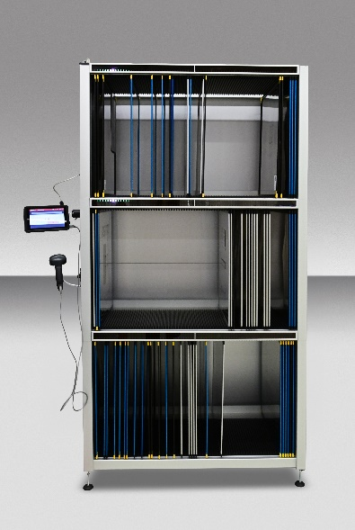 | 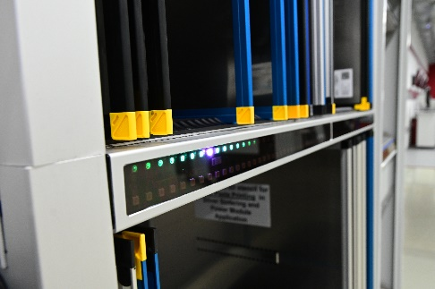
ASMPT’s Active Stencil Storage accommodates up to 240 DEK VectorGuard stencils efficiently organized next to the production line.  Image credit: ASMPT | The LED-based guidance system and the barcode scanner ensure error-free and efficient stencil handling.  Image credit: ASMPT

About ASMPT Limited (“ASMPT”)
ASMPT Limited is a leading global supplier of hardware and software solutions for the manufacture of semiconductors and electronics. Headquartered in Singapore, ASMPT’s offerings encompass the semiconductor assembly & packaging, and SMT (surface mount technology) industries, ranging from wafer deposition to the various solutions that organize, assemble and package delicate electronic components into a vast range of end-user devices. ASMPT partners with customers very closely, with continuous investments in R&D helping to provide cost-effective, industry-shaping solutions that achieve higher productivity, greater reliability, and enhanced quality. ASMPT is a founding member of the Semiconductor Climate Consortium.
To learn more about ASMPT, please visit www.asmpt.com.

The ASMPT SMT Solutions segment
The mission of the SMT Solutions segment within ASMPT is to implement and support the Intelligent Factory at electronics manufacturers worldwide.
ASMPT solutions support the networking, automation, and optimization of central workflows with hardware, software and services that enable electronics manufacturers to transition to the Intelligent Factory in stages and enjoy dramatic improvements in productivity, flexibility, and quality. With its integrated open automation concept, ASMPT opens the door for its customers to economically feasible automation, entirely in accordance with their individual requirements – modular, flexible, and vendor-independent.
The product range includes hardware and software such as SIPLACE placement solutions, DEK printing solutions, inspection and storage solutions, and the WORKS Software Suite. With WORKS, ASMPT offers electronics manufacturers high-quality software for planning, controlling, analyzing and optimizing all processes on the shop floor. Maintaining close relationships with customers and technology partners is a central component of ASMPT’s strategy.
For more information about ASMPT SMT Solutions, visit smt.asmpt.com.
Media contacts:
AMCAS ASMPT Press Office
SMT Solutions
Mark Ogden
Phone: +1 (770) 797 3189
E-mail: ogden.mark@asmpt.com
Website: smt.asmpt.com
Global ASMPT Press Office
ASMPT Limited
Susanne Oswald
Rupert-Mayer-Strasse 48
81379 Munich
Germany
Tel: +49 89 20800-26439
E-mail: susanne.oswald@asmpt.com
Website: asmpt.com
HighTech communications GmbH
Barbara Ostermeier
Brunhamstrasse 21
81249 Munich
Germany
Tel.: +49-89 500778-10|
E-mail: b.ostermeier@htcm.de
Website: www.htcm.de

