Press Release

Symeo at The Rise of IoT, AI & Data in Rail conference for the first time
20–21 May 2026
Radar technology for greater resilience in rail infrastructure and protection against sabotage
Neubiberg (Germany), March 26, 2026 – Symeo, a leading provider of radar-based sensor technology, is taking part in the conference “The Rise of IoT, AI & Data in Rail” for the first time as a bronze sponsor and exhibitor. The conference will take place on 20 and 21 May 2026 at the Maritim Hotel Cologne. Railroad specialists are gathering there to discuss the digital aspects of rail traffic, infrastructure monitoring, and maintenance. Symeo will present a newly developed technology that uses a digital twin of the trackside infrastructure for hazard prevention and predictive maintenance.
During The Rise of IoT, AI & Data in Rail, Symeo will be presenting the concept of radar-based sensor technology for infrastructure monitoring in the rail sector. In countless applications under harsh conditions, from container ports to bulk goods logistics and steelworks, Symeo has proven that radar sensor technology is extremely robust, maintenance-free, and resilient. It is therefore ideal for detecting objects, movements, distances, and infrastructure changes along railroad tracks.
New developments in the field of Synthetic Aperture Radar (SAR) allow detailed data acquisition along railroad lines. With the help of AI-based big data analysis and pattern recognition, this provides a valuable addition to infrastructure monitoring. Tracks and their surroundings can be recorded as a digital twin and constantly updated. Among other things, data synchronization can identify hazards such as environmental or sabotage damage.
Symeo is looking to talk to potential partners at the Cologne conference.

Available image material
The following printable images are available for download on the Internet:
https://kk.htcm.de/press-releases/symeo/

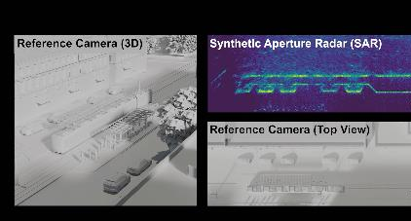Image source: Symeo  SAR application example: recording the immediate surroundings of a streetcar line | Image source: Symeo  Setting the scene for the vision: imaging radar generates a digital twin of railroad lines.

Symeo
Symeo develops and markets products and solutions for precise, non-contact, maintenance-free position detection, distance measurement, and collision avoidance, including radar systems compliant with the functional safety standard EN ISO 13849 PLd. Symeo’s products feature extremely robust designs to make them suitable for applications in harsh industrial environments.
Symeo’s LPR® radar sensor technology offers a wireless and real-time-capable measuring system that is ideally suited for industrial applications. Symeo has many years of experience in the development of cost-efficient and customer-specific industrial solutions on the basis of LPR® technology.
The company delivers standardized products and complete solutions to system integrators, original equipment manufacturers (OEMs), and end customers worldwide.
Headquarters: Symeo GmbH
Prof.-Messerschmitt-Strasse 3 a, 85579 Neubiberg, Germany
Phone: (+49-89) 6607-7960, Fax: (+49-89) 66077-96190
E-mail: info@symeo.com, Website: www.symeo.com

Press contact:
HighTech communications GmbH
Marcus Planckh
Brunhamstrasse 21 (Building 202/2nd floor)
81249 Munich
Germany
Phone: (+49-89) 500-77822
E-mail: m.planckh@htcm.de
Website: www.htcm.de/en/

