PRESS RELEASE
Würth Elektronik ICS acquires MRS Electronic
Bringing together expertise in vehicle electronics
Niedernhall / Rottweil (Germany), March 23, 2026– Würth Elektronik ICS and MRS Electronic have today announced that Würth Elektronik ICS GmbH & Co. KG has signed an agreement to acquire 100% of the shares in MRS Holding GmbH. The acquisition will bring together the expertise of both companies under the umbrella of Würth Elektronik ICS. Customers from the mobile machinery and commercial vehicle segments will benefit from an even broader product portfolio in future.
As part of the agreement, the headquarters of MRS Electronic in Rottweil with around 250 employees and the company’s sites in Croatia, Poland and Turkey will also be acquired. MRS Electronic becomes part of the Würth Group but will remain an independent company within the Würth Elektronik ICS Group.
Completion of the acquisition is still subject to approval by the relevant competition authorities.
Long-standing partnership as the foundation of the acquisition
Würth Elektronik ICS develops intelligent systems and components for signal and power distribution, function control, and display and operating solutions. The company is one of the leading suppliers in Europe, particularly in the field of power distribution for mobile machinery.
MRS Electronic has more than 25 years of experience in the development and production of control, communication and connected solutions for electronic vehicle systems. The company offers a broad portfolio of standard and customised electronics and software solutions, including compact controllers, relays, gateways, HMI displays and test systems for power semiconductors.
A close supplier and development partnership has existed between MRS Electronic and Würth Elektronik ICS for over 15 years. Controllers from MRS Electronic are used, among other things, as integral components in ICS central electrical units and power boxes. They enable the intelligent control of electrical consumers and ensure their seamless integration into CAN-based on-board network architectures of commercial vehicles and mobile machines.
The acquisition is a logical step in the long-term growth strategy of both companies and at the same time strengthens the solution portfolio for customers, who will benefit from broader and integrated system and development expertise of the Würth Elektronik ICS Group in the future.

Expansion of system expertise and portfolio for vehicle electronics
With the acquisition of MRS Electronic, Würth Elektronik ICS is strategically expanding its existing portfolio with additional products, technologies and development expertise in the fields of control, communication and connectivity for electronic vehicle systems. This enables the company to address rising market demand – for example in cybersecurity, ISOBUS, functional safety and modern processor platforms – in an even more targeted manner and to shorten innovation cycles. Customers will benefit from significant added value thanks to broader system expertise and even closer hardware and software integration.
‘With the acquisition of MRS Electronic, we have reached the next strategic milestone and will be able to provide our customers with even more comprehensive support in the realisation of complex projects in the future’, says Karl-Heinz Groß, CEO of Würth Elektronik ICS. And Jean-Baptiste Delcroix, also CEO of Würth Elektronik ICS, adds: ‘Commercial vehicles and mobile machines increasingly require electronic solutions for complex, connected and software-driven functions. With the expertise of our colleagues at MRS Electronic, we are perfectly positioned in this area.’
Long-term growth opportunities for MRS Electronic
MRS Electronic will benefit from the international positioning, strong market presence and broad customer access of Würth Elektronik ICS. The global sales structures and established position of Würth Elektronik ICS in the market for mobile machinery and commercial vehicles open up additional opportunities for MRS Electronic to scale existing solutions more rapidly and position new technologies more broadly. In addition, the cooperation enables the company to integrate its own products into more comprehensive system solutions and thus open up new fields of application and market segments.
‘We have enjoyed a close partnership based on trust for many years. The merger with Würth Elektronik ICS opens up a number of new opportunities for us. As part of a strong corporate group, we will be able to develop our technologies in an even more targeted way in future and position ourselves more broadly on the international market’, explains Günther Dörgeloh, founder and CEO of MRS Electronic GmbH.

Available images
The following images can be downloaded from the Internet in printable quality: https://kk.htcm.de/press-releases/wuerth-ics/

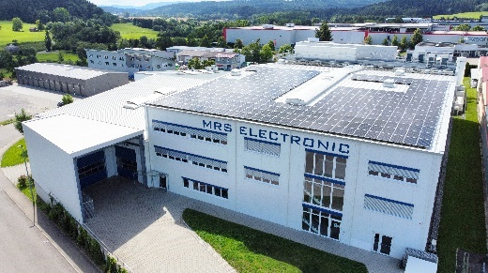  Headquarters of MRS Electronic in Rottweil – soon part of the Würth Elektronik ICS Group  Image source: MRS Electronic | 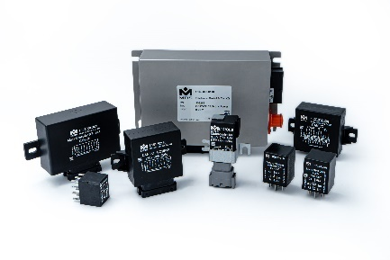  MRS Electronic’s portfolio – electronic and software solutions for the control, communication and connectivity of modern vehicles  Image source: MRS Electronic

About Würth Elektronik ICS GmbH & Co. KG
Würth Elektronik ICS is a system supplier for electromechanical and electronic solutions for signal and power distribution, control, and display and operating solutions. The company’s key customers include well-known manufacturers of construction and agricultural machinery as well as commercial vehicles. Sectors such as industrial technology or renewable energies also benefit from products and services provided by ICS. The company is headquartered in Niedernhall-Waldzimmern (Germany). Further subsidiaries are located in France, Great Britain, Italy, the USA, and India.
Würth Elektronik is part of the Würth Group, the global market leader in the development, production, and sale of fastening and assembly materials, and employs around 7,300 people. In 2025, the Würth Elektronik Group generated sales of €1.06 billion.
Würth Elektronik: more than you expect!
Further info at www.we-online.com/ics

About MRS Electronic GmbH & Co. KG
MRS Electronic has been developing and producing smart, cross-industry electronic products and customised hardware and software solutions for the automotive industry at its headquarters in Rottweil for over 25 years. The expertise of MRS Electronic lies primarily in the niche market of compact controllers and products such as relays, gateways, controllers, CAN controllers, HMI displays and test systems for power semiconductors.
Of our 285 employees worldwide, 250 work at the main site in Rottweil, Germany. Internationally, MRS Electronic has operations in Croatia, Scandinavia, Poland and Turkey to support partners worldwide in realising their vision.
More information:  Würth Elektronik ICS GmbH & Co. KG  Sandra Herter  Gewerbepark Waldzimmern  Würthstrasse 1  74676 Niedernhall  Germany  Phone: +49 7940 9810-1503  E-mail: sandra.herter@we-online.de  www.we-online.com/ics | Press contact:  HighTech communications GmbH  Marcus Planckh  Brunhamstrasse 21  81249 Munich  Germany  Phone: +49 89 500778-22  E-mail: m.planckh@htcm.de  www.htcm.de
MRS Electronic GmbH & Co. KG
Marius Wörrle
Klaus-Gutsch-Straße 7
78628 Rottweil

Phone: +49 741 2807 1158
E-mail: Marius.Woerrle@mrs-electronic.com
www.mrs-electronic.com

